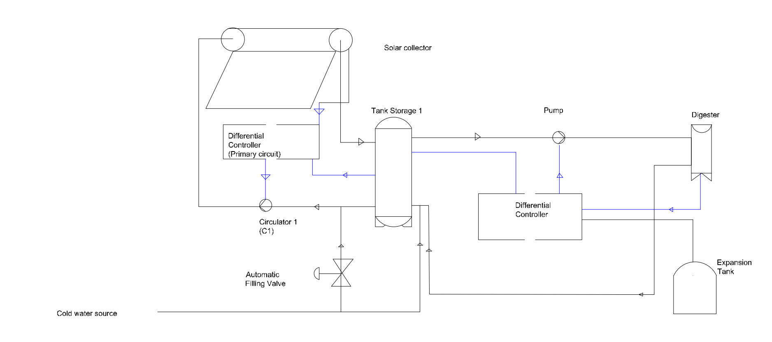
Figure 1: Solar water heating system components
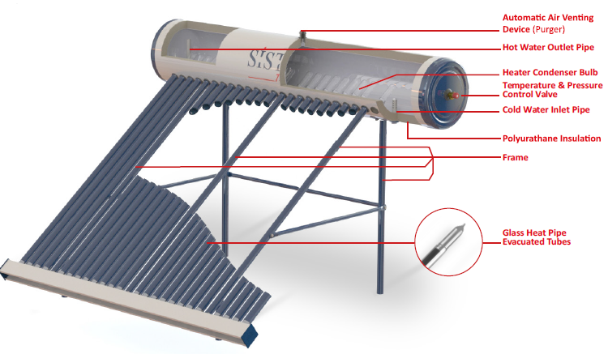 Figure 2: a SisTEM Tabular solar water heater[8]

Figure 3: Glass heat pipe evacuated tube
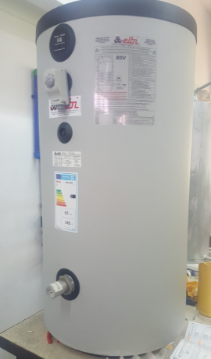
Figure 4: ELBI storage tank
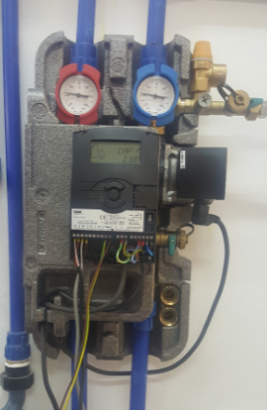
Figure 5: Resol DeltaSol C4 Regulator components
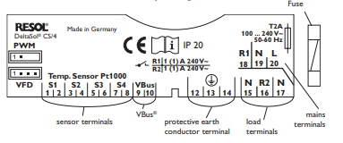
Figure 6: Resol DeltaSol CS/4 regulator connection board
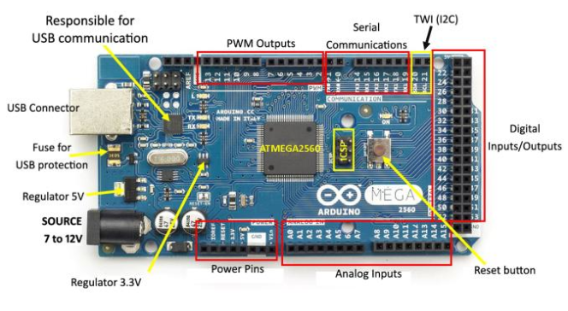
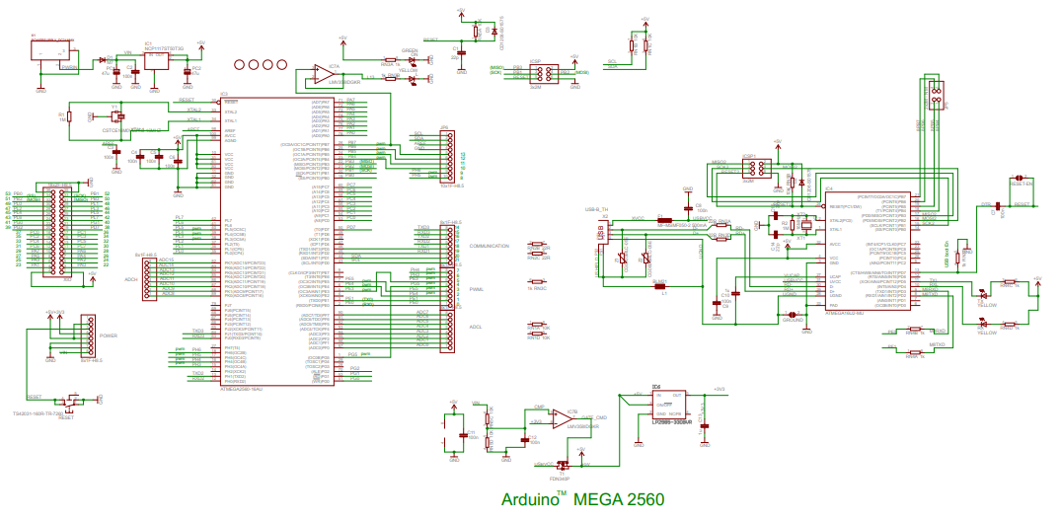
Figure 7: Arduino Mega board (a) and circuit (b) specifications
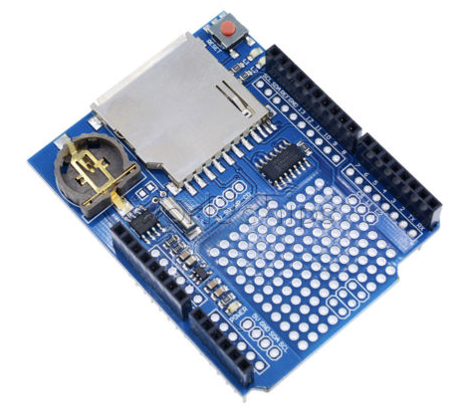
Figure 8: V.1 data logging shield for Arduino
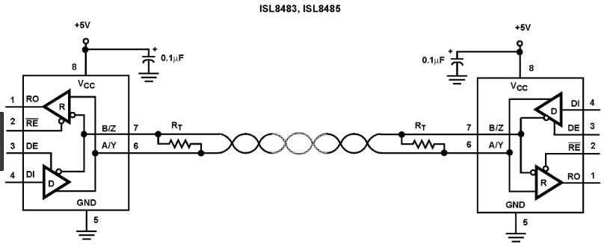
Figure 9: RS485 communication protocol interface for data transmission and reception
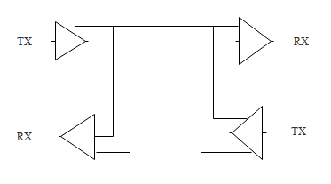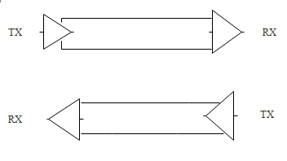
Figure 10: RS485 (a) and RS422A (b) communication principal
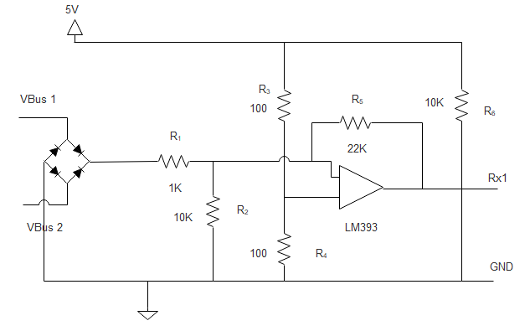
Figure 11: VBus to UART adaptation circuit
