Optimal Intelligent Speed Controller of a Brushless DC Motor
Muhammed A.Ibrahim*, Ausama Kh. Mahmood **, Nashwan S. Sultan***

*,** Dep. of System and control Department / Ninevah university
*** Dep. of Power Technichal Engineering/ Northern Technichal University

Article Info |  | ABSTRACT
Article history:  Received Jun 12, 201x  Revised Aug 20, 201x  Accepted Aug 26, 201x |  | Brushless DC (BLDC) motor is commonly employed for many industrialized application because of their high torque and efficiency. This article produce an optimal designed controller of Brushless DC motor speed control depended on the genetic algorithm (GA), the optimization method used for searching of the ideal Proportional–Integral-Derivative (PID) factors. The several kinds of controller design methods of brushless DC motor incorporate trial and error, PID design, auto-tuning PID design and genetic algorithm based controller design. A PID controller is intended by Integral absolute error criterion (IAE) and integral squared error (ISE) error criteria for BLDC motor control system. A GA-PID controller is designed to enhance the performance provisions by means of genetic algorithm. PID controller factors ${(K}_{p}, K_{i} and K_{d})$are calculated by GA to produce optimal PID as the hybrid PID with GA controller .The closed loop speed response of PID controller is experiential for IAE and ISE error criteria. A comparison output system performance monitored for every controller schemes. The results appear that the time characteristics performance of GA-PID controller based on ISE cost function has the best performance with other techniques.
Keyword:
Brushless direct current motor.
Genetic\ algorithm. Proportional– Integral – Derivative.
Copyright © 201x Institute of Advanced Engineering and Science.
All rights reserved.
Corresponding Author:
Nashwan S. Sultan
Dep. of Power Technichal Engineering/ Technical College of Engineering
Northern Technichal University
Mosul/ Iraq
Email: sultan_nashwn@yahoo.com, nashwan.saleh@ntu.edu.iq

- INTRODUCTION

The BLDC motors are common used widely in industrial application and instrumentation over than conventional DC motor due to high efficiency, high torque, high speed, low noise, low volume and long life due to it hasn’t brush like DC motor therefore no sparks during operation which allows using the motor in hazard areas, low maintenance cost, no friction at commutator [1-2]. Three phase BLDC motor mostly wide used, as shown in Fig. 1 simple cross section BLDC motor which contain stator carry windings and the rotor contains permanent magnets for arrangement two magnetic pairs of pole. The stator windings are divided in two kinds: sinusoidal and trapezoidal, which states of the form for the back electromotive force indication. The form of the BEMF is resolute by dissimilar coil inter - connections and the space of the air gap [2]. Extra to the back emf, the phase current similarly tracks a sinusoidal and trapezoidal form. A sinusoidal motor type products flatter electromagnetic torque than another trapezoidal motor type, however on a greater cost because the additional copper windings. A BLDC motor works a easy construction through trapezoidal stator windings [3].
The conventional DC motor which produce flux when current pass through the stator winding, but the BLDC motor use permanent magnetic to provide the necessary air gab flux. In [4], BLDC motor digital control with PID and Hybrid Fuzzy-PID for steady state operation and many different speeds (Dynamic State), from result, Fuzzy-PID controller has more efficient over PID controller (better performance). In [5], The controller PID and BF-PSO PID optimization algorithm (which combine BFO and PSO) was used with ISE, IAE,IATE and MSE error criteria , from the result, BF-PSO PID controller improve the performance better than PID controller. In [2], used PI as BLDC motor controller and compared it with Fuzzy-PI, the result of Fuzzy-PI already better performance than PI conventional controller. In [6], the gain of PID controller is obtained by conventional methods of Ziegler-Nicholas (ZN), Cohen Coon (CC) and Amstron-Hagglund (AH) using Fractional Order PID to control the speed and improvement in transient performance. In [7] was design and implement PID controller using parameters calculated by PSO algorithm, PSO algorithm provide PID parameters more efficient search than GA and LQR (Linear Quadratic Regulator).
BLDC motor Speed and torque control is extremely significant, speed control require to adjustment the input electric power to the motor to reach speed which is needed. Moreover speed control is important when the motor speed stable which desired with changeable torque.

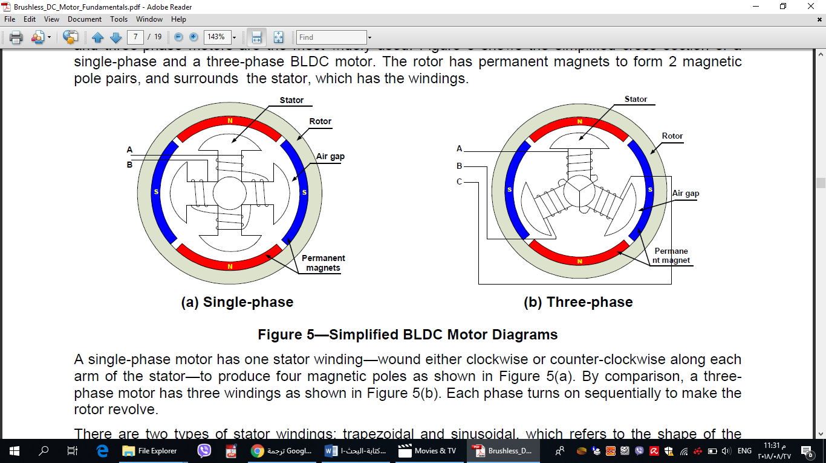
Figure 1 BDCM simple cross section.

2. BLDC Motor Mathematical Modeling:
The variance between the straight DC motor and BLDC motor is increasing of parts complicated that touches the BLDC motor general results [8]. The inductive and resistive shares of the BLDC motor organization becomes pretentious after there’s phase alteration. Fig. 2 shows the symmetrical 3- phase “wye” internal connection of this motor. The BLDC motor mathematical model can be created from the typical DC motor mathematical model.
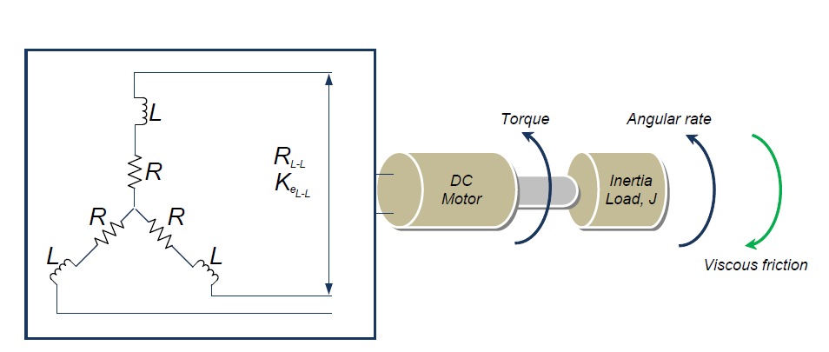

DC Motor
Inertia
Load, J
Angular
Rate
Viscous Friction
Torque
Figure 2 BLDC motor model.

BLDC motor is like conventional DC motor inspect of there is 3 phases in BLDC motor, the BLDC motor output speed is regulated through ways of a three-phase inverter (pulse-width modulation). The motor dynamic physiognomies is alike to permanent magnet DC motors. The typical equations of BLDC motors which considered like [7]:

$$v_{app}\left(t\right)=L\frac{di\left(t\right)}{dt}+R*i\left(t\right)+v_{emf}\left(t\right) (1)$$
$V_{emf}=k_{b}*w\left(t\right) (2$)
$T\left(t\right)=K_{t}*i\left(t\right) (3$)
$T\left(t\right)=J\frac{dw(t)}{dt}+D*w\left(t\right) (4$)
Whereas :
$v_{app}\left(t\right)$ : applied voltage
$w\left(t\right)$: Motor speed
$V_{emf}$: Back electromotive force
$i\left(t\right)$ : Current of the motor
L: The stator inductance
T: The motor torque
D: Viscous coefficient
J: Moment of inertia
Kb: Back electromotive force
The transfer function of BLDC motor control system is calculated:
$G\left(s\right)=\frac{w(s)}{V(s)}=\frac{k_{t}}{L*J*s^{2}+(LD+RJ)*s+k_{t}k_{b}} (5)$
The BLDC motor mathematical model is calculated depending on the chosen motor strictures from [7] which are represented in Table 1.
Table 1. Parameters values of the studied motor
Parameters | Values
Stator resistance ( R) | $$21.2 Ω$$
Inductance of the stator(L) | $$0.052 H$$
Motor torque constant (Kt) | $$0.1433 Kg-m/A$$
Back electromotive force constant (Kb) | $$0.0419 V/rad/S$$
Moment of inertia (J) | $$1*{10}^{-5} Kgm s^{2}/rad$$
Viscous coefficient(D) | $$1*{10}^{-4}kg-m s/rad$$

3. PID controller
The PID (Proportional, Integral and Deferential) controller design based on Ziegler-Nichols method was depend on trial and error to tuning the parameters ($K_{p}, K_{i} and K_{d})$, this method was performed employing the transfer function of open loop system and then finding the required values of motor parameter necessary of the calculation for the P, PI and PID factors gain values in order to get best response [6]. This technique needs the step response of transfer function open loop system.
However, conventional PID controller is worked to control speed - torque of BDCM motor because of PID controller have advantages like: simple and easily to use, stable, easy to adjustable and high reliability [9]. The conventional methods of PID tuning is not reliable for real time response. Fig. 3 shows the BDCM with PID controller system block diagram. The control function expressed as.
$$u\left(t\right)=k_{p}+\frac{k_{i}}{s}+k_{d}s ( 7)$$
Where:
$K_{p}$ : The proportional gain value.
𝐾𝑖: The Integral gain value.
𝐾𝑑: The derivative gain value
.
+
-
$$K_{p}+\frac{K_{i}}{s}+K_{d}s$$
Brushless DC
Motor
Error
$$E_{s}$$
Set Point
$$R_{s}$$

PID Controller
Plant
Control
Signal
Actual
Output
Feedback Signal
Figure 3. BLDC motor with PID controller system block diagram.

PID Tuning Implementation: There are many method to tuning conventional PID, in this paper, two method was chosen for tunnig:
- Tarial and Error Tunning.
In this method, Kp,Ki and Kd values are selected based on the desiner's experience[REF102015], from this method the obtained value of PID gains are:
Kp= 800 , Ki= 290 , Kd=0.039.
The response of BDCM using traial and error and time characterstics was shown in fig. 4
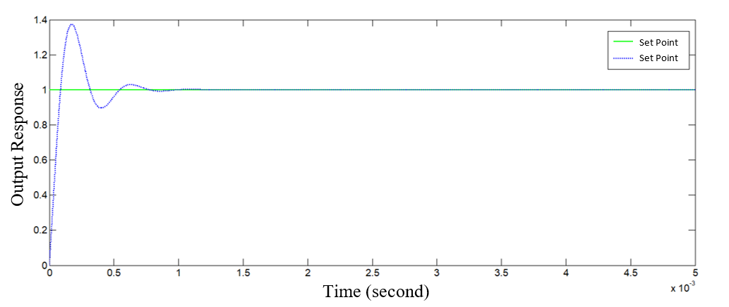

PID

Figure 4 Step response of trial and error for BLDC motor system

- MATALB PID Tunner App.
The Kp,Ki and Kd values are achieved by using MATLAB PID Tuner Application in MATALB R2017a software as shown below: Kp=700 , Ki=360 , Kd=0.09.
The response of BDCM using MATLAB Tunner traial and error and time characterstics was shown in fig. 5.
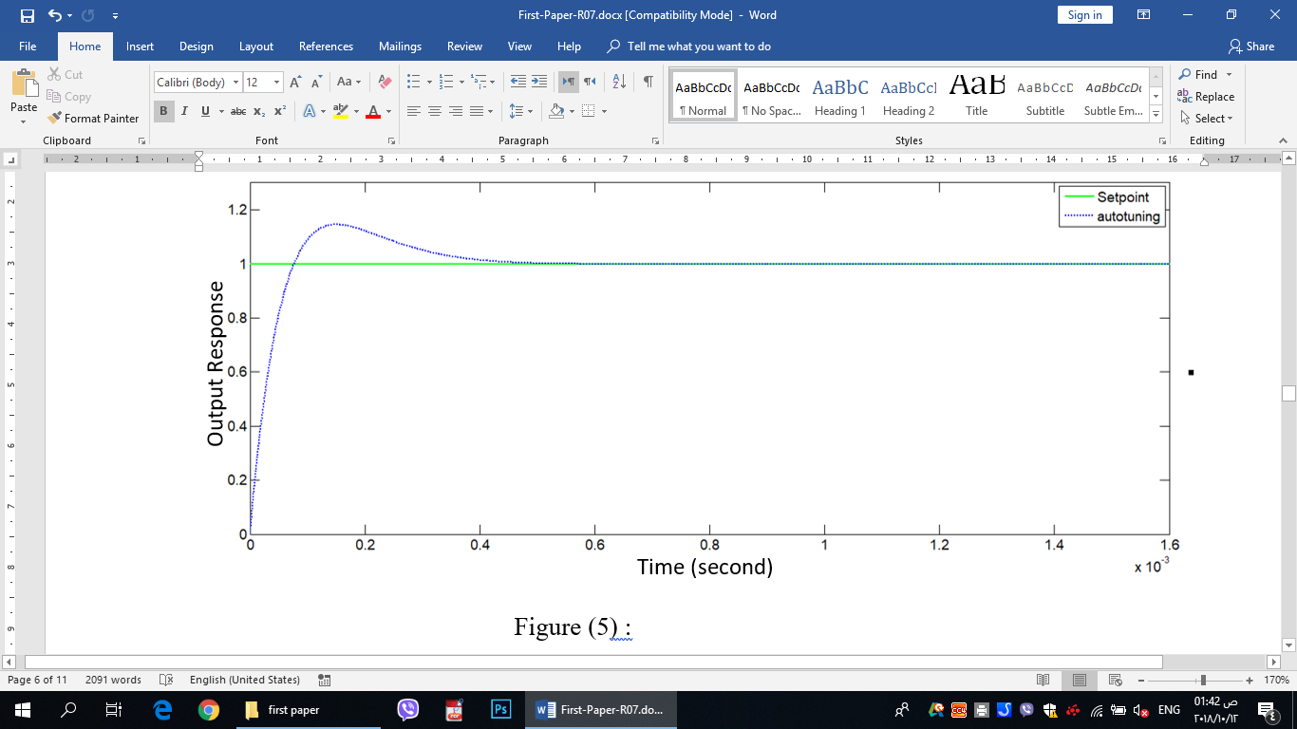

Figure 5 Step response of auto tuning for BLDC motor system.

4. Genetic algorithm
Genetic algorithms it go to the major categorize of evolutionary algorithms (EA) that create resolutions to optimization difficulties retaining methods stimulated by usual development, as selection,inheritance, mutation and crossing. GA is operated to decide on optimally the rates of PID controller gains for the selected BLDC motor system. The controller is proposed of the centers the error decrease of the output response with admiration to the orientation signal[9]. The error is computed equally the performance table, achieved by reducing the error between the unit step input response. The physiognomies for the wanted performance are typically stated in relations of time field amounts. The configuration of the genetic algorithm modification PID controller factors shown in the Fig. 6.

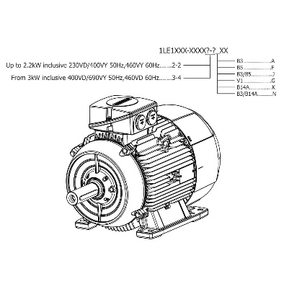
Output
Figure 6 Optimal PID Controller configurations.
GA Tuning
PID
Controller
+
-
Input

The performance of control system is measured equally to optimum if the parameters values of PID controller are select such the performance table is lowest. Integral squared error (ISE) and integral absolute - error criterion (IAE) are selected as an purpose function in the controller plan technique. The genetic software design is used to mitigate the zones specified in Fig. 7. The error criteria IAE and ISE formulas are as follows [10]:

$IAE=\int_{0}^{Tss}{abs \left(e\left(t\right)\right)dt}$ (8)

$ISE= \int_{0}^{Tss}{ {e(t)}^{2}dt}$ (9)

Where (Tss) is the time at which the response goes steady state.

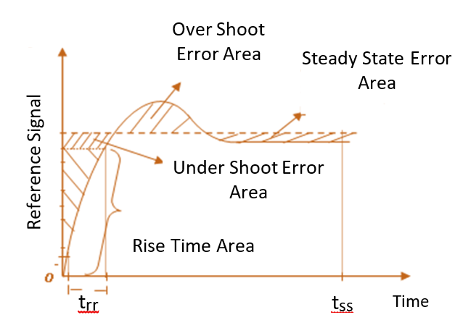

Figure 7 Area of error for the system response.
The major characteristics of the considered optimizer are as outlines in Table 2.
Table 2. Parameters of GA
1/IAE & 1/ISE | Fitness function  (performance index)
Roullete | Selection method
40 | Generation size
30 | Population size
Proportional | Fitness scaling
Arithmetic crossover | Crossover method
90% | Crossover probability
2% | Mutation probability
Uniform mutation | Mutation method
20 | Stalled generation

The flowchart below illustrations the full procedure of GA evaluation more obviously in Fig. 8.

Start
Generate Initial Population
$$K_{p}, K_{i}, K_{d}$$
Generation = Generation+1
Mutation
Crossover
Selection
Time Domain Analysis
∆F the response
Find Fitness Value
$$\frac{1}{IAE} , \frac{1}{ISE}$$
stop criterion confirmed
Specify GA Parameters
GA Operator
Stop
Result
Yes
No

Figure 8 Genetic algorithm process design flowchart.
Area of error for the system response
The table 3 reviews the ideal gain values of PID controller attained through using genetic algorithm for different error criteria. The response of GA_PID of both error criteria is shown in fig. 9.

Table 3. Gains of PID controller enhanced by genetic algorithm
parameters | IAE | ISE
Kp | 389.625 | 463.765
Ki | 499.822 | 499.853
Kd | 15.597 | 174.886

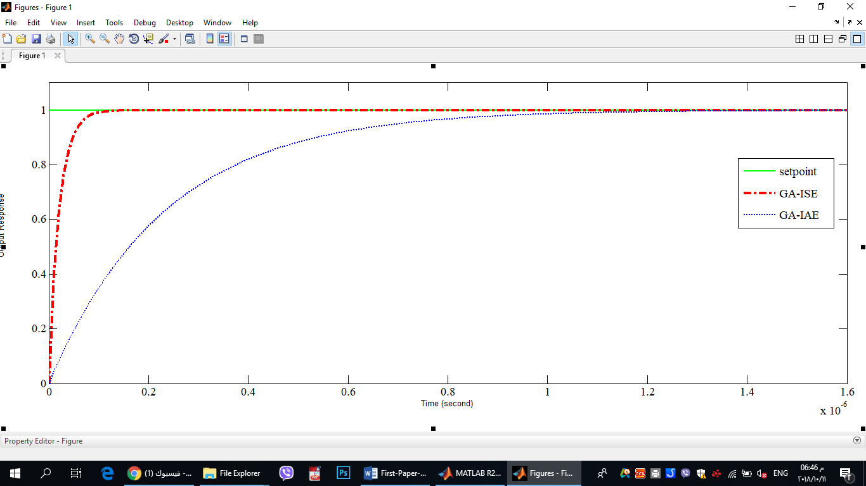
Output Response
Time (second)
Figure 9 Step response of GA-PID for BLDC motor system.

5. Analysis of Results
The achievement of conventionally PID controller is not getting the perfect results for high performance control system design of BLDC motor system then the appropriate optimized gain values of controller are gotten by the employment of genetic algorithm based PID controller. A simulation program is planned to associate the steady and dynamic performances for the certain BLDC motor control system. The time response characteristics of different controller are presented in Fig. 10.

5. Analysis of Results
The achievement of conventionally PID controller is not getting the perfect results for high performance control system design of BLDC motor system then the appropriate optimized gain values of controller are gotten by the employment of genetic algorithm based PID controller. A simulation program is planned to associate the steady and dynamic performances for the certain BLDC motor control system. The time response characteristics of different controller are presented in Fig. 10.
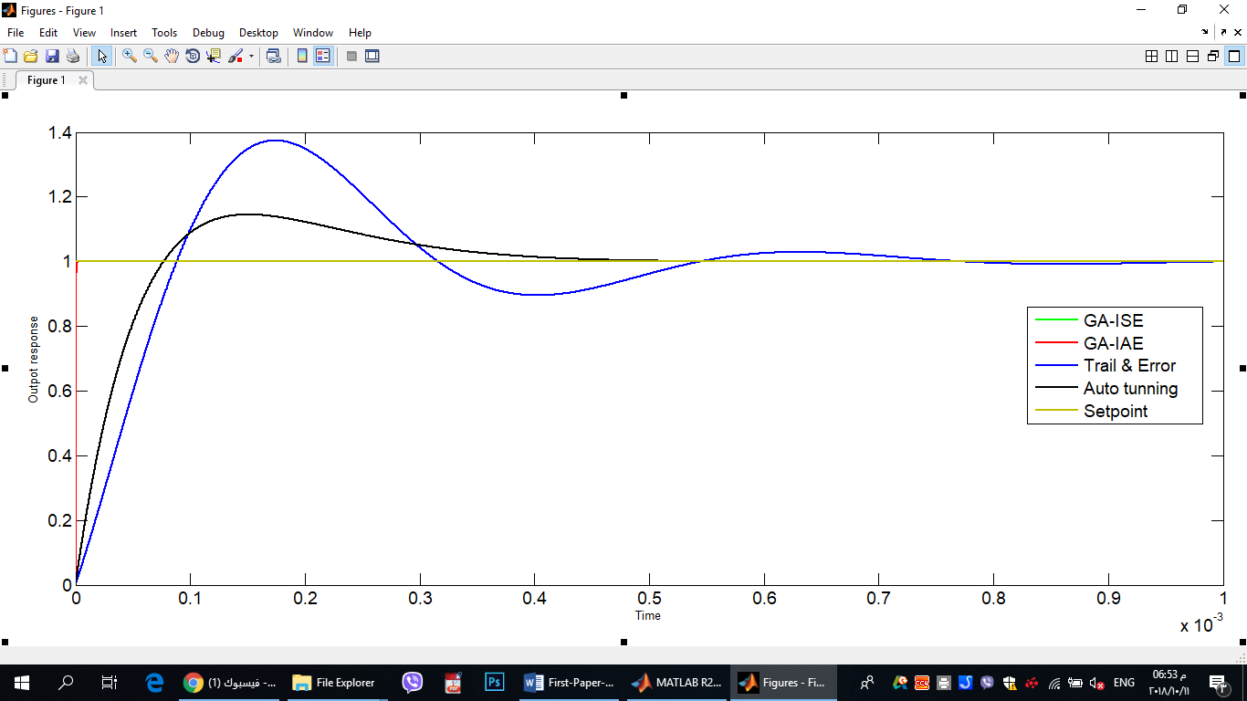
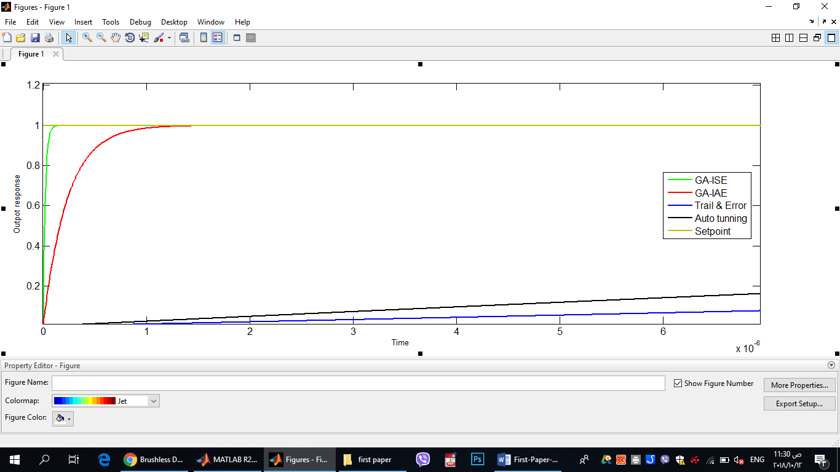
Time (second)
Output Response
Figure 10 Step response of Comparative result for PID based on GA, trail & error and conational PID controllers for BLDC motor system.
Zooming

To calculate the performance and steadiness of the controlled system a series of dimension have been accomplished. We have chosen the steady-state error, rise time, settling time and maximum overshoot. This transient parameter are obtained and shown in comparison Table 4.

Table 4. Comparison result of time response characteristics
Controller scheme  parameters | Trail & error | MATLAB tuner | GA-IAE | GA-ISE
Rise time(s) | 6.87e-5 | 5.64e-5 | 5.11e-7 | 4.56e-8
Settling time(s) | 0.000692 | 0.000375 | 9.11e-7 | 8.12 e-8
Overshoot (%) | 37.4 | 14.5 | 0 | 0
Peak | 3.74 | 1.44 | 1 | 1
Steady state error | 0 | 0 | 0 | 0

6. Conclusion
The designed PID for BLDC motor control system including enhancement by GA has much better time response characteristics compared with the conventional technique. The conventional method for tuning PID parameters is informal in computation and suitable for providing us the initial point of the PID controller factor values. Though the genetic algorithm designed PID is abundant finest in relations of the rise time settling time than the conventional technique. In GA_PID design two performance index have been used IAE and ISE in error computation. The ISE criterion easy to calculate and it admits discriminating overdamped from underdamped system. IAE makes slower response than ISE outputs but without a big oscillation over time.
7. References
[1] Rashid, Muhammad H., ed. “ Power electronics handbook. Butterworth-Heinemann ”, 2017.‏
[2] Ahmed, Ahmed M., et al. " Brushless DC motor speed control using both PI controller and fuzzy PI controller " International Journal of Computer Applications 109.10 (2015): 29-35.‏
[3] Zhao, Jian, and Yangwei Yu. " Brushless DC motor fundamentals application note " MPS, Futur. Analog IC Technol (2011): 7-8.‏
[4] Soni, Yogendra Kumar, and Rajesh Bhatt. " BF-PSO optimized PID controller design using ISE, IAE, IATE and MSE error criteria " International Journal of Advanced Research in Computer Engineering and Technology 2.7 (2013): 2333-2336.
‏[6] Khubalkar, S. W., et al. " Design and tuning of fractional order PID controller for speed control of permanent magnet brushless DC motor " Control, Measurement and Instrumentation (CMI), 2016 IEEE First International Conference on. IEEE, 2016.‏
[7] Nasri, Mehdi, Hossein Nezamabadi-Pour, and Malihe Maghfoori. " A PSO-based optimum design of PID controller for a linear brushless DC motor " World Academy of Science, Engineering and Technology 26.40 (2007): 211-215.
[8] Oguntoyinbo, Oludayo. " PID control of brushless DC motor and robot trajectory planning simulation with MATLAB®/SIMULINK®." (2009).‏

‏[9] S Dawood, Younis, Ali K Mahmood, and Muhammed A Ibrahim. " Comparison of PID, GA and Fuzzy Logic Controllers for Cruise Control System " International Journal of Computing and Digital Systems 7.05 (2018): 311-319.‏
[10] Krohling, Renato A., and Joost P. Rey. " Design of optimal disturbance rejection PID controllers using genetic algorithms " IEEE Transactions on Evolutionary computation 5.1 (2001): 78-82.‏

BIOGRAPHIES OF AUTHORS

 | . Muhammed A.Ibrahim. B.Sc in Power Technical Engineering/ Northern Technical University in 2011 with grade very Good with woner degree. MSc in Electrical Engineering /Control Engineering from Electrical Eng. Dept./College of Engineering /University of Mosul in 2013 with grade very Good. Currently he is an assisting lecturer at the Department System and control/ electronics engineering / Ninevah university
 | Ausama Kh. Mahmood. B.Sc in Power Technical Engineering/ Northern Technical University in 2011 with grade very Good. MSc in Electrical Engineering /power electronic Engineering from Electrical Eng. Dept./College of Engineering /University of Mosul in 2013 with grade very Good. Currently he is an assisting lecturer at the Department System and control/ electronics engineering / Ninevah university.
 | Nashwan saleh Sultan  Nashwan S.Sultan. B.Sc in Power Technical Engineering/ Northern Technical University in 2008 with grade very Good with woner degree. MSc in Electrical Engineering /Control Engineering from Electrical Eng. Dept./College of Engineering /University of Mosul in 2013 with grade very Good. Currently he is an assisting lecturer at the Department Power Technical Engineering/ Engineering Technical College/Mosul.

