Comparative Study of Two Control Strategies The C.V and the "Sine-Triangular" PWM Control of an MADA Dedicated to a Wind Application.

${CHEBEL .A}^{1,a*},{BENRETEM .A}^{1,a},{DOBREV.I}^{2,b},{BARKATI}^{1,a}$.

¹ Laboratoire: Génie Electromécanique, Université Badji-Mokhtar-Annaba 23000, Annaba, Algérie.
² Laboratoire DynFluid, Arts et Métiers-Paris Tech, 151, bd L' Hôpital, Paris, 75013, France.

¹chblahlem@gmail.com.;¹benretem_a@yahoo.fr;²Ivan.dobrev@ensam.eu.;¹bessouma2007@hotmail.com.

Abstract- This paper presents a study of the modeling of a system of energy recovery of wind currents coupled to an asynchronous machine with double feeding. The main objective is to compare two types of control which are the vector control and the PWM command of a dual power asynchronous machine for a wind energy conversion system.

Keywords: wind power, asynchronous doubly fed, vector control, control by the Modulation Pulse Width, inverter, MATLAB Simulink.

- INTRODUCTION

The development of the mathematical model of the asynchronous doubly fed is performed by the basic change that is based on the theory of Park aims to simplify and representation of differential equations.
Nowadays, with the development of technology, the use of computer has become indispensable for solving differential equations with a calculation time significantly reduced.
The work presented in this paper is part of the modeling and simulation Matlab and present the technique of vector control and PWM applied to the asynchronous doubly fed to a wind energy system. Some simulation results are also presented to show improved dynamic performance of the wind system.

- CONTROL OF THE MADA

  - PRINCIPLE OF VECTOR CONTROL
Vector control, called FOC (Field Oriented Control), consists in making the behaviour of the asynchronous motor identical to that of the DC machine. This method is based on the transformation of electrical variables to a reference frame that rotates with the rotor flux vector. Therefore, rotor flow dynamics are linear, hence the use of a simple PI to regulate the flow. When the rotor flow dynamics have reached a constant setpoint, the velocity dynamics becomes linear and can be regulated by a conventional PI [1].
The flow-oriented control allows the machine to be controlled in two axes: one axis for the flow and another for the torque. Many variants based on this guiding principle.
Generally these techniques differ according to:

- Voltage control.
- Current control.
According to the orientation of the marker:
- The rotor flow.
- The stator flux
- The air gap flow.
Depending on the determination of the flow position:
- Direct by measurement or observation of flow vector (module, phase) (in English: Direct Field Oriented Control or DFOC).
- Indirect Field Oriented Control (IFOC).

3.2. DIRECT AND INDIRECT VECTOR CONTROL
3.2.1. DIRECT VETCTOR CONTROL
Direct measurement makes it possible to know exactly the position of the flows. This control mode ensures correct decoupling between flow and torque at all operating points. In most cases, there is no flow sensor available and therefore estimators and observers are used from measurements made on the assembly.
Because the application of the first method imposes several disadvantages of different natures:
- the unreliability of the flow measurement;
- Measured signal filtering problem;
- Poor accuracy of the measurement, which varies with temperature.

3.2.2. INDIRECT VECTOR CONTROL
In this method, the rotor flow is not regulated and therefore neither a sensor nor a flow estimator or observer is required [2]. If the actual rotor flow is not used, its position must be known to make the coordinate changes; this requires the presence of a rotor position sensor, the flow orientation is achieved by the position deduced by integrating the self-piloting position, it is deduced from the velocity from the de-flow block fig. 1.
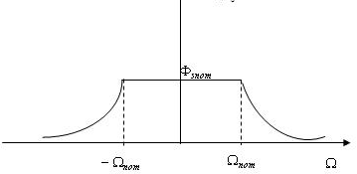
Figure.1 defluxing block

The defluxing block allows the optimal use of the machine's magnetic capacities; it allows operation at constant torque if the speed is lower than the nominal speed.
3.3. VECTOR CONTROL BY STATOR FLUX ORIENTATION
The asynchronous machine is a multi-variable system governed by differential equations. The use of Park's transformation by changing the reference points, under certain hypotheses, makes it possible to simplify these equations and thus to understand a better understanding of the machine's physical behaviour.
A suitable choice of reference (d-q) is made so that the stator flux is aligned with the axis (d) to obtain a torque expression in which two orthogonal currents (Ird, Irq) are involved, the first flux generator and the other torque generator.
Based on the orientation of the stator flux, we can write:

φ_{sd} =φ_{s} and φ _{sq} =0 then :
$ϕ_{sq}$=$L_{s}I_{sq}+L_{m}I_{rq}$=0
Impose : $I_{sq}=\frac{{-L}_{m}}{L_{s}}I_{rq}$ (1)

By introducing equation (1) in the expression of flow φ _{rd}
$ϕ_{rq}$=$L_{r}I_{rq}+L_{m}I_{sq}$
We find:
$ϕ_{rq}$=$σL_{r}I_{rq}$
$C_{em}=p\frac{L_{m}}{L_{s}}ϕ_{s}I_{rq }$ (2)
$ϕ_{sd}$=$L_{s}I_{sd}+L_{m}I_{rd}$
So :
$ϕ_{s}$=$L_{m}I_{rd}{(I}_{sd}=0)$ (3)

By introducing equation (2) in the expression (3) are:
$C_{em}=K_{t}I_{rd}I_{rq}$ (4)
With${ K}_{t}=p\frac{{L_{m}}^{2}}{L_{s}}$
The expression (4) is similar to that of the torque of a direct current machine. This allows to obtain a decoupled vector control where the Irq component controls the torque and flow imposed φ_{s} by the component Ird.
Since φ_{sd} =φ_{s} and φ _{sq} =0 can write the following equations:

$$\left\{\begin{aligned} \frac{dϕ_{s}}{dt}=\frac{-1}{T_{s}}ϕ_{s}+\frac{L_{m}}{T_{q}}I_{rd} \\ \frac{dϕ_{sq}}{dt}=0={-w}_{s}ϕ_{s}+\frac{L_{m}}{T_{s}}V_{sq} \\ \frac{dI_{rd}}{dt}=\frac{L_{m}}{σL_{s}T_{s}K_{r}}ϕ_{S}-\frac{1}{σ}(\frac{1}{T_{r}}\frac{{L_{m}}^{2}}{L_{s}T_{s}L_{r}}{)I}_{rd}+\left( w_{s}-w\right)I_{rq}- \\ \frac{L_{m}}{σL_{s}L_{r}}V_{sd}+\frac{1}{σL_{r}} V_{rd} (5) \\ \frac{dL_{m}}{dt}=\frac{L_{m}}{σL_{s}L_{r}}wϕ_{s}-\left(w_{s}-w\right)I_{rd}-\frac{1}{σ}\left(\frac{1}{T_{r}}+\frac{{L_{m}}^{2}}{L_{s}T_{s}L_{r}}\right)I_{rq}- \\ \frac{L_{m}}{σL_{s}L_{r}}V_{sq}+\frac{1}{σL_{r}} V_{rq} \\ I_{sd}=\frac{{ϕ_{s}}^{*}}{L_{m}} \end{aligned}\right.$$

So
$\frac{dθ_{s}}{dt}=w_{s}=(\frac{R_{s}L_{m}}{L_{s}}I_{sq}+V_{sq}){ϕ_{s}}^{*}$ (6)

And from equation (2):
$I_{rq}$=$\frac{{C_{em}}^{*}}{K_{t}{ϕ_{s}}^{*}}$ (7)

  - THE REGULATION
To set the currents${ I}_{rd} I_{rq}$ two PI controllers are used and a third controller may be considered for speed control.
As a general rule, a looped system must respond quickly to changes in its set point and quickly compensate for disturbances.
The reaction time is of course closely related to the inertia of the process itself.
All the regulators, which will be used in our work, will be of the PI type whose form is given by the relationship:

$G_{PI}\left(S\right)=K_{P}\frac{K_{I}}{S}$ (8)
According to the system of equations (5) we have:
$\left\{\begin{aligned}\begin{aligned}V_{d-cor}=R_{r}I_{rd}+σL_{r}\frac{dI_{rq}}{dt} \\ V_{q-cor}=(R_{r}+\frac{{L_{m}}^{2}}{L_{s}T_{s}}I_{rq})+σL_{r}\frac{dI_{rq}}{dt}\end{aligned} \\ V_{d-cp}=σL_{r}\left(w_{s}-w\right)I_{rq} \\ V_{dl}=V_{d-cp}-\frac{L_{m}}{L_{s}}V_{sd} \\ V_{q-cp}=\left[σL_{r}w_{s}-(\frac{L_{m}}{L_{s}}+σL_{r})\right]I_{rd} \\ V_{ql}=V_{d-cp}-\frac{L_{m}}{L_{s}}V_{sq} \end{aligned}\right.$ (9)
.
    - CALCULATION OF CONTROLLERS
3.4.1.1 CURRENT REGULATOR I _{rd}
It takes as input the currentI _{rd}* reference and measurement. It acts on the reference voltage V _{rd}. Regulate the current at a constant value, guarantee a constant stator flux.
The transfer function is given by the following expression:

$\frac{{I_{rd}}^{*}}{{V_{rd}}^{*}}$=$\frac{\frac{1}{R_{r}}}{1+σT_{r}S} (10)$
The open loop transfer function is given by:
$F.T.B.O+\frac{K_{d}}{R_{r}S}\frac{(1+σT_{r}S)}{(1+σT_{r}S)}\frac{K_{dl}}{S}=T$ (11)
With $K_{dl}=\frac{K_{d}}{R_{r}}$
The closed loop transfer function is given by:
$F.T.B.F=\frac{T}{T+1}=\frac{K_{dl}}{K_{dl}+S}=\frac{1}{1+\frac{1}{K_{dl}}S}=\frac{1}{1+τS}$ (12)
We choose:
$τ=σT_{r}\frac{1}{K_{dl}}=\frac{R_{r}}{K_{d}}⇒K_{d}=\frac{R_{r}}{{σT}_{r}}$ (13)
${Reg}_{d}=\frac{R_{r}}{{σT}_{r}}+\frac{1+{σT}_{r}S}{S}$ (14)

3.4.1.2. CURRENT REGULATOR I _{rq}
It takes as input the current reference I _{rq}* and measurement. It acts on the reference voltage V _{rq} to adjust the current I_{rq}.
The transfer function is given by the following equation:
$\frac{{I_{rq}}^{*}}{{V_{rq}}^{*}}=\frac{1}{K_{1}+σL_{r}S}=\frac{\frac{1}{K_{1}}}{1+K_{2}S}$ (15)
With:
$K_{1}=R_{r}+\frac{{L_{m}}^{2}}{L_{s}T_{s}} , K_{2}=\frac{L_{r}L_{s}T_{s}}{R_{r}L_{s}T_{s}+{L_{m}}^{2}}$ (16)

The open loop transfer function is given by:
$F.T.B.O=\frac{K_{q}}{K_{1}S}\frac{(1+K_{2}S)}{(1+K_{2}S)}=\frac{K_{q1}}{S}=T$ (17)

The closed loop transfer function is given by:
$F.T.B.F=\frac{T}{T+1}=\frac{K_{q1}}{K_{q1}+S}$=$\frac{1}{1+\frac{1}{K_{q1}}S}=\frac{1}{1+τS}$ (18)
${Reg}_{q}=\frac{K_{1}}{σL_{r}}\frac{1+K_{2}S}{S}$ (19)

3.4.1.3. CALCULATION OF THE SPEED REGULATOR
It takes as input the speed reference and the measured speed. It acts on the couple (that is to say its output is the reference torque) to regulate the speed.
We have:
$K_{p}+\frac{K_{i}}{S}=K\frac{(1+τS)}{S} , τ=\frac{K_{p}}{K_{i}}$ (20)

$\frac{Ω(S)}{Ω_{ref}(S)}=\frac{1}{\frac{J}{K_{i}}S^{2}+τS+1}$ (21)

By comparing the characteristic equation of the transfer function with the standard form are:

$\frac{KI}{J}={w_{0}}^{2} , τ=\frac{2ξ}{w_{0}}$ (22)
For critical damping ξ =1are:

$τ=\frac{4J}{τ^{2}} , K_{p}=K_{I}τ$ (23)

  - SIMULATION RESULTS
The following figures (2, 3, 4) show the performance of the asynchronous doubly fed during a load operation.

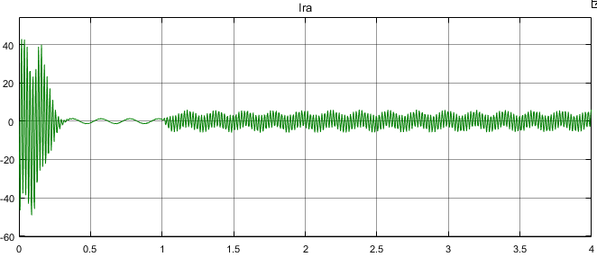
Figure.2 The rotor current Ira(A) of MADA.

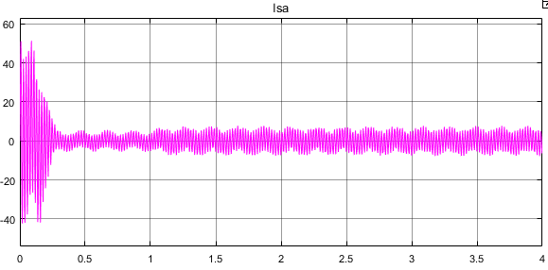
Figure.3 The stator current Isa (A) of MADA.

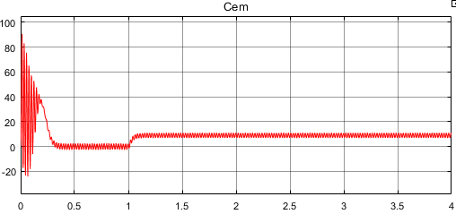
Figure.4 Electromagnetic torque Ce (Nm) of MADA.

- MADA-INVERTER ASSOCIATION:
4.1. PULSE WIDTH MODULATION:
pulse-width modulation (PWM), as it applies to motor control, is a way of delivering energy through a succession of pulses rather than a continuously varying (analog) signal. By increasing or decreasing pulse width, the controller regulates energy flow to the motor shaft. The motor’s own inductance acts like a filter, storing energy during the “on” cycle while releasing it at a rate corresponding to the input or reference signal. In other

4.2. DESCRIPTION OF THE INVERTER
The voltage inverter is a static converter that provides an alternating voltage of adjustable amplitude and frequency from a DC voltage source.

4.3. INVERTER MODEL ING
In our case, the static converter consists of two three-phase bridges, each bridge consists of three arms, and each arm consists of two transistors whose control is complementary. The transistors are shunted by recovery diodes.
The converter diagram is given in Fig. 5. Each arm of the inverter can be presented by a switch with two positions as indicated below

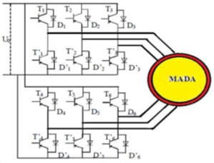
Figure .5 Static converter structures
In controllable fashion, the arm is a two-position switch that allows obtaining at the output the two voltage levels.
This arm is constituted by two diodes peer-transistors, all of these are considered ideal switches
The inverter is modeled by associating each arm a logical function defined:
The voltage inverter comprises three transistors switching arm or thyristors. Each arm consists of two cells each having a diode and a transistor or a thyristor. All of these are considered ideal switches.
In controllable fashion, the arm is a two-position switch that allows to obtain at the output two voltage levels [3].
1 if Ti is closed, T i is open
0 if Ti is opened, T i is closed
Thus the line voltages are given by:

Uab1=Vas1-Vbs1=Vdc (F1-F2) (24)

Ubc1=Vbs1-Vcs1=Vdc (F2-F3) (25)

Uca1=Vcs1-Vas1=Vdc (F3-F1) (26)

Uab2=Vas2-Vbs2=Vdc (F4-F5) (27)

Ubc2=Vbs2-Vcs2=Vdc (F5-F6) (28)

Uca2=Vcs2-Vas2=Vdc (F6-F4) (29)

Assuming the voltage Vas was, Vbs and Vcs form a balanced three-phase voltage system then:
From (24) - (24) found

V_{bs1}=$\frac{Vdc}{3}($2F₂-F₁-F₃$)$ (30)
From (25) - (26) found

V_{cs1}=$\frac{Vdc}{3}($2F₃-F₁-F₂$)$ (31)

From (24) - (26) found

V_{as1}=$\frac{Vdc}{3}($2F₁-F₂-F₃$)$ (32)

Similarly methods include:

V_{bs2}=$\frac{Vdc}{3}($2F₅-F₄-F₆$)$ (33)
V_{cs2}=$\frac{Vdc}{3}($2F₆-F₄-F₆$)$ (34)
V_{as2}=$\frac{Vdc}{3}($2F₄-F₅-F₆$)$ (35)

So:
$\left[\begin{aligned}V_{as1} \\ V_{bs1} \\ V_{cs1}\end{aligned}\right]=\frac{V_{dc}}{3}\left[\begin{matrix}2 & -1 & -1 \\ -1 & 2 & -1 \\ -1 & -1 & 2\end{matrix}\right]\left[\begin{aligned}F_{1} \\ F_{2} \\ F_{3}\end{aligned}\right]$
$\left[\begin{aligned}V_{as2} \\ V_{bs2} \\ V_{cs2}\end{aligned}\right]=\frac{V_{dc}}{3}\left[\begin{matrix}2 & -1 & -1 \\ -1 & 2 & -1 \\ -1 & -1 & 2\end{matrix}\right]\left[\begin{aligned}F_{4} \\ F_{5} \\ F_{6}\end{aligned}\right]$
  - INVERTER CONTROL
The inverter control by PWM (Pulse Width Modulation)[4] allows these quantities to be reconstructed from a source with a fixed frequency and voltage, via a static converter.
    - SINE-TRIANGULAR CONTROL
The MLI technique makes it possible to obtain alternating output voltages, which are made up of several slots. This can be done by adopting switch control techniques.
The Sinus-Triangular MLI uses the principle of intersection between a sinusoidal reference of frequency fs, called modulating and a triangular signal of high frequency fp, called the carrier p, to determine the switching times. The schematic diagram is given in the following figure.
In this technique, two parameters must be defined, which are:
- The modulation index "m" which represents the ratio between the carrier frequency
"fp" at the reference frequency "fs".
- The voltage adjustment coefficient "r" which represents the ratio between the amplitude of the reference wave and the peak value of the carrier wave

  - SIMULATION RESULTS
The following figures (6,7,8) represent the double-fed asynchronous machine performance with and without inverter.

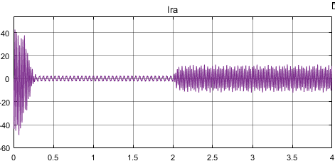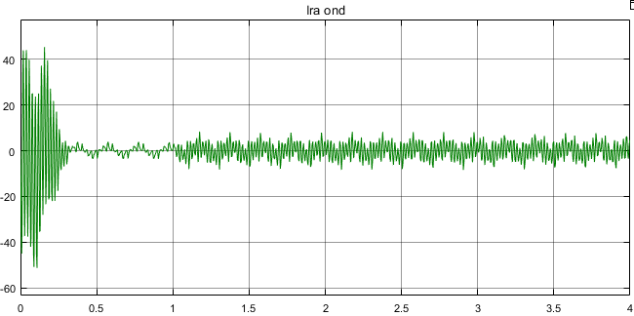

Figure .6 The rotor current without and with inverter of MADA
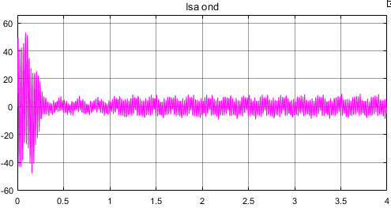

Figure. 7 The stator current without and with inverter of MADA.
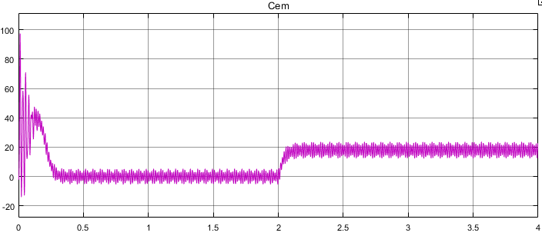
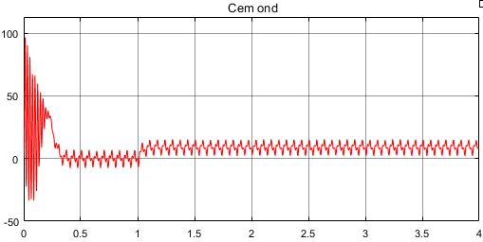
Figure.8 Cem without and with inverter of MADA.

- WIND TURBINE MODELISATION
The purpose of the wind system is to convert the kinetic energy of the wind into mechanical energy available on a transmission shaft, then into electrical energy through a generator.
By applying the theory of the quantity of movement and Bernoulli's theorem, we can determine the available power (the theoretical power), due to the wind:
$P_{disp}=1/2.ρ.S.v^{3}$ (36)

The mechanical power of the wind turbine is then:
$P_{tur}=C_{p}(λ,β)$ .$\frac{{ρ. S . v}^{3}}{2}$ (37)

This quantity is defined by the Betz limit:
$P_{tur}=P_{max}$=$\frac{16}{27}$ . $P_{disp}$=0.59 $. P_{disp}$ (38)

The power coefficient is defined by the ratio of the power captured by the turbine to the wind power:
$C_{p}$=$\frac{P_{tur}}{P_{disp}}$ (39)

The evolution of the Cp depends on the blade orientation angle β and the specific speed λ:

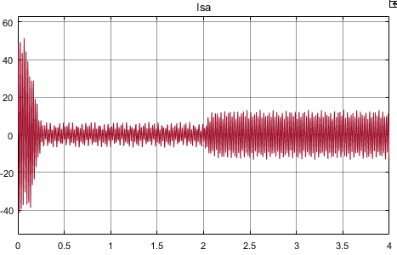
λ = $\frac{Ω_{t}.R}{v}$ (40)

The evolution of the power coefficient is a specific data for each wind turbine. From surveys carried out on a wind turbine, the expression of the power coefficient was approached, for this type of turbine, by the following equation [5]:

$C_{p}^{max}$(λ,β)=$\frac{16}{27}≈0.593$ (41)

$C_{p}\left(λ , β\right)=$0.22$({\frac{116}{λ_{i}} – 0.4β-5)e^{λ_{i}}}^{-21}$ (42)

$\frac{1}{λ_{i}}$=$\frac{1}{λ+0.08β}-\frac{0.035}{β^{3}+1}$ (43)

The aerodynamic torque on the slow axis can be expressed by Equation 44 [6]:

$C_{aer}$:$\frac{P_{disp}}{Ω_{t}}$=$\frac{1 }{2}$ρ.𝓢.$C_{p}\left(λ , β\right)v^{3}\frac{1}{Ω_{t}}$ (44)

$C_{aer}$: Torque on the slow axis (turbine side);

The role of the multiplier is to transform the mechanical speed of the turbine speed of the generator and the aerodynamic torque of the torque multiplier.
This multiplier is mathematically modeled by the following equations:

$C_{r}=\frac{C_{aer}}{G}$ (45)
$Ω_{turbine}$=$\frac{Ω_{mer}}{G}$ (46)

J=$\frac{J_{turbine}}{G^{2}}$+$J_{r}$ (47)

The fundamental equation of dynamics to determine the evolution of the mechanical speed of the total mechanical torque (${ C}_{mec}$ ) Applied to the rotor:
J$× \frac{{dΩ}_{mec}}{dt}$=${ C}_{mec}$ (48)

The mechanical speed is related to the turbine rotation speed by the multiplier coefficient. The torque on the slow axis is connected to the torque on the fast axis (generator side) by the multiplier coefficient.
$C_{mec}=-C_{em}-C_{vis}$ (49)

The friction-resistant torque is modelled by a viscous friction coefficient f :
$C_{vis}= f × Ω_{mec}$ (50)

$\frac{C_{aer}}{G}-C_{em}=\left(\frac{J_{T}}{G^{2}}+J_{g}\right)\frac{{dΩ}_{g}}{dt}+(\frac{f_{T}}{G^{2}}+f_{g})Ω_{g}$ (51)

We ask:
$\frac{J_{T}}{G^{2}}+J_{g}=J$ (52)
$\frac{f_{T}}{G^{2}}+f_{g}=f$ (53)

the mechanical equation becomes:

$\frac{C_{aer}}{G}-C_{G}=J\frac{{DΩ}_{g}}{dt}+fΩ_{g}$ (54)

  - SIMULATION RESULTS OF TURBINE OPERATION
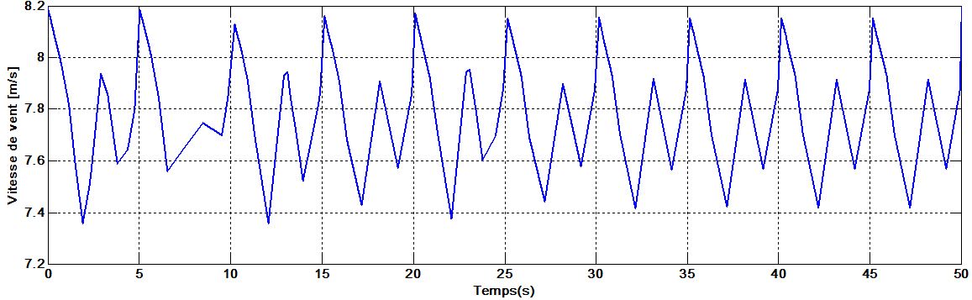
Figure.9 Profile wind applied to the turbine.

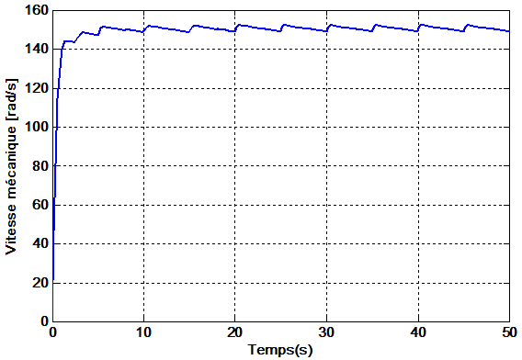
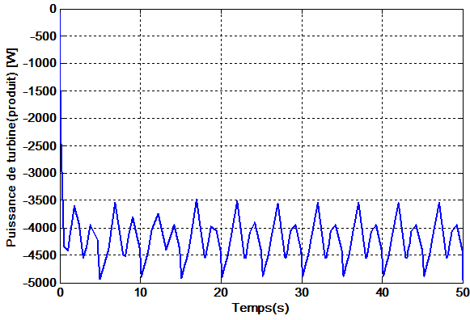
Figure.10 mechanical speed and power product.
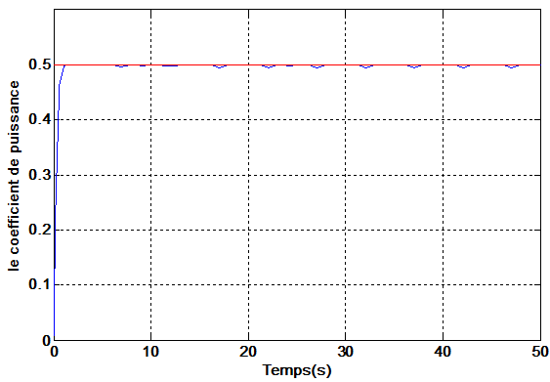
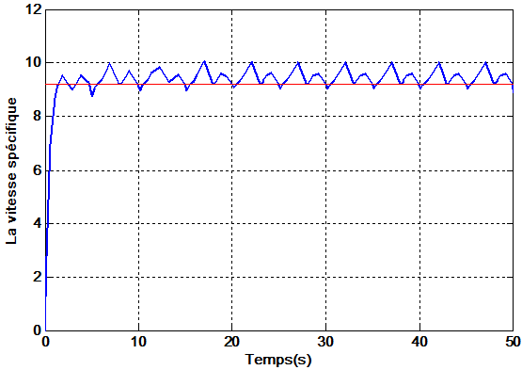
Figure. 11 The power factor and the specific speed
- CONCLUSION

This work dealt with the modelling and control of a variable speed wind system based on a MADA. First, we presented the principle of vector control modeling by stator flux orientation, which allows the asynchronous dual-powered machine to be treated in a similar way to the direct current machine.
The results of the simulation in speed regulation mode lead us to say that the vector-controlled MADA is a real electronic speed variator. The performance of the MADA obtained by a vector control depends on the choice of the reference frame.
Then we presented the structure of the two-level inverter and its modeling for control. We then studied the control strategy, namely the PWM (sinus-triangle) control.
From the simulation results it can be seen that the sinus-triangular PWM control has a main advantage which is the elimination of harmonics, the digital simulation results show the need to adjust the rotor speed independently of the applied load.
The second part is devoted to the modelling of the wind system.
Finally, the response characteristics obtained by the simulation results. These results show the performance of the dual-powered asynchronous machine, which provides an interesting solution for the use of wind energy, especially with PWM control. These machines have certain advantages over conventional machines, in particular: High power production, variable speed operation and reduced sizing of static converters.

- REFERENCES

[1] : Belkacem, S," Etude comparative des performances statique et dynamique d’un Contrôle de découplage et d’u DTC d’un moteur induction alimenté par un convertisseur statique",Thèse de magistère en électrotechnique, université de Batna, 2005.

[2] : G. A. Capolino, H. Hénao et V. T. Nguyen Phuoc, ″Méthode de Conception D’une Commande Vectorielle pour Machine à Induction″, SEE, Journée d’Etudes, Organisée par le Groupe Nord, le Club 13, Lille, France, Décembre 1992.

[3]: D. Hadiouche, H. Razik et A. Rezzoug, " Space Vector PWM Techniques for Dual Three-Phase AC Machines: Analysis, Performance Evaluation and DSP Implementation", Conf. Rec.IEEEIAS2003, Vol.1, pp. 648-655.

[4] : K. Taniguchi, Y. Ogino et H. Irie, "PWM Technique for Power MOSFET Inverter",
IEEE Trans. Power Elec., Vol. 3, No. 3, pp. 328-334, Jul. 1988.

[5] D. Aguglia, P. Viarouge, R. Wamkeue and J. Cros, ‘Determination of Fault Operation Dynamical Constraints for the Design of Wind Turbine DFIG Drives’, Mathematics and Computers in Simulation, Vol. 81, N°2, pp. 252 – 262, 2010.

[6] MEZERZI IMAD «contribution à la modélisation et la commande d’une éolienne à base d’une génératrice asynchrone à double alimentation » master en génie électrique, université de m’sila, 2012/2013.

