Improvement of adaptive fuzzy control to adjust speed for a Doubly Fed Induction Motor drive (DFIM)

Dahhou Brahim¹, Bendjebbar Mokhtar², Lachtar Salah³
^{1,2}Laboratoire de développement des entrainements électriques (LDEE) USTO M.B.Oran, Algeria
³Centre de Développement des Energies Renouvelables, CDER, 01000 Adrar, Algeria

Article Info |  | ABSTRACT
Article history:  ReceivedApr 17, 2019  Revised Jul 22, 2019  Accepted Aug3, 2019 |  | .  This paper presents the doubly fed induction motor (DFIM) speed control using adaptive fuzzy logic controller proportional integral (AFLC-PI). This controller is classified as a new technique in control of nonlinear systems in order to prove its dynamic performances and reliability. The application of this type of control is very satisfactory to replace the fuzzy logic controller (FLC-PI) and the classic proportional integral controller (PI-C). Accordingly, an improvement in dynamic and robustness is clearly appeared in AFLC-PI simulation results compared with the FLC-PI and PI-C. Simulation Results are presented for the aforementioned techniques using Matlab/Simulink to prove the dynamic performances and robustness.
Keywords:
Doubly-Fed Induction Motor
proportional integral controller fuzzy logic controller
the adaptive fuzzy logic controller
Torque tracking
Speed tracking
Copyright ©2019Institute of Advanced Engineering and Science.
All rights reserved.
Corresponding Author:
Corresponding Author,
Department of Electrical and Computer Engineering,
National Chung Cheng University,
168 University Road, Minhsiung Township, Chiayi County 62102, Taiwan, ROC.
Email: lsntl@ccu.edu.tw

- INTRODUCTION
The variable speed control of doubly fed induction motor (DFIM) drive becomes a growing area of research and importance in recent years. DFIM has a key role in the industrial sector because of its low cost, rigidity, reasonable size, low maintenance and it's one of the most widely used machines to convert electrical energy to mechanical energy [1]–[3].
Control techniques applied on the doubly fed induction motors become efficient thanks to the progress made in semi-Power drivers and digital technologies. This converter-machine unit, however, remains restricted to the lower limit of the high power range (up to a few MW), due to the electrical stresses experienced by the semiconductors and their low switching frequency.
The induction motors have many advantages such as simplicity, robust and inexpensive machine structure. In the field of high power drives, there are other solutions using the alternative machine operating in a particular mode, it is DFIM.
The DFIM is a wound rotor asynchronous three-phase machine supplied by the stator and the rotor from two external voltage sources. This solution is very attractive for variable speed and high power industrial applications requiring high dynamic performances such as spindles to coil up laminated steel sheets, compressors, and fans [4]. The DFIM has some distinct advantages over the conventional squirrel-cage machine.
- Due to the high flexibility of the DFIM (four degrees of control freedom), independent control of ﬂux, torque, slip and power factor becomes feasible [5].
- The rotor currents are measurable quantities, and the acquisition of the ﬂux vector necessary for vector control purposes depend only on the knowledge of the machine reactance.
- The use of DFIM offers the opportunity to modulate power ﬂux into and out the rotor winding in order to have, at the same time, a variable speed in the characterized super-synchronous or sub synchronous modes. However, the control of DFIM is considered to be complicated because the difﬁcult of obtaining the decoupling of the torque and the ﬂux. To overcome these difﬁculties, high-performance algorithms have been developed [6], [7].
To satisfy the performance of an electromechanical system drive, the generally used strategy consists in controlling the speed by a PI controller to cancel the static error and reduce the response time. This speed is often characterized by an overshoot startup and depends on the parameters of the machine. In order to overcome these complications, several methods have been developed to adjust the PI regulator.
The use of AFLC as alternative methods for tuning PI controllers has been a recent topic of research in electric machines control [8]–[10].
Recently, the AFLC has improved results of nonlinear and complex processes. The main idea of this approach does not need a precise mathematical model of the electric machine, AFLC is robust and one of its performances is the insensitivity to parameter variations. With the increasing evolution of approximation theory, the adaptive control method has been presented to cope with the nonlinear systems with parametric uncertainty based on the fuzzy logic system[11], [12].
There are two disadvantages to the conception of FLC. The ﬁrst one, is the obtaining of a suitable rule-base for the application, while the second is the selection of scaling factors prior to fuzziﬁcation and after defuzziﬁcation, in order to overwhelm these drawbacks and expedite the determination of the design parameters and to reduce the time consumption. Several solutions are adapted to remedy these problems. In [13], the authors present an online method for adapting the scaling factors of the FLC, the authors suggest a solution to design an adaptive fuzzy controller. The objective of the proposed form to adopt online scaling factors according to a performance measure in order to reﬁne the controller and increase the performance of the drive system.
In this paper, an investigation of the AFLC performances for optimizing DFIM fuzzy-PI speed controller gains. The paper is organized as follows. In section 2, modeling of DFIM, the field oriented control and inverter are developed. The methodology approaches of the conventional adaptive fuzzy logic controller and fuzzy logic controller are presented, in section 3. The simulation results and their discussion are presented in section 4. Finally, a conclusion is presented in the last section.
- Description of the system
The overall system is illustrated in Figure.1 below, it consists of two converters (rectifier and inverter), one is connected to the stator and the other is connected to the rotor of the machine studied [14].
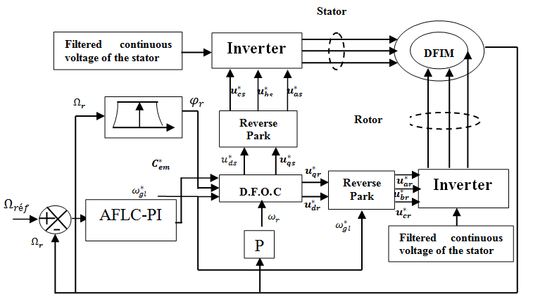
Figure 1.Global scheme of the studied system with adjustable speed control

In order to control the electrical system, it is necessary to study and analyze its mathematical model taking into account certain hypotheses in order to obtain a simplified model [15].

- Modeling system
The structure of the DFIM is very complex. Therefore, in order to develop a model, it is necessary to consider the following simplifying assumptions [16]: the machine is symmetrical with constant air gap; the magnetic circuit is not saturated and it is perfectly laminated, with the result that the iron losses and hysteresis are negligible and only the windings are driven by currents; the MMF created in one phase of stator and rotor are sinusoidal distributions along the gap. By this means, the DFIM state equations are described as follow:

$\left\{\begin{aligned}\dot{x}=Ax+Bu \\ y=Cx\end{aligned}\right.$ (1)
With,
${x=\left[i_{sd}i_{sq}i_{rd}i_{rq}\right]}^{T}$is the state vector
${u=\left[V_{sd}V_{sq}V_{rd}V_{rq}\right]}^{T}$ is input vector

$A=\left[\begin{aligned}\frac{-R_{s}}{σL_{s}} \\ \frac{\left(1-σ\right)ω+ω_{s}}{σ} \\ \frac{R_{s}M}{σL_{s}L_{r}} \\ \frac{Mω}{σL_{r}}\end{aligned}\begin{aligned}\frac{\left(1-σ\right)ω+ω_{s}}{σ} \\ \frac{-R_{s}}{σL_{s}} \\ \frac{-Mω}{σL_{r}} \\ \frac{R_{s}M}{σL_{s}L_{r}}\end{aligned}\begin{aligned}\frac{R_{r}M}{σL_{s}L_{r}} \\ \frac{Mω}{σ{L_{s}L}_{r}} \\ \frac{-R_{s}}{σL_{s}} \\ \frac{ω-σω_{s}}{σ}\end{aligned}\begin{aligned}\frac{Mω}{σL_{s}} \\ \frac{R_{r}M}{σL_{s}L_{r}} \\ \frac{σω_{s}-ω}{σ} \\ \frac{-R_{s}}{σL_{s}}\end{aligned}\right]$ (2)

$B=\left[\begin{aligned}\frac{1}{σL_{s}} \\ 0 \\ \frac{-M}{σL_{s}L_{r}} \\ 0\end{aligned}\begin{aligned} 0 \\ \frac{1}{σL_{s}} \\ 0 \\ \frac{M}{σL_{s}L_{r}}\end{aligned}\begin{aligned} \frac{-M}{σL_{s}L_{r}} \\ 0 \\ \frac{1}{σL_{r}} \\ 0\end{aligned}\begin{aligned} 0 \\ \frac{-M}{σL_{s}L_{r}} \\ 0 \\ \frac{1}{σL_{r}}\end{aligned}\right]$ (3)

$C=\left[\begin{aligned}1 \\ 0 \\ 0 \\ 0 \end{aligned}\begin{aligned}0 \\ 1 \\ 0 \\ 0 \end{aligned}\begin{aligned}0 \\ 0 \\ 1 \\ 0 \end{aligned}\begin{aligned}0 \\ 0 \\ 0 \\ 1\end{aligned}\right]$ (4)

The global DFIM dynamic model in the reference d-q can be reported as following[17]:

$\frac{d}{dt}\left[\begin{aligned}i_{sd} \\ i_{sq} \\ i_{rd} \\ i_{rq}\end{aligned}\right]=\left[\begin{aligned}\frac{-R_{s}}{σL_{s}} \\ \frac{\left(1-σ\right)ω+ω_{s}}{σ} \\ \frac{R_{s}M}{σL_{s}L_{r}} \\ \frac{Mω}{σL_{r}}\end{aligned}\begin{aligned}\frac{\left(1-σ\right)ω+ω_{s}}{σ} \\ \frac{-R_{s}}{σL_{s}} \\ \frac{-Mω}{σL_{r}} \\ \frac{R_{s}M}{σL_{s}L_{r}}\end{aligned}\begin{aligned}\frac{R_{r}M}{σL_{s}L_{r}} \\ \frac{Mω}{σ{L_{s}L}_{r}} \\ \frac{-R_{s}}{σL_{s}} \\ \frac{ω-σω_{s}}{σ}\end{aligned}\begin{aligned}\frac{Mω}{σL_{s}} \\ \frac{R_{r}M}{σL_{s}L_{r}} \\ \frac{σω_{s}-ω}{σ} \\ \frac{-R_{s}}{σL_{s}}\end{aligned}\right]\left[\begin{aligned}i_{sd} \\ i_{sq} \\ i_{rd} \\ i_{rq}\end{aligned}\right]+\left[\begin{aligned}\frac{1}{σL_{s}} \\ 0 \\ \frac{-M}{σL_{s}L_{r}} \\ 0\end{aligned}\begin{aligned} 0 \\ \frac{1}{σL_{s}} \\ 0 \\ \frac{M}{σL_{s}L_{r}}\end{aligned}\begin{aligned}\frac{-M}{σL_{s}L_{r}} \\ 0 \\ \frac{1}{σL_{r}} \\ 0\end{aligned}\begin{aligned} 0 \\ \frac{-M}{σL_{s}L_{r}} \\ 0 \\ \frac{1}{σL_{r}}\end{aligned}\right]\left[\begin{aligned}V_{sd} \\ V_{sq} \\ V_{rd} \\ V_{rq}\end{aligned}\right]$ (5)

The mechanical equation of motion is given by the following equation:
$J\frac{dΩ}{dt}=T_{em}-T_{l}-k_{f}Ω$ (6)
The electromagnetic torque is given by the following equation:
$T_{em}=P\frac{M}{L_{r}}(φ_{rd}i_{sq}-φ_{rq}i_{sd})$ (7)
Where
$θ_{s}$ ,$θ_{r}$ : Stator and rotor electrical angles
$θ; Ω$ : Rotor mechanical position and speed
$ω_{s}{,ω}_{r},ω$ : Electrical frequencies of stator, rotor and shaft
$T_{l}{,T}_{em}$: Load and electromagnetic torque
$σ=1-\left(\frac{M^{2}}{L_{s}L_{r}}\right)$: Leakage coefficient
$v_{sd},v_{sq},v_{rd},v_{rq}$ : Stator and rotor d-q axes voltages
$i_{ds},i_{qs},i_{rd},i_{rq}$ : Stator and rotor d-q axes currents
$R_{s},R_{r}$ : Stator and rotor resistance
$k_{f}$: Friction coefficient

The vector control aimed to ensure control decoupled of the flux and torque[18].In the synchronous reference Frame whose axis d is aligned with the rotor flux vector $φ_{rd}=φ^{*}$and$φ_{qr}=0$.Figure.2. Shows the vector representation of vector control.
$$θ_{r}$$
Stator axis
Rotor axis
d
$$φ_{r}=φ_{rd}$$
$$θ$$
$$θ_{s}$$
$$i_{s}$$
$$i_{sq}$$
$$i_{sd}$$
$$q$$

Figure 2. Rotor orientation diagram
In order to obtain a good decoupling between the axes d and q, the intermediate voltages are defined by the following equations:
$\left\{\begin{aligned}V_{tsd}=V_{sd}-\frac{M}{L_{r}}.V_{rd} \\ V_{tsq}=V_{sq}-\frac{M}{L_{r}}.V_{rq} \\ V_{trd}=V_{rd}-\frac{M}{L_{s}}.V_{sd} \\ V_{trq}=V_{rq}-\frac{M}{L_{s}}.V_{sq}\end{aligned}\right.$ (8)
The transfer functions connecting the stator and rotor components of each axis are:
$\left\{\begin{aligned}\frac{I_{sd}(s)}{V_{tsdc(s)}}=\frac{I_{sd}(s)}{V_{tsqc(s)}}=\frac{1}{R_{s}+σL_{s}.S} \\ \frac{I_{rd}(s)}{V_{trdc(s)}}=\frac{I_{rq}(s)}{V_{trqc(s)}}=\frac{1}{R_{r}+σL_{r}.S}\end{aligned}\right.$ (9)

4. Adaptive fuzzy control design for DFIM
For adaptive fuzzy control based on the Lyapunov theory, two steps are followed. The first step is dedicated to the design of a PI-fuzzy controller[19], [20]. The second step is to define the methodology for determining the gains of a fuzzy regulator based on the Lyapunov theory. The control applied to the DFIM is provided by an FLC-PI. We proposed a new adaptive fuzzy control strategy based on the Lyapunov theory to determine the earnings of $K_{e}$ and $K_{dce}$ (Normalized) this can be applied for a broad class of nonlinear systems. It combines the advantages of two techniques considered robust and which are the control by fuzzy logic and adaptive control [18], [21].
The control application on a DFIM in order to make it follow the reference speed is possible to highlight this characteristic.
5. Study of the adaptation mechanism:
There are many notions of stability for dynamic systems. We will study the following notion:
Asymptotic stability: Lyapunov stability + trajectories tend asymptotically to 0.
We consider a nonlinear system whose mechanical equation of DFIM is described in the following form:
$\frac{J}{s}\frac{dΩ_{r}(t)}{dt}=T_{em}-T_{l}-\frac{k_{f}}{s}Ω_{r}(t)$ (10)
The previous equation can be reformulated as follow:
$\dot{Ω_{r}}\left(t\right)=\frac{dΩ_{r}(t)}{dt}=b_{p}T_{em}\left(t\right)-d_{p}T_{l}-a_{p}Ω_{r}\left(t\right)$ (11)
By replacing equation (43) in equation (44), we obtain the following form:
$\dot{Ω_{r}}\left(t\right)=-a_{p}Ω_{r}\left(t\right)+b_{p}T_{em}^{*}\left(t-1\right)+b_{p}K_{dce}dT_{nem}(t)-d_{p}T_{l}$ (12)
The error e (t) and it's derivative $\frac{de(t)}{dt}$ are used to build the base of the adaptation mechanism of the adaptive fuzzy logic controller. Each size of the adaptation mechanism is of the following form: The speed error noted e (t) is defined by:
$e(t)=k_{e}\left(Ω_{réf}-Ω_{r}(t)\right)$ (13)
The derivative of the speed error noted by:
$\dot{e}\left(t\right)=\frac{de(t)}{dt}=k_{e}\left(\frac{dΩ_{réf(t)}}{dt}-\frac{dΩ_{r}(t)}{dt}\right)$ (14)
So, we get as follows:
$\dot{e}\left(t\right)=\frac{de(t)}{dt}=k_{e}\left(-a_{p}Ω_{r}\left(t\right)+b_{p}T_{em}^{*}\left(t-1\right)+b_{p}K_{dce}dT_{nem}(t)-d_{p}T_{l}\right)$ (15)
Since $\frac{dΩ_{réf(t)}}{dt}=0$analysis of the stability of the proposed order.

6. RESULTS AND DISCUSSION
After the contribution and implementation of the machine model with different types of speed-adjustable in the Matlab/Simulink environment, the torque and speed simulation result is shown in the Figure5.The machine operating in its nominal condition with a reference speed 150rad / s, at (0.7s <t <1.7s) and a torque load$T_{l}$ = 10N.m.
The DFIM responses speed and torque with AFLC-PI respectively shown in figure (5. (a) and 5.(b)) is almost identical with the reference compared with the two others controllers.
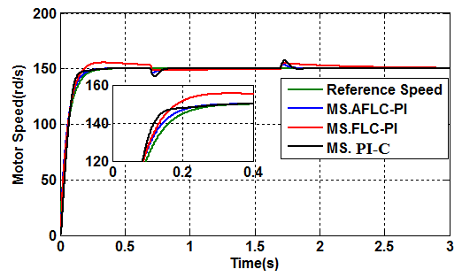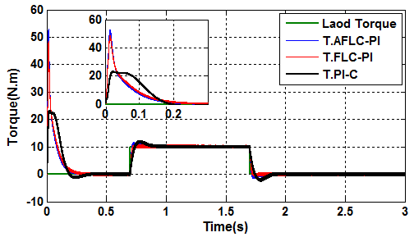
b
a
Figure 5. Simulation results in nominal case: (a) tracking of the Motor speed, (b) Electromagnetic torque.

To achieve a satisfactory transient control performance considering the requirement of stability, a sudden change in direction of speed is shown in figure 6 (a). The response of the proposed controller is very satisfactory compared with the FLC-PI and classic PI even in the transient conditions. So, the AFLC-PI prove its robustness against the speed variation.
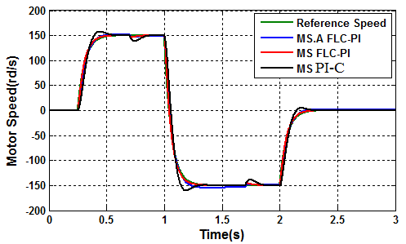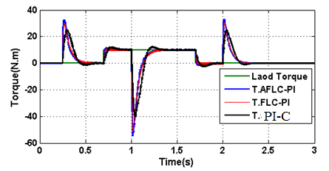
c
d
Figure 6. Simulation results in nominal case: (a) tracking of the Motor speed, (b) Electromagnetic torque.

7. Test with DFIM with perturbation parameters
The motor is operating in the same conditions aforementioned (nominal conditions). To study the effect of parameters variation on the performance of the different controllers, an increase with 50% of the Rr, Rs, and J, the performance of DFIM drive is greatly affected by the variation of these parameters, especially at low speed. At $0.7s<t<1.7s$ a sudden nominal load is applied to the motor.
Figure 7 shown the speed and torque with a 50% increase in Rr. Figures 7 (a) and (b) show respectively the speed and torque under nominal conditions and the inversion of the speed at t = 1s shown in Figure 7 (c) to test the robustness of the controller under transient conditions. Figure 7 (d) shows the torque response. Figures 7 shows excellent performance, not only in continuation but also in control, with a good follow-up of reference speed with zero static error and fast response time compared to FLC-PI and PI-C. Insensitivity of disturbances is excellent. We also note that the rotor flux is well done, and the electromagnetic torque has a good response. The speed control is perfect and has a very good performance against the load variation and especially during the reversal of the rotation direction as shown in figure 7 (c), which confirms the robustness of the AFLC-PI, the time of setting up speed decreases with respect to the FLC-PI and PI-C. Also, the electromagnetic torque oscillations are remarkably decreased figure 7 (d).
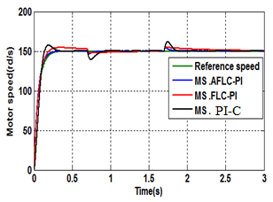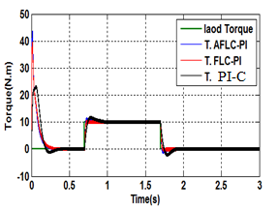
b
a
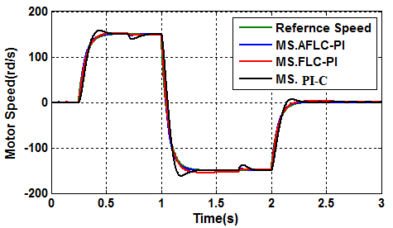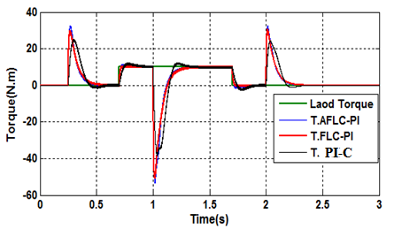
d
c
Figure7.Simulation results in the perturbed case during Rr variation (1.5$×$Rr): (a) and (b) tracking of the rotor speed, (c) and (d) Electromagnetic torque.

Figure 8 shown the speed and torque with a 50% increase in Rs. Figures 8 (a), (b), (c) and (d) show respectively speed, torque, speed inversion at t = 1s and torque response under speed inversion. Similarly, the Rs variation gives the same effect with respect to the Rr variation. Always noticed that speed and torque responses are excellent when using AFLC which appears a high performance compared with the FLC-PI and classic PI.

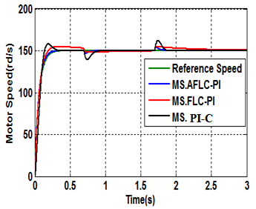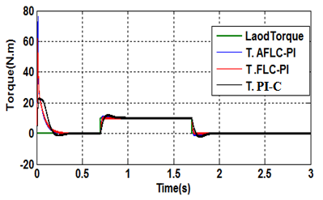
a
b
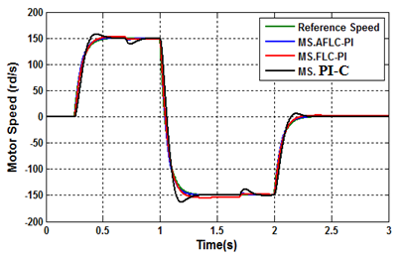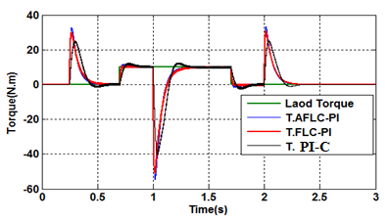
c
d
Figure 8. Simulation results in perturbed case during Rs variation (1.5$×$Rs): (a) and (b) tracking of the rotor speed, (c) and (d) Electromagnetic torque.
Figure 9 shown the speed and torque with a 50% increase in J. Figures 9 (a), (b), (c) and (d) show similar conditions in figure 8 (a), (b), (c) and (d). Similar performances appear between the AFLC-PI and the two other controllers in steady state condition. But, in transient condition, the FLC-PI responses show a difficult to follow the reference and a little massive divergence between responses and references in speed and torque compared to the AFLC-PI which appears high performance in steady-state and transient conditions against inertia variation. The classic PI response shows an enormous divergence between response and references in speed and torque in transient conditions under inertia variation.
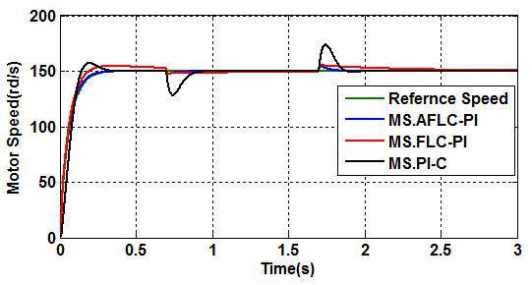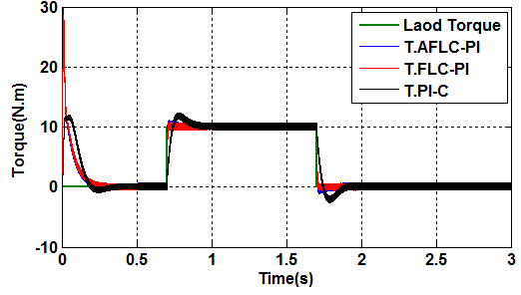
a
b
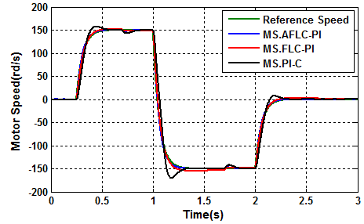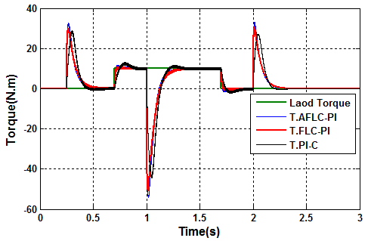
d
c
Figure 9. Simulation results in the perturbed case during J variation (1.5$×$J): (a) and (b) tracking of the rotor speed, (c) and (d) Electromagnetic torque

8. Conclusion
The main motivation of this paper consisted of addressing the torque and speed tracking of a DFIM using an appropriate adaptive fuzzy vector control scheme. The control design is carried thanks Procedure which ensures naturally the stability of the control system. Unlike in the available controllers that have been particularly developed for DFIM, the proposed controller does not require a DFIM mathematical model. Simulation results have been presented to show the effectiveness of the proposed adaptive fuzzy controller, namely its ability to perform torque and speed tracking accuracy together with satisfactory ﬂux control in the presence of parameter variations, unstructured model uncertainties, an unknown load. Of particular interest, the proposed adaptive fuzzy control system has shown to be more effective in performing the tracking control than the feedback-linearization vector control system. Future work will address the experimental implementation of the proposed controller.
References
[1] S. Dettori, V. Iannino, V. Colla, and A. Signorini, “A Fuzzy Logic-based Tuning Approach of PID Control for Steam Turbines for Solar Applications,” Energy Procedia, vol. 105, pp. 480–485, 2017.
[2] A. Zemmit, S. Messalti, and A. Harrag, “A new improved DTC of doubly fed induction machine using GA-based PI controller,” Ain Shams Eng. J., vol. 9, no. 4, pp. 1877–1885, 2018.
[3] A. F. Payam, “An Adaptive Input-Output Feedback Linearization Controller for Doubly-Fed Induction Machine Drives,” J. Electr. Eng., vol. 5, no. 1, pp. 139–154, 2008.
[4] Z. Tir, O. P. Malik, and A. M. Eltamaly, “Fuzzy logic based speed control of indirect field oriented controlled Double Star Induction Motors connected in parallel to a single six-phase inverter supply,” Electr. Power Syst. Res., vol. 134, pp. 126–133, 2016.
[5] D. Cherifi and Y. Miloud, “Performance analysis of adaptive fuzzy sliding mode for nonlinear control of the doubly fed induction motor,” Indones. J. Electr. Eng. Informatics, vol. 6, no. 4, pp. 436–447, 2018.
[6] H. A. Aroussi, E. Ziani, and B. Bossoufi, “Contribution to the enhancement of dual dtc application: Doubly fed induction motor,” Proc. - 3rd Int. Conf. Adv. Technol. Signal Image Process. ATSIP 2017, no. February 2018, 2017.
[7] R. Babouri, D. Aouzellag, and K. Ghedamsi, “Introduction of doubly fed induction machine in an electric vehicle,” Energy Procedia, vol. 36, pp. 1076–1084, 2013.
[8] N. Bounar, A. Boulkroune, F. Boudjema, M. M’Saad, and M. Farza, “Adaptive fuzzy vector control for a doubly-fed induction motor,” Neurocomputing, vol. 151, no. P2, pp. 756–769, 2015.
[9] E. A. Ramadan, M. El-Bardini, and M. A. Fkirin, “Design and FPGA-implementation of an improved adaptive fuzzy logic controller for DC motor speed control,” Ain Shams Eng. J., vol. 5, no. 3, pp. 803–816, 2014.
[10] A. M. Zaki, M. El-Bardini, F. A. S. Soliman, and M. M. Sharaf, “Embedded two level direct adaptive fuzzy controller for DC motor speed control,” Ain Shams Eng. J., vol. 9, no. 1, pp. 65–75, 2018.
[11] T. C. Lin, H. L. Liu, and M. J. Kuo, “Direct adaptive interval type-2 fuzzy control of multivariable nonlinear systems,” Eng. Appl. Artif. Intell., vol. 22, no. 3, pp. 420–430, 2009.
[12] Y. Li and S. Tong, “Command-filtered-based fuzzy adaptive control design for MIMO-switched nonstrict-feedback nonlinear systems,” IEEE Trans. Fuzzy Syst., vol. 25, no. 3, pp. 668–681, 2017.
[13] H. Sathishkumar and S. S. Parthasarathy, “A novel fuzzy logic controller for vector controlled induction motor drive,” Energy Procedia, vol. 138, pp. 686–691, 2017.
[14] L. Keltoum, B. Leila, and B. Abderrahmen, “Speed control of a Doubly-Fed induction motor (DFIM) based on fuzzy sliding mode controller,” Int. J. Intell. Eng. Syst., vol. 10, no. 3, pp. 20–29, 2017.
[15] K. Loukal and L. Benalia, “Interval type-2 fuzzy gain-adaptive controller of a Doubly Fed Induction Machine (DFIM),” J. Fundam. Appl. Sci., vol. 8, no. 2, p. 470, 2016.
[16] S. Georges, M. Rita, P. Maria, and A. H. Analysis, “M ixed S ensitivity H  C ontrol of D oubly F ed I nduction M otor,” pp. 1300–1304, 2007.
[17] M. Hasni, Z. Mancer, S. Mekhtoub, and S. Bacha, “Parametric identification of the doubly fed induction Machine,” Energy Procedia, vol. 18, pp. 177–186, 2012.
[18] N. El Ouanjli, S. Motahhir, A. Derouich, A. El Ghzizal, A. Chebabhi, and M. Taoussi, “Improved DTC strategy of doubly fed induction motor using fuzzy logic controller,” Energy Reports, vol. 5, pp. 271–279, 2019.
[19] D. Ben Attous and Y. Bekakra, “Speed control of a doubly fed induction motor using fuzzy logic techniques,” Int. J. Electr. Eng. Informatics, vol. 2, no. 3, pp. 179–191, 2010.
[20] B. N. Kar, K. B. Mohanty, S. Member, and M. Singh, “Indirect Vector Control of Induction Motor Using Fuzzy Logic Controller,” no. 4, pp. 6–9, 2011.
[21] M. Taoussi, M. Karim, B. Bossoufi, D. Hammoumi, A. Lagrioui, and A. Derouich, “Speed variable adaptive backstepping control of the doubly-fed induction machine drive,” Int. J. Autom. Control, vol. 10, no. 1, p. 12, 2016.

