Induction Motor Rotor Bars Type: The Effects on Energy Efficiency, Economic and Environment

Mohd Khairil Rahmat ¹, Yanawati Binti Yahya ²
^{1,2} Universiti Kuala Lumpur (UniKL) British Malaysian Institute, Gombak, Selangor Malaysia

Article Info |  | ABSTRACT
Article history:  Received Apr 17, 2019  Revised Jul 22, 2019  Accepted Aug 3, 2019 |  | Nowsday, the induction motor is currently he most exploited machine for industrial motor global. Its ease of use, self-starting, small in size, light in weight, high efficiency, less maintenance and cheap per same power rating which usually met the required characteristics for industry as attract its application in industry. It is presented from small horse-power up to thousands of horse-power. Induction motor was employed in application such as small pumps, conveyors, drilling machines, fans, blowers and escalators. The increment in energy efficiency was investigated using copper for rotor bar slots. Normally, the copper losses in rotor part of induction motor is contributing to the energy losses. The work proposed a new design for the rotor part, with modified rotor bar type, bar size and rotor bar design. This work has been investigated using two methods, specifically, MotorSolve (IM) software and theoretically calculation. A set of simulation was showed the significant improvement in the energy efficiency for the new design. The theoretical calculation utilised MATLAB simulations. The comparison on efficiency between the existing design and the proposed new design was carried out using MotorSolve (IM) simulation. The result showed that the proposed new design was increased energy efficiency of 76.92% as compared to exiting design of 74%. The result was proven using MATLAB. For energy & cost saving and emission reduction (ER), a new design rotor was saved 154kWh/year, utility bills of RM60.20/year and 0.113 ton/year of CO₂ for each motor. Lastly, a cost estimate for 100,000 pieces of induction motor with a new rotor bar type design is presumed and shows the value was saved nearly RM6.02million.
Keywords:
Induction motor
Energy efficiency
Emission Reduction
Cost Saving
Energy Saving
Rotor Bar type
Bar Size
Bar Design
Copyright © 2019 Institute of Advanced Engineering and Science.
All rights reserved.
Corresponding Author:
Mohd Khairil Rahmat, Yanawati Binti Yahya,
Universiti Kuala Lumpur (UniKL),
British Malaysian Institute (BMI),
Gombak, Selangor Malaysia.
Email: mkhairil@unikl.edu.my, yanawatiyahya@yahoo.com

- INTRODUCTION
Performance of 3-phase induction motor was affected by several features that are install with different rotor bar types which are reduce in terms of energy efficiency. This induction motor was assembling with different rotor bars type can affect the current and voltage usage because of the lower power factor and efficiency.
The induction motor known as “asynchronous motor”, which is the most widely used electrical machine in industrial sector. Generally, the induction motor is cheaper and easier to maintain compared to other electric motors. The induction motor is made up of stator windings and the rotor. The winding stator consists of a series of very low resistance permanently attached to the motor frame. The rotor consists of two parts which are wound rotor and squirrel cage rotor. Rotor and stator are separated by an air space (known as air gap) that allows free rotation of the rotor [1].
The squirrel cage rotor consists of laminated cylindrical core having parallel slots on its outer diameter. The copper or aluminum bar was placed in each slot. The squirrel-cage rotor is composed of bare copper bars, slightly longer than the rotor, which are pushed into the slots. The opposite ends are welded to two copper end-rings, so that all the bars are short-circuited together. The entire construction bars and end-rings resemble a squirrel cage, from which the name is derived [2].
The induction motor losses consist of resistance losses in the stator and rotor cage, iron losses, friction, windage losses, and stray losses. The resistivity of copper and aluminum for circular mil per foot at 20oC are 10.37 ohm and 16.06 ohm separately. At this stage the same current requirement, by changing copper with aluminum was reduction in resistance loss. This idea leads to provide a copper bar in the rotor structure instead of aluminum bar. For long term the motor manufacture has noticed that the simple substitution of aluminum for copper in the squirrel cage rotor will commonly provide an important reduction in losses. Accordingly, an efficiency increments in motor due to the fact that the electrical conductivity of copper was approximately 60% higher than aluminum [3].
The squirrel cage induction motor rotor bar is alternative technique to increase the efficiency of induction motor. To improve the performance of induction motor rotor bar can be divided into numerous sections which are rotor bar type, total number of rotor bars and diameter of bars. For different rotor bar type, if lower in the iron loss and total loss with thickness reduction of steel sheets will cause increasing the efficiency of the induction motor. Based on simulation it shows that the Round Bars type has more efficiency by 1.2% compared to round outer and inner bars type which are 76.92% and 76.02% each [4].
In consequent investigate for the round bar type are suitable to increase the efficiency of squirrel cage induction motor. Otherwise, the number of Round Bar rotor was affected to the efficiency of the induction motor. The earlier researcher was declared that when increase the number of Round Bar can improve the efficiency and reduce the power loss compare to decreasing the number of Round Bar in rotor bar [5].
Besides that, the diameter of rotor bars also will improve the efficiency after refer the previous research paper. When increase the diameter of the rotor bars it will reduce the power losses in induction motor because of the increasing in the conductivity of rotor bars. It means that when the power loss decreases the efficiency of induction motor become more efficient [6].
In theory for the design and analysis of induction motors and generators, the MotorSolve IM software has an automatic finite element module result to ensure that the design and analysis are accurate. It has the pattern based on the user with simple handle lots of editable rotor and stator types. There are several factors can be account into the motor designation which are iron losses, leakage inductances, efficiency, deep bar effects, skewing, stator end effects and the effects of switching on the motor characteristics due to inverter fed phases [7].
After evaluate the induction motor design by using the MotorSolve IM simulation method it will be continuing to prove the design by theoretically method solve using MATLAB. The purpose of doing this theoretically method is to produce a squirrel cage induction motor with a good performance in term of efficiency and to prove the first simulation result method. Secondly, the theoretically calculation method has been started using the MATLAB programming equation method. Besides that, a calculation for the equivalent circuit in this work will derive. The calculation such as stator and rotor impedance, air gap impedance, efficiency, power factor, torque and power loss has been stated. The purpose of this calculation is to prove with MATLAB results. Based on mathematical calculations, which will assist in designing and validating induction motors using MATLAB programming. The efficiency of the induction motor can be determined using equation 1.
$Efficiency, η=\frac{P_{OUT}}{P_{IN}}×\left(100\%\right) =\left(\frac{P_{IN}+P_{CORE LOSS}}{H_{p}×746}\right)×100\%$ (1)
Where η is the efficiency, P_{OUT} is the output power, P_{IN} is the input power, P_{CORE LOSS} is the core loss power and Hp is the horsepower which is equal to $0.5 Hp$. [8].
This data is then analyzed to investigate the breakdown of machinery energy consumption, peak and off-peak usage behavior, power factor and energy consumption of certain trends. The energy audit results were presented that the highest electrical energy-using machinery was an electric motor followed by pumps and air compressors. This research study mentions that around 64% electrical energy was used in peak hours thru the industries and the average power factor ranged from 0.88 to 0.92. This research study was estimated the energy and bill savings using high efficiency electrical motor along with the payback period [9].
Today, the electricity is an important to evolution and development. In contrast, in the process of electricity generation by fuel, a number of toxic by-products affect the conservation of natural ecosystems. Furthermore, the use of electrical equipment due to gas fueled anti-environment also effects on human health and climate. This study focuses on the estimated energy consumption, energy saving, reduction of greenhouse gas emissions for the use of home appliances in Malaysia between 1999 and 2015. The outcomes from this research study shows that a large amount of energy can be saved and that a large amount of toxic emissions can be controlled [10].
Emissions in the use of the process of producing adverse effects on the environment that affect human health, the growth of organisms and climate change. Energy savings as much as possible to reduce the generation of electricity from power plants. As a result, the CO₂ reduction and other emissions from the fuels used by the energy sector can budget. Total emissions can be reduced is associated with energy savings above can be estimated using the following equation 2 below:
$Emission Reduction, ER=AES×EF$ (2)
Where ER is the Emission Reduction (kg), AES is Annual Energy Saving and EF is the Emission Factor (kg/kWh) [11].
The cooling tower is one of the most significant in industrial utilities and residential facilities. These research paper evaluations the energy efficiency, economic and environmental benefits of cooling tower. The energy-saving measures with the use of high-efficient motor and variable speed drive were used to save more energy. At 50 % load condition, using high-efficient motor, reduction of emissions is about 6.97 ton of CO2, 38,400 kg of SO2, 18,109 kg of NOx and 4,601 kg of CO. the number of utility bills can be saved by using high-efficiency motor and apply VSDs. Can be concluded that using the variable speed drive and high-efficient motor, the economic and emissions can be saved [12].
The operation of three phase induction motor is based upon the application of Faraday’s Law and the Lorentz Force on a conductor. The one set of electromagnets in an AC induction motor is formed in the stator because of the AC supply connected to the stator windings. The alternating nature of voltage supply induces an electromagnetic force (EMF) in the rotor as Lenz’s law principle, which is generating another set of electromagnets; its call as induction motor. Like most motors so an AC induction motor has a fixed outer portion and called as the stator, and a rotor that rotate inside of motor with a carefully and between of them have air gap. Virtually, the all electrical motors are using the magnetic field rotation to rotate the rotor. A three phase AC induction motor is the type of a squirrel cage and the rotating magnetic field is created naturally in the stator with the nature of supply [13].
Charles I. Hubert (2002e) in his book “Electric Machines: Theory, Operation, Applications, Adjustment and control” found that the three-phase squirrel cage induction motor was invented by Nikola Tesla in 1888. It requires no electrical connections to the rotating part and the transfer energy from the stationary part to the rotating part is by means of electromagnetic induction. A rotating magnetic field is produced by a stationary winding (stator part), induced an alternating emf and current in the rotor part.

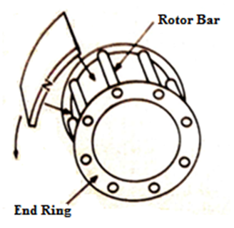
(a)  Rotating Field Sweeping a Rotor Bar | (b)  Direction of Flux Generated Around Rotor Bar | (c)  Direction of Rotor Bar Current
Figure 1: The Principle of Three Phase Squirrel Cage Induction Motor on Rotor Part [14]

The rotating flux or known as rotating field is produced by three phase current in stator winding coils that will be linked to the rotating field that produced by a magnet sweeping around the rotor as shown in Figure 1 (a). Figure 1 (a) shows the rotating field that cuts the rotor bars in term counter clockwise (CCW) sweep around the rotor bars. According to Lenz’s law that the voltage, current, and flux are generated by the relative motion between a conductor (rotor bars material), and magnetic field and have direction to oppose the relative motion. Hence, to verify the Lenz’s law so the conductors must develop a mechanical force and have same direction as indicated by the rotating flux (CCW). This is a reason why the flux bunching must occur on the right side of the conductor. It is because the generated flux due to rotor bar current must be clockwise (CW) as shown in Figure 1 (b). The direction of rotor bar current that produces by CW flux is determined by the right-hand rule as shown in Figure 1 (c) [14].
TEC Electric Motors (2013) in their Motor Catalogue 2013 mention that the motors are categorized through ruggedness and efficiency. They are manufactured using state of the equipment to exacting standards in order to certify performance and consistency. A broad diversity is accessible to suit agricultural and industrial applications such as compressors, power looms, sugar cane crushers, Agro industrial machinery, thrashers, textile machinery, rice mills, and Industrial machinery. Table 1 shows the technical data for 4 Pole 0.5 Hp three phase squirrel cage induction motor at 50 Hz. Figure 2 shows the manufacture of the a) stator and b) rotor lamination for stator teeth slot and rotor bars slot design for Induction Motor [15].

Table 1: The technical data for 4 Pole 0.5 Hp Three Phase Squirrel Cage Induction Motor at 50 Hz [15]
Model | Power (KW) | Speed (r/min) | Efficiency (%) | Power factor $\left(\cos{θ}\right)$ | Current (A)
 |  |  |  |  | 230 V | 400 V | 690 V
MSBCCL712-4 | 0.37 | 1370 | 76.5 | 0.74 | 1.92 | 1.11 | 0.64

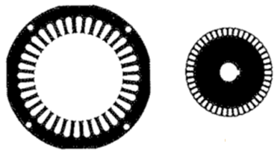
(a) (b)
Figure 2: The Manufacture of (a) the Stator and (b) Rotor Lamination [15]

VTU e-Learning Centre (2016) extended their analysis and revealed that a proper numbers of rotor bars slots are selected in relation to the number of stator slots or else undesirable effects will be found at the starting of the motor. The cogging and crawling are the two phenomena that observed due to unsuitable combination of number of rotor bars slots and stator slots. In addition, the induction motor might extend random hooks and cusps in torque speed description or the motor may run with lot of noise. Thus, this study aims to investigate the best implement and selection of number between stator slots and rotor bars slots to get the best rotor induction motor in terms of high efficiency with minimum the losses [16].
Several studies have attempted to describe about National Electrical Manufacturers Association (NEMA) design for classification and performance characteristics as shown in Table 2 below:

Table 2: NEMA Design for Classification and Performance Characteristics
Design | Bezesky & Kreitzer (2001) found that the [17]: | Charles I. Hubert (2002a) argue that the [18]: | Presently, Ali Emadi (2005) extended their analysis [19]:
A | have low slip and high efficiencies (not suitable for applications requiring bypass / across the line starting) | has higher breakdown torque with higher starting current). | has high torque, low slip with high locked amperes.
B | - was characterized by their high efficiencies and low slip.  - are used in variable torque, constant torque and horsepower applications | The design serves as the basis for comparison of motor performance with other design. | has normal torque and slip with normal locked amperes.
C | - was designed to assist the high starting torque requirements of across the line starting.  - was present higher losses and lower efficiency compared to design B | higher locked rotor torque, lower breakdown torque with higher starting torque. | has high torque, normal slip with normal locked amperes.
D | are used in high starting torque or high inertia loads | higher locked rotor torque and high slip. | has high locked rotor torque with high slip.
E | -Nil- | high efficiency, lower locked rotor torque, breakdown torque and pull up torque with high starting current. | -Nil-
This study and research aims are investigating the NEMA design three phase squirrel cage induction motor rotor for round bars type with high efficiency, lower losses, and save energy.
Investigation and analysis of Squirrel Cage Induction Motor by changing the bar type, material, design and size for the purpose of improve the efficiency increment of induction motor. The methods that used are theoretical calculation solved using MATLAB simulation. Simulation software that has been used in this research is MotorSolve (IM) and MATLAB software. The purpose of simulation and theoretical calculation are to compare the result between two methods in terms of efficiency increment of induction motor was presented.

- MOTORSOLVE (IM) SOFTWARE SIMULATION: ROTOR PART CHARACTERISTIC’S
Figure 3 shows the specifying of the rotor characteristic for 0.5 Hp 3-phase squirrel cage induction motor using MotorSolve (IM) software simulation. The bars, bridges, core and diameters are modified based on design and analysis. The characteristic changed in the rotor part as indicate in Figure 3 below.

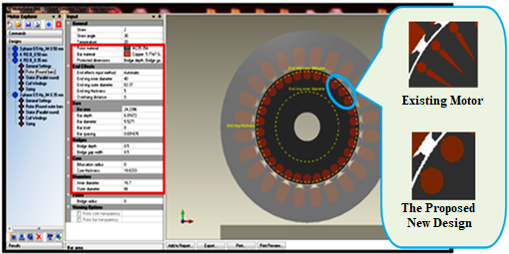
Figure 3: Specifying the Rotor Characteristic’s using MotorSolve (IM) Software

Other than that, the bar bridge angle, bar spacing, bridge depth, bridge gap width, bifurcation thickness, core thickness, inner diameter and outer diameter are also must be change accordingly as shown in Table 3. Table 3 shows the value of parameters in specifying the rotor characteristic for 0.5 Hp 3 phase squirrel cage induction motor.

Table 3: The Value of Parameters in Specifying the Rotor Characteristic for 0.5 Hp 3 Phase Squirrel Cage Induction Motor
Parameters | Values | Parameters | Values
Bar area | 14.768mm² | Bar spacing | 2.048mm
Bridges depth | 4.786mm | Bridge gap width | 0.5mm
Inner Diameter | 16.7mm | Outer diameter | 66.0mm
Rotor Material | M235 | Rotor Thickness Model 1 | 0.35 mm
Bar Material | Copper | Rotor Thickness Model 2 | 0.50 mm

- RESULTS AND DISCUSSION

3.1. The comparison results for both designs using the MotorSolve (IM) Software
The rotor bar design was analyzed using performance chart in terms of efficiency improvement for both designs using the MotorSolve (IM) Software. The graph of efficiency against speed for the both designs were shown in Figure 4.

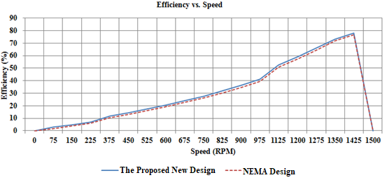
Figure 4: The Graph of Efficiency vs. speed for Both Design

Based on figure 4, it shows that the graph of efficiency against speed for both design which are Existing design and the proposed new design with different rotor bar dimension. Based on Figure 4, the graph shows the energy efficiency for the new design is higher up to 76.92 % as compared to the Existing design of 74%. The new design has an efficiency increment of 3.8 % compare to the Existing design. It is because the efficiency is inverse proportional to the losses. Reducing the total loss, the energy efficiency will be increase.

3.2. The comparison validate result between a set MotorSolve (IM) simulation and MATLAB for the new design.
Equation 1 shows the relationship between core loss and efficiency of induction motor. The value of efficiency will be affected from the increment or decrement the core loss based on equation 1. The proposed new design was analysed using a set simulation and MATLAB in terms of energy efficiency. The graph of efficiency against speed for both simulations was shown in Figure 5.

Figure 5: The Graph of Efficiency against speed for both simulation software

Based on Figure 5, when speed was reached at 1425 rpm the energy efficiency shows of 76.92% for MotorSolve (IM) result, it is verified with the MATLAB of 72.99%. From the result, it shows the new design has increase the energy efficiency and can produce between range 76 % to 77 %.

- ANALYSIS
The flux density check area for rotor frame is at rotor core ($B_{rcm}$). The value of flux density for the new design is exactly 0.97 T while the Existing design is exactly 1.22 T. For a good design, the value of rotor core flux density ($B_{rcm}$) should not exceed more than 1T. It is because if the flux density more than 1T, the flux will pass through the axial ventilation hole of rotor core shaft. Meanwhile, the reduction in the area for flux flow should be considered. It shows that the new design is a good design compared to Existing design.

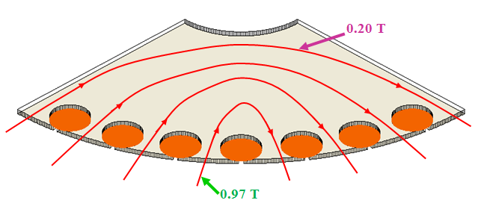 | 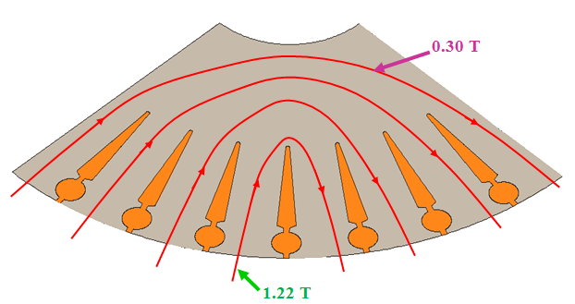
- Bars Type for The New Design | - Bars Type for Existing Design
Figure 6: The Flux Transfer for (a) New Design and (b) Existing Design Bars Type

Figure 6 shows the flux transfer for both design of rotor bars type. Based on Figure 6, the value of flux density near the shaft area (the inner diameter of rotor frame) is lower than flux density flow at the rotor bars area which are 0.2T of the inner side and 0.97T of the outer side for the new design. The flux density value of Existing design is 0.3T of the inner side and 1.22T of the outer side. It is because if the reluctance and length was increase, the value of magnetic flux and flux density will be decrease. The reluctance of magnetic circuit (or section of a magnetic) was related to its length, cross sectional area and permeability of material.
Figure 7 shows the rotor bars type used in designing the three-phase squirrel cage induction motor. Based on Figure 7, it shows that the maximum value of rotor core flux density using equation 3 as below:

For Rotor Core Material Flux Density, $B_{rcm}=\frac{C_{1}}{\left(C_{2}-2d_{r1}\right)C_{3}}$ (3)
Where; $C_{1}=Φ_{m}$ $C_{2}=D_{r}-D_{sh}$ $C_{3}=l_{b}.SF$

B_{rcm} should not to exceed 100 kilolines/in² (1 T). If axial ventilation holes pass through the rotor core. The reduction in the area (bar depth) for the flux flow should be considered. It shows that increasing the bar depth (d_{r1}) of rotor bar type will increase the rotor core material flux density of Three Phase Squirrel Cage Induction Motor.

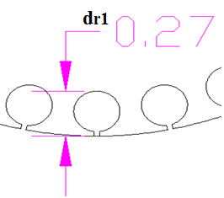 | 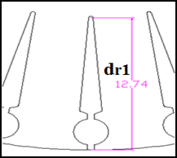
- New Design | - Existing Design

Figure 7: The Bar Type for Both Design (a) New Design (b) Existing Design

- NEW ROTOR BARS DESIGN: ENERGY & COST SAVING AND EMISSION REDUCTION
The total of money was saved depends on motor size, annual hour, increase the energy efficiency and the quota utility’s charges. A new design rotor was increased nearly 3.8%. It shows the new design rotor bar type was increased the energy efficiency and decreases the losses of the copper rotor.
The utility billing from Tenaga Nasional Ber-had (TNB) in Malaysia, the normal industrial tariff for factory is 38.0 sen/kWh and the lowest monthly charge is RM7.20 for the overall monthly consumption more than 200kWh/month.

Annual energy savings (AES) thru replacing a new rotor bar type design was showed and used equation 4 below.
$AES=hp×L×0.746×\left[\frac{100}{E_{STD}}-\frac{100}{E_{CR}}\right]$ (4)
$=0.5×1×0.746kW×\left[\frac{100}{74}-\frac{100}{76.92}\right]=19.1 W$
Where AES → the annual energy savings, hp → horsepower, L → load factor, hr → the yearly operating hours, E_{std} → the existing rotor efficiency (%) and E_{ee} → the new design rotor efficiency (%).

The annual bill savings (kWh_{savings)} was attained thru multiplying the operating hours number with specified load was used equation 5 as below.
${kWh}_{savings}=AES×hr$ (5)
$=8064h×0.0191=154 kWh$
Where ${kWh}_{ savings}$ ⇒ the expected annual bill savings (RM), AES ⇒ the annual energy savings and hr ⇒ $24×336$ working days.

Total cost savings (TCS) can be explained through equation 6 as below.
$TCS=\left(AES×12×Monthly Demand Charge\right)+\left({kWh}_{savings}×Energy Charge\right) (3)$ $TCS=\left(AES×12×Monthly Demand Charge\right)+ \left({kWh}_{savings}×Energy Charge\right)$ (6)
$TCS=\left(AES×12×Monthly Demand Charge\right)+\left({kWh}_{savings}×Energy Charge\right)$$TCS=\left(0.0191×12×RM7.20\right)+\left(154 kWh× \frac{RM0.380}{kWh}\right)$ $=RM 60.20$

According to the low voltage industrial tariff based on Tariff D, a monthly demand charge is RM7.20 and energy charge is RM0.380 / kWh.

The amount of emission that can be reduced associated with the above energy saving can be estimated using the Equation 7 as below:
$Emission Reduction, ER=AES×EF$ (7)
$=154 kWh×0.73159 {kgCO2}/{kWH}$ $=112.67 kgCO2$ $=0.113tCO2$
Where ER is the Emission Reduction (kg), AES is Annual Energy Saving (kWh) and EF is the Emission Factor (kg/kWh) ~ for Malaysia is 0.73159 kgCO2/kWh.

- CONCLUSION
This research was intended to prove in evaluation the amount of energy saving using high energy efficiency motors. The new design was used as an example in the evaluation. Additionally, the potential benefit and challenge in bringing the new design for industrial application was discussed. The study has proven that a substantial amount of energy can be saved if high efficiency motors are used for industrial motors. The proposed new design rotor bar was designed in this study has demonsrated 3.8 % higher efficiency than the Existing design, which will reduce the amount of motor losses. A set of simulation results for the proposed new design was verified using MATLAB. Its shows the theoretical calculation from MATLAB proves that the simulation result from MotorSolve (IM) was corrected since the error value is below than 6%. Aimed at energy and cost saving, a new design rotor was saved 154 kWh/year and RM60.20/year of utility bills for each motor. Lastly, a price estimation for 100,000 pieces of a new rotor bar type design was presumed and showed the value was saved nearly RM6.02 million.

ACKNOWLEDGEMENTS
The authors wish to thank the Director and members of Center for Research & Innovation (CoRI), Universiti Kuala Lumpur (UniKL), for the technical and financial support and also to Infolytica for the Motorsolve (IM) software.

REFERENCES
- Bednarczyk, I. J. R. (2012). Induction Motor Theory, 176.
- Al-Oraini, D. S. B. I. (2010). Chapter Four Three Phase Induction Machine 4.1.
- Ranganathan, G. (2009). REVIEW ON EFFICIENCY IMPROVEMENT IN SQUIRREL CAGE INDUCTION MOTOR BY USING DCR TECHNOLOGY, 60(4), 227–236.
- Yanawati, Y., & Maizana, D. (2014). Performance Comparison on 0.35 mm and 0.50 mm thicknesses of Non-oriented Steel Sheets Using FEM, The 4th International Malaysia-Ireland Joint Symposium on Engineering, Science, and Business 2014, IMiEJS2014, Penang Island, Malaysia, 25th - 26th June 2014.
- Daut, I., Anayet, K., Gomesh, N., Irwan, M., Asri, M., & Rashid, M. A. (2012). Development of 0 . 5 HP induction motor with reduced slots in rotor and stator core and its performance evaluation, 7(11), 2004–2011. http://doi.org/10.5897/IJPS11.1688.
- Yanawati, Y., Daut, I., Shafiqin, S. N., Pungut, I., Syatirah, M. N., Gomesh, N., … Haidar, N. (2012). Thicknesses of Non-oriented Steel Sheets for 0.5 Hp Induction Motor, 2(2), 1–5. http://doi.org/10.5923/j.ijme.20120202.01.
- MotorSolve (IM) Software. (2014). MotorSolveIM. 2014. Retrieved from http://www.infolytica.com/en/products/motorsolve/im/.
- Jimmie J. Cathey. (2001). Electric Machines, Analysis and Design Applying Matlab. McGraw-Hill Publishing Com. Lmt, pg 375-415.
- Saidur, R., Rahim, N. A., Hasanuzzaman, M. (2010) "A review on compressed air energy use and energy savings", Renewable and Sustainable Energy Reviews, 14(4), 1135-1153.
- Saidur, R., Masjuki, H.H., Jamaluddin, M.Y., Ahmed, S., (2007). Energy and associated greenhouse gas emissions from household appliances in Malaysia, Energy Policy, Volume 35, Issue 3, March 2007, Pages 1648-1657.
- Mahlia, T.M., (2002a). " Emissions from electricity generation in Malaysia", Renewable Energy, Volume 27, Issue 2, October 2002, Pages 293-300, https://doi.org/10.1016/S0960-1481(01)00177-X.
- Saidur. R., Abdelaziz. E.A., Hasanuzzaman. M,. Mamun. M.A.H., (2010). " A Study Of Energy Efficiency, Economic And Environmental Benefits Of A Cooling Tower", International Journal of Mechanical and Materials Engineering (IJMME), Vol. 5 (2010), No. 1, 87-94.
- Jianfeng Yu, Zhang Ting, & Jianming Qian. (2011). Electrical Motor Products. Woodhead Publishing Limited, ISBN: 978-0-85709-077-5 (print) ISBN: 978-0-85709-381-3 (online).
- Charles I. Hubert. (2002e). Principles of Three Phase Induction Machines. In Stephen Helba (Ed.), ELECTRIC MACHINES: Theory, Operation, Applications, Adjustment and Control (Second Edi, pp. 133 – 136). Prentice Hall.
- TEC Electric Motors. (2013). Motor Catalogue 2013, (1)
- VTU e-Learning Centre. (2016). Design of Rotor: Number of Slots. Retrieved January 23, 2016, from http://elearning.vtu.ac.in/16/ENotes/Elec Mac Des/Unit6VH.pdf
- Bezesky, D. M., & Kreitzer, S. (2001). NEMA Application Guide for AC Adjustable Speed Drive Systems. In IEEE/PCIC 2001 Conference (pp. 1–10).
- Charles I. Hubert. (2002a). Classification, Performance, Applications and Operation of Three Phase Induction Machines. In Stephen Helba (Ed.), ELECTRIC MACHINES: Theory, Operation, Applications, Adjustment and Control (Second Edi, pp. 167 – 177). Prentice Hall.
- Ali Emadi. (2005). Induction Motor Characteristics. In Energy Efficient Electric Motors (Third Edit, pp. 1 – 17). Marcel Dekker, Inc. Retrieved from http://www.dekker.com

BIOGRAPHIES OF AUTHORS

 | Ir. Dr. Mohd. Khairil is the Principal Researcher of Universiti Kuala Lumpur’s Renewable Energy Research Laboratory (RENERAL) He has obtained his PhD. and MSc. in Electrical Power Engineering from University of Strathclyde, UK and BEng degree from University of Southampton, UK. He also has obtained MBA (Marketing) from Universiti Putra Malaysia.  His research interest includes reliability study of electrical power systems, renewable energy and energy efficiency management. He has published many articles and research findings in journals and has presented in many international conferences.  Prior to joining the higher education industry, he has involved in various design, installation, testing and commissioning of electrical systems mainly in the integrated electrical back-up power supply systems. He has worked with engineers and technical personnel at various levels in the United Kingdom, Australia, New Zealand, the Philippines, Singapore and Malaysia. He is a Professional Engineer with the Board of Engineers Malaysia (BEM), and a Chartered Engineer (CEng) with the Institution of Engineering and Technology (IET), UK.
 | Yanawati Binti Yahya has been a Post-Doctoral Researcher at the Department of Electrical Engineering in University Kuala Lumpur (UniKL) British Malaysian Institute in Malaysia since January 2019. She received her Ph.D in Electrical Engineering System in University of Malaysia Perlis (UniMap) Malaysia. she received her MSc in Electrical Engineering System and B.Eng. (Hons) in Industrial Electronic Engineering from University Malaysia Perlis in Malaysia. She received her Diploma in Industrial Electronics Technology at University Technology Malaysia (UTM). Her research interest is in Electrical Machine Design, energy policy, energy security and modelling using FEM.

