**Wind Speed Data Modeling Based Measurement and Testing validity**

**Suwarno**

Department of Electrical Engineering, Faculty of Engineering,

Muhammadiyah University of North Sumatra, Jl. Denai No 217, Medan (20371), Indonesia

|  |  |  |
| --- | --- | --- |
| **Article Info** |  | **ABSTRACT** (10 PT) |
| ***Article history:***  Received Jan 17, 2019  Revised Jul 22, 2019  Accepted Aug 3, 2019 |  | This paper aims to model wind speed using data obtained from measuring PCE-FWS 20. This tool can record and store wind speed data that can be set with a duration of 10, 30, 60 minutes, and so on. In this study, wind speed data was taken with a duration of 30 minutes which was accumulated into daily, monthly, annual data and data collection for one year (2019). Based on the data from wind speed measurements obtained from the above tool, a mathematical modeling is carried out which is expected to represent the actual wind speed. To validate the results of the proposed modeling, a suitability test of the measurement data recorded with the modeling data was carried out using the correlation coefficient (R2), root means square error (RMSE), and mean absolute percentage error (MAPE). The development of mathematical modeling for wind speed simulation or modeling is expected to help obtain wind speed data for the benefit of planning a power plant in the future. |
| ***Keywords:***  Wind speed  Measurement data  Wind speed modeling  Test fit-of data |
| *This is an open access article under the* [*CC BY-SA*](https://creativecommons.org/licenses/by-sa/4.0/) *license.* |
| ***Corresponding Author:***  Suwarno,  Department of Electrical Engineering, Faculty of Engineering,  Muhammadiyah University of North Sumatra, Jl. Denai No 217, Medan (20371), Indonesia  Email: suwarno@umsu.ac.id | | |

1. **INTRODUCTION (10 PT)**

There have been many different approaches and problems in scientific studies of wind energy ([1], [2], [3]. According to several previous researchers [4], [5] Weibull and others have done many presentations of wind speed parameters, but in general, not many have done a mathematical modeling approach to wind speed. Wind characteristics are analyzed in depth to improve the performance of electricity production in certain locations [6], [7], but there is a weakness that has not been obtained for modeling wind speed, if one day the expected data not obtained and this can hamper the process of assessment of the wind energy potential.

One ARIMA (Autoregressive Integrated Moving Average) model has been used frequently in recent decades to model wind speed and wind power variation over large intervals, usually on the order of one hour [8]. In the energy market, in terms of investment strategies, modeling wind generation output is very important [9], including variations in energy demand [10], and monthly variations in wind power [11]. ARIMA models are used to describe fluctuations, on a shorter time scale of about 10 minutes [12], and this model has the advantage of the computational cost, as well as on simple repetitive procedure [13]. The artificial neural network model, uses a model of the learning process through a series of previous measurements and has also been applied to predict wind speed [14]. Several approaches have been used to forecast wind power by developing an algorithmic model to anticipate the level of uncertainty and variability of wind generation. Using an automatic regressive moving average model to estimate the next ten-minute production rate for a hypothetical wind power plant and investigating the possibility of pairing wind output with responsive demand to reduce variability in the grid, wind output [15]. Developed an Artificial Neural Network (ANN) model to predict wind power with a resolution of 10 minutes [16].

Modeling the development of several models that have been carried out by previous investigators, need to do more research on the development of modeling wind speed, and in the discussion paper here using a model approach taken by Rayleigh, to test the fit of the data from measurements or data recorded by the data modelling. The main objective of this proposed research is to find out how accurate the modeling is acceptable by mathematical analysis.

1. **RESEARCH METHOD**

Wind speed data retrieval were observed in this study were obtained from the measuring instrument PCE-FWS 20. The proposed modeling wind speed is approached with the measurement data recorded by the device, and then test to ensure the suitability of the proposed wind velocity model mathematically acceptable. Test suitability modeling needs to be done to determine the suitability of the data recorded with the data being modeled. The fit test uses the correlation coefficient (R2), root means square error (RMSE), and mean absolute percentage error (MAPE). This is done to determine whether the proposed modeling is statistically acceptable or not.

*2.1. Wind speed data recorder*

PCE-FWS 20 is a wireless weather station that is versatile, as it allows the accurate recording of wind direction, wind force, temperature, relative humidity, and rainfall. Weather data is sent up to 100 meters via a radio signal to the main station, equipped with the latest technology in weather analysis and powered by solar panels and batteries. With a USB interface and the included USB cable, the weather data can be sent directly from the wireless weather station to a PC or laptop. All these data are stamped with the time/date to be set even after a longer period of time and weather data can be stored indefinitely.

The analysis software provided makes it possible to observe and compare the weather over a longer period of time using charts. The PCE-FWS 20 Weather Station allows high accuracy detection of wind direction, wind speed, temperature, relative humidity, and rainfall. The PCE-FWS 20 station is shown in Figure 1.

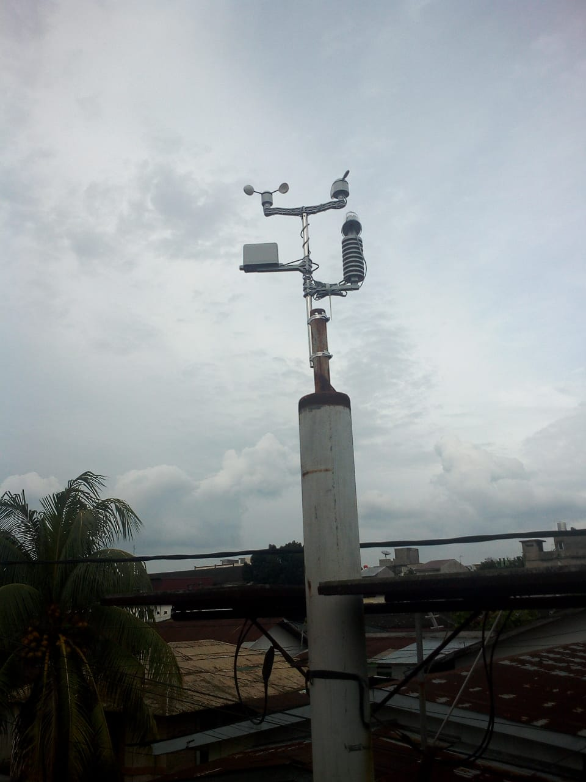 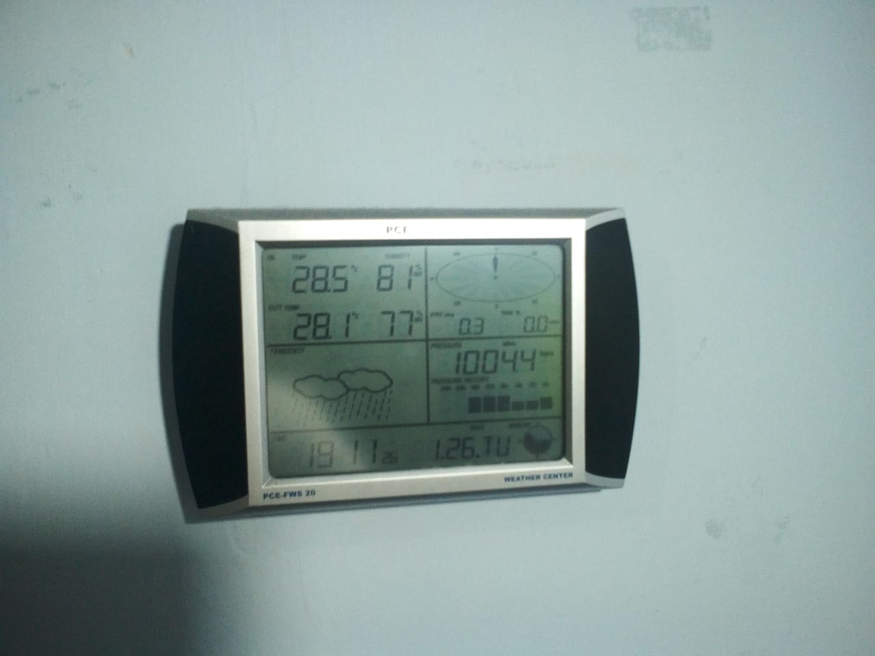

1. Wind speed detector b) Wind speed recording device

**Figure 1** device PCE-FWS 20

*2.2. Wind speed data*

Wind speed data recording with PCE-FWS 20, where the data is taken based on a 30-minute duration and processed into daily and monthly wind speed data, from January to December 2019.

*2.3. Wind speed modeling*

The Rayleigh distribution is often used in physics which deals with the modeling of processes such as sound and light radiation, wave height, and wind speed. In addition to a Weibull distribution, Rayleigh distribution is also a distribution as deemed appropriate to describe the distribution of wind speed. This distribution is used if the Weibull distribution area is considered less accurate to apply. By giving the value k = 2 to the Weibull distribution, the Rayleigh probability density function is expressed as follows:

 (1)

Parameters scale to the Rayleigh distribution (Cr) were obtained using maximum likelihood estimator as expressed by equation 1 as follows:

 (2)

where *Cr* is the Rayleigh scale parameter and *vi* is the wind speed at the ith time. The average of the Rayleigh distribution function is determined by equation (3).

 (3)

where 𝑣̅*𝑟* is the average of the Rayleigh distribution function.

Modeling wind speeds proposed in this study is based on a Rayleigh distribution and is expressed as follows;

 (4)

where *N* is the number of data;

*vi i*s the measured (recorded) wind speed data;

*vn* is a proposed wind speed modeling.

*2.4. Statistical test-fit-of the data*

The model selection has become an important focus in recent years in statistical learning, machine learning, and big data analytics [17], [18], [19]. Currently, there are several criteria in the model selection literature. Many researchers [20], [21] have studied the problem primarily variable regression election in three decades. The statistical significance of the model comparison can be determined based on the suitability criteria in the literature [22].

Table 2 presents a statistical test in the case of this study

|  |  |  |  |
| --- | --- | --- | --- |
| No. | Criteria | Formula | Explanation |
|  | R2 |  | Measures the amount of variation accounted for the fitted model |
|  | RMSE |  | The square root of the measures the deviation between the fitted values with the actual data observation |
|  | MAPE |  | MAPE is percentages, compares them between sets, and can easily understand and interpret percentages |

where *yi* is the *ith* data;  is the mean data to *ith*;  is the average data *n* is the number of model observations; *k* is the estimated number where *At* are actuals and *Ft* corresponding forecasts or predictions

**3. RESULTS AND DISCUSSION**

*3.1. Wind speed data recording*

Based on the results of data recording with PCE-FWS 20, after processing the recording data with a duration of 30 minutes into daily and monthly data, the results are shown in Figure 2.



**Figure 2** Wind speed measure

Figure 2 shows the wind speed fluctuates between 2.4 to 7.4 m/s. The minimum, maximum and average wind speeds are 2.37, 7.39, and 5.06 m/s, respectively.

*3.2. Wind speed data modeling*

Based on the equation (1), the obtained results of modeling wind speed is shown in Figure 3.



**Figure 3** Wind speed modeling

Figure 3 shows the wind speed fluctuates between 3.6 to 6.3 m/s. The minimum, maximum and average wind speeds are 3.62, 6.38, and 5.25 m/s, respectively.

*3.3. Comparison of wind speed modeling and measurement*

Comparison of the wind speed of the recorded data and modeling are shown in Figure 4.



**Figure 4** Comparison of measurement and forecast wind speed

Figure 4 shows a comparison between the measurement data and modeling based on a graph, where the blue color of the measurement data, while the green color for data modeling. The comparison of the two data shows a difference between the minimum, maximum and average values of 0.525, 0.136, and 0.037, respectively.

The comparison of wind speed data from measurement and modeling is shown in Figure 5.

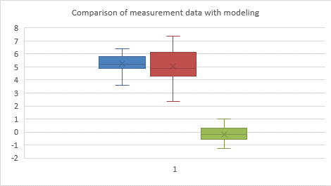

**Figure 5**  Comparison of measurement and forecast wind speed

Figure 5 shows a comparison of the two data blocks, in which the red color to the measurement data, blue for data modeling, while the green color is an error ratio of the two data.

*3.4. Statistical test results*

Based on the results of the suitability test of the measurement and approach wind speed data with the correlation coefficient (R2), root mean square error (RMSE), and mean absolute percentage error (MAPE) are shown in Table 3 as follows;

**Table 3** Statistic analysis for monthly of R2, RMSE, and MAPE

|  |  |  |  |
| --- | --- | --- | --- |
|  | R2 | RMSE | MAPE |
| January | 0.9968 | 0.1126 | -40.21 |
| February | 0.9960 | 0.1191 | -27.17 |
| March | 0.9956 | 0.1303 | -39.65 |
| April | 0.9988 | 0.1055 | -31.11 |
| May | 0.9971 | 0.1073 | -27.98 |
| June | 0.9976 | 0.0986 | -2.686 |
| July | 0.9985 | 0.0902 | -34.33 |
| August | 0.9994 | 0.0950 | -9.664 |
| September | 0.9979 | 0.0793 | -7.439 |
| October | 0.9989 | 0.0938 | -1.571 |
| November | 0.9969 | 0.0921 | -13.80 |
| December | 0.9987 | 0.0943 | 10.583 |
| Average | 0.9145 | 0.1015 | -18.7528 |

1. **CONCLUSION**

The proposed modeling wind speed has met the statistical test, according to the correlation coefficient (R2), RMSE and MAPE. It can be concluded from the analysis as follows;

1. The results of the data test with monthly statistics and the average show that modeling with the correlation coefficient approach is acceptable, because it has an R2 value of 0.9145 close to the value of one (1).
2. The results of the data test with statistics for monthly and average shows that modeling with the RMSE approach is acceptable, because it has a very small error value of around 0.1015.
3. The results of the data test with statistics for monthly and average shows that modeling with the MAPE approach is acceptable, because it has a very small error value of around -18.7528.
4. Wind speed modeling uses R2, RMSE, and MAPE which shows that the proposed model is acceptable based on the results of these statistical tests

**ACKNOWLEDGEMENTS (10 PT)**

The authors thank the chief editor and his staff, as well as to the Executive Board Muhammadiyah University of North Sumatra which has provided the opportunity to publish the results of thought and research, wich may be useful for everything.

**REFERENCES**

[1] N. . Cook, “Confidence limits for extreme wind speeds in mixed climates,” *J. Wind Eng. Ind. Aerodyn.*, vol. 92, pp. 41–61, 2004.

[2] A. G. Davenport, “The application of statistical to the wind loading of structure,” in *Proceeding of institution of civil engineering*, 1962, pp. 449–471.

[3] D. L. I. Deaves, “On the fitting of low mean wind speed data to the Weibull distribution,” *J. Wind Eng. Ind. Aerodyn.*, vol. 66, no. 3, pp. 169–178, 1997.

[4] W. Weibull, “A statistical distribution function of wide applicability,” *Jounzal Appl. Mech.*, vol. 18, pp. 293–297, 1951.

[5] W. Weibull, *The phenomenon of rupture in solids, Angeniors Vetenskaps Akademien Handlingar*. 1939.

[6] E. L. D. Mazzeo; G. Oliveti, “Estimation of wind speed probability density function using a mixture of two truncated normal distributions,” *Renew. energy*, vol. 115, pp. 1260–1280, 2018.

[7] V. Katinas; M. Marciuskaitis; G Gecevicius; A Markevicius;, “Statistical analysis of wind characteristics based on Weibull methods for estimation of power generation in Lituania,” *Renew. energy*, vol. 113, pp. 190–201, 2017.

[8] B. G. Brown, R. W. Katz, and A. H. Murphy, “Time series models to simulate and forecast wind speed and wind power,” *J. Clim. Appl. Meteorol.*, vol. 23, no. 8, pp. 1184–1195, 1984.

[9] Ghadikolaei H; Ahmadi A; Aghaei J; Najafi M;, “Risk contrained self-scheduling of hudro/wind units for short term electricity markets considering intermittency and uncertainty,” *Renew. Sustain. Energy Rev.*, vol. 16, pp. 4734–4743, 2012.

[10] Ediger V; Akar S;, “ARIMA forecasting of primary energy demand by fuel in Turkey,” *Energy Policy*, vol. 25, pp. 667–676, 2007.

[11] Chen P; Pedersen T; Bak-Jensen B; Chen Z;, “ARIMA-Based time series model of stochastic wind power generation,” *IEEE Trans. Power Syst.*, vol. 25, pp. 667–676, 2010.

[12] O. Kisi, S. Heddam, and Z. M. Yaseen, “The implementation of univariable scheme-based air temperature for solar radiation prediction: New development of dynamic evolving neural-fuzzy inference system model,” *Appl. Energy*, vol. 241, pp. 184–195, 2019.

[13] Lau A; Mcsharry P;, “Approaches for multi-step density forecasts with application to aggregated wind power,” *Ann. Appl. Stat.*, vol. 4, pp. 1311–1341, 2010.

[14] Kadhem A; Wahab N; Aris I; Jasni J; Abdalla A;, “Advanced wind speed prediction model based on a combination of Weibull distribution and an artificial neural network,” *Energies*, vol. 10, pp. 1744-, 2017.

[15] C Lindsay Anderson; Judith B Cardell, “Reducing the variability of wind power generation for participation in day Ahead electricity markets,” 2008.

[16] Kittipong M; Shitra Y; Wei Lee; James R;, “An integration of ANN wind power estimation into unit commitment considering the forecasting uncertainty,” *IEEE Trans. Ind. Appl.*, vol. 43, no. 6, 2007.

[17] Burnham KP; Anderson D R;, *Model selection and multimodel inference: A practical information theoretic approach, 2nd ed.; Springer: Berlin, Germany*. 2002.

[18] Burnham KP; Anderson D R; Huyvaert K;, “AIC model selection and multimodel inference in behavioral ecology: Some background, observations, and comparations,” *Behav. Ecol. Sociobiol.*, vol. 65, pp. 23–35, 2011.

[19] Guyon I; Elisseefff A;, “An intriduction to variable and feature selection,” *J. Mach.Learn. Res.*, vol. 3, pp. 1157–1182, 2003.

[20] Akaike H, “Information theory and an extension of the maximum likelihood principle,” in *In Proceedings of the second international symposium on information theory; Petrov. B.N., Caski. F., Eds.; Akademiai Kiado; Budapest, Hungary*, 1973, pp. 267–281.

[21] Wagenmakers E J; Farrell S;, “AIC model selection using Akaike weights,” *Psychon. Bull. Rev.*, vol. 11, pp. 192–196, 2004.

[22] Song K Y; Chang I H;, “A testing coverage model based on NHPP software reliability considering the software operating enviroment and the sensitivity analysis,” *Mathematics*, vol. 7, p. 450, 2019.

**BIOGRAPHIES OF AUTHORS**

|  |  |
| --- | --- |
| D:\FOTO\foto arno-min.jpg | Bachelor 1986, Medan Institute of Technology (ITM)  Postgraduate 1996, Bandung Institute of Technology (ITB)  Doctoral 2016, Universiti Malaysia Perlis (UniMAP)  The areas of research: renewable energy, power electronics and drive systems |