FUZZY LOGIC CONTROLLED HARMONIC SUPPRESSOR FOR POWER QUALITY IN CASCADED MULTILEVEL INVERTER

Y.Lalitha Kameswari*, Dr.O.Chandra Sekhar**
* Department of Electrical and Electronics Engineering, K.L.University

Article Info |  | ABSTRACT
Article history:  Received Jun 12th, 201x  Revised Aug 20th, 201x  Accepted Aug 26th, 201x |  | Maintenance of power quality to obtain enhanced efficiency of power electronic equipment seeks limitations on the total harmonic distortion (THD). For power quality control a Fuzzy Logic Control (FLC) giving comparatively better harmonic reduction than the conventional controllers. A high performance multilevel inverter should have a clean output voltage with low total harmonic distortion (THD) for both linear and non linear loads. Harmonic distortion is the most important power quality problem stirring in multilevel inverter, the harmonics can be eliminated by an optimal selection of switching angles. A hybrid evaluation technique evaluates the obtained optimal switching angles that are attained from the fuzzy inference system as well as neural network. The proposed technique is tested with a seven level cascaded H-bridge inverter. The proposed method will be implemented in MATLAB working platform and the harmonic elimination performance will be evaluated.
Keyword:
Power quality
Harmonics
Switching angles
THD
Multilevel inverter
Fuzzy logic
Copyright © 201x Institute of Advanced Engineering and Science.
All rights reserved.
Corresponding Author:
Y.Lalitha Kameswari
Departement of Electrical and Electronics Engineering,
K.L. University,
Guntur, A.P, India.
Email: saiproject14@gmail.com

- INTRODUCTION
Current harmonics were introduced by powerelectronic eqipments . Due to these current harmonics
problems such as a low power factor, low efficiency, power system voltage fluctuations and communications interference takes place. Irrespect of variations in the input source or load condition, maintaining a constant voltage and constant frequency supply for critical connected loads. Harmonics are undesirable voltages or currents that have frequencies which are integral multiples of the frequencies of the supply system [1]. Harmonics can be introduced by non linear loads which cause faulty operation of the connected equipments [2]. By the non linear loads current is drawn in a non sinusoidal manner that are connected to the sinusoidal supply voltage [3]. The two types of harmonic sources into which non linear loads can be categorized are harmonic current source and harmonic voltage source [4]. Total harmonic distortion(THD) can be diminished by the power conversion approach by getting the output voltage in steps and taking the output nearerly to sinusoidal wave [5]. Generation of an estimated sinusoid voltage from number of stages of dc voltages usually from capacitor voltage sources is the general concept of multilevel inverters [6].
In previous number of APF designs, PWM based techniques such as constant frequency control,hysteresis control, and triangular waveform control, sliding mode control are used to control the number of switches in the APF with the help of time domain approach. The main shortcome of this method is that, in order to obtain optimal results, relative high switching frequencies are needed, which consequently leads to high switching losses. Frequency domain methods includes encoded harmonic injection and PWM based techniques such as adaptive frequency control and optimized injection method and are proposed as substitute to time domain approach. The switching frequencies for time domain schemes can be much higher than frequency domain methods, resulting in more lower switching losses. The main disadvantage of frequency domain method is longer computational time than normal time domain methods. Nowadays high speed processors were available to reduce computational time. Whether it may be frequency domain approach or time domain approach , the conventional APFs are too composite and costly in practical, when the quantity to be controlled varies over a long range. Hence an increased alternative is to use artificial intelligent (AI) techniques such as embedded system, fuzzy logic, neural network etc.
The proposed hybrid technique reduces the harmonics in the powersystem by combining the techniques of fuzzy logic and the neural network. This technique can eliminate the harmonics selectively by optimal selection and choosing the switching angles of the multilevel inverter. By selecting optimal selection of switching angles, generation of harmonics can be avoided in cascaded H-bridge multilevel inverter.

- MULTILEVEL CONVERTERS
Multilevel inverters are considerably different from the normal inverter where only two levels are obtained. The semiconductor devices are not linked in series to one solitary high-voltage switch. In which each assembly of devices put in to astep in the output voltage waveform. The steps are augmented to obtain an almost sinusoid waveform. The number of involved switches is increased for increment of every level. Multilevel converters are several types . The main three types of multilevel converters are: diode-clamped multilevel converters, capacitor-clamped multilevel converters, and cascaded H-bridges multilevel converters.
Let us discuss the difference between “multilevel inverter” and “multilevel converter”. The term “multilevel converter” suggest to the converter itself. The main purpose of a multilevel inverter is to produce a preferred ac output voltage waveform from several levels of dc input voltages. These dc voltages may be equal or may not be equal to each another. The ac output voltages obtained from these dc input voltages approach a sinusoid. The conventional two or three levels inverter does not completely eliminate the undesirable harmonics in the output voltage waveform. Therefore, using the multilevel inverter as an substitute to conventional PWM inverters is examined.
In this topology the number of output voltage levels at the converter terminals is 2N+1, where N is the number of dc link voltage sources. In this topology, each cell has split dc link capacitors and the voltage across the capacitors capacity differ among the each cell. So, each power circuit just need one dc input voltage source. The dc link capacitor number is proportional to the phase voltage levels number .Each H-bridge cell may contain zero,positive or negative voltages. Final ac output voltage is the sum of all H-bridge voltages and is balanced with respect to neutral point, so the number of output voltage levels is odd.
Cascaded H-bridge multilevel inverters characteristically use IGBT switches. These switches have high switching frequencies and low blocking voltages.

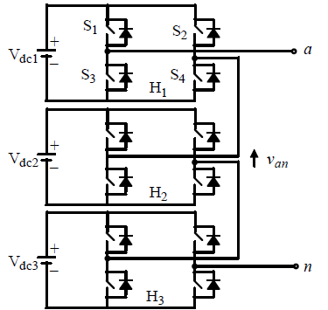
Fig.1. Cascaded H-bridge 7-level Inverter
Consider the seven level multilevel inverter; it requires total of 12 IGBT switches and three dc input voltage sources(by the formula mentioned above i.e 2N+1). This seven level multilevel inverter is shown in the Fig.1. The cascaded H-bridge multilevel inverter is basically a series connection of multiple H-bridge inverters. Each H-bridge inverter has the same arrangement as a typical single-phase full-bridge inverter.
The output of the inverter is a sporadically alternating staircase output waveform, not a sinusoidal waveform as predictable. The inverter output waveform enclose harmonics. Mathematically, the output waveform is a outline of an infinite chain of harmonics. The magnitude of the harmonics must always be restricted below threshold levels.

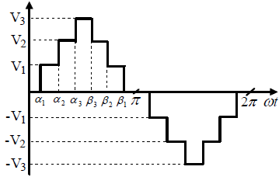
Fig 2. Output waveform

The cascaded H-bridges multilevel inverter uses Separate DC Sources (SDCSs) to produce an AC output voltage waveform. Each single H-bridge inverter is linked to its own DC source Vdc. By cascading the AC output voltages of each single H-bridge inverter, an AC output voltage waveform is produced. By closing the suitable switches, each H-bridge inverter can produce three different types of voltages: +Vdc, 0 and -Vdc. Cascade multilevel inverter[CMLI] is one of the most important topology.It requires low number of components with compare to diode-clamped and flying capacitors type multilevel inverters.This circuit is simulated using the MATLAB software. The output waveform shown in Fig.2

- CONSIDERATION OF SWITCHING ANGLES

The proposed technique execute evaluation to determine the most favorable switching angles, which can reduce the creation of harmonics in the multilevel inverter. The complete technique considers the constraint of eliminating the harmonics origination by selectively justifying any of the harmonics. In other words, the technique can justify(mitigate) the selected harmonics and so the entire harmonics origination . Accordingly, the technique determines the voltage pattern that has low Hth order voltage harmonics. For instance, if the 5th order and 7th order harmonics are to be strictly justified in eliminating the harmonics origination, the harmonic voltages 5V and 7 V should be too small. From the data set the switching angle model corresponding to the selected harmonic voltage model is determined. To perform the selective justification, the selection factors have to be given as input. Then, iterative approach is instigate with the initiation of switching angles in their intervals. In the approach, a collection of subjective vectors are generated as follows

$Z_{a}=\left[α_{0 }^{\left(a\right)}α_{1}^{\left(a\right)}………α_{N_{l-1}}^{\left(a\right)} \right]; 0≤ a ≤ P_{size}$ (1)
where, Z_{a} is the a^{th} vector present in the collection and $α_{j}^{(a)}$is the jth switching angle of $a^{th}$vector. Every vector in the collection needs to satisfy the constraint,
$α_{0}^{(a)}< α_{1}^{(a)}<…<α_{l-1}^{(a)}$ (2)
The obtained vector is calculated by giving input vector to the neural network and trained FIS. From the attained output vectors, the evaluation factor is resolved as follows

${ E}_{f}^{(a)}= 0.3\left[β_{1}{THD}_{a}^{net} + β_{2}{THD}_{a}^{FIS} + {\left({THD}_{a}^{net} - {THD}_{a}^{FIS}\right)}^{2}\right]$ (3)

where, $E_{f}^{(a)}$is the evaluation factor for each and every arbitrary vector, ${THD}_{a}^{net}$and ${THD}_{a}^{FIS}$are the total harmonic distortion, when the a^{th} vector is the switching angle pattern estimated by the neural network and FIS, respectively and b1 and b2 are constants. The THD can be determined as following

${THD}_{a}^{net} = \frac{1}{\left|V_{{out}_{1}}^{(a)}\right|}\sqrt{\sum_{H=3,5..}^{N_{H}}{σ_{H}{\left|V_{H}^{(a)}\right|}^{2}}}$ (4)

where, $V_{{out}_{1}}^{(a)}$ and $V_{H}^{(a)}$are the fundamental voltages expected by the neural network for the a^{th} and h^{th} order harmonics voltages respectively and $σ_{H}$ is the selection factor for h^{th} order harmonic. From the collection, ${P_{size}}/2$ vectors that have least evaluation factor are preferred and subjected to vector substitute. In the vector substitute operation, the vector that has the least evaluation factor is obtained. Based on the vector, the substitute of elements of the remaining vector are executed as follows
$α_{j}^{new} = \left\{\begin{aligned}\frac{α_{j}^{2}+1 }{α_{j}} ; α_{j}< α_{j}^{least} \\ α_{j} ; α_{j}= α_{j}^{least} \\ \frac{α_{j}^{2}-1 }{α_{j}} ; α_{j}> α_{j}^{least}\end{aligned}\right\}$ (5)

where,$α_{j}^{new}$ is the j^{th} new switching angle and $α_{j}^{least}$is the j^{th} switching angle, which is attained from the vector that has the least performed factor. Thus obtained new vectors are subjected to satisfy the constraint in above given equation. Once the vector elements substitution is done, ${P_{size}}/2$ vectors are gained. They are placed in the collection along with the selected ${P_{size}}/2$ vectors so as to make the collection(pool) size to be P size . The entire process is is repeated until reaches I_{max by} the number of iterations . Once the maximum number of iterations is reached, the process is completed and the vector which has the less evaluation factor is obtained from the collection(pool). The resultant vector has the best(optimal) switching angles that can prevent the formation of harmonics for the given multilevel inverter, by selectively justifying (mitigating) the given elements of harmonics.
Fuzzy logic controller is considered for the best selection of switching angles for harmonic justification in multilevel inverter. The following steps were implicated in the design procedure.
- The input variables and the output variables are the switching angles and the harmonic voltage.
- The universe of discourse is portioned for the input and output variables.
- For the input and output variables Triangular membership functions is taken and are designed.
- The Linguistic control rules were stored in the Rule base required by rule evaluator. In the projected work three inputs were used.
- For the input and output variables no normalization is done.
- The inputs are applied.
- Fuzzy estimated reasoning is applied to the inputs.
- For defuzzification centroid method is used .

- SIMULATION RESULTS AND DISCUSSION

The implementation of the proposed technique is executed in the raised area of MATLAB (version 7.10) and we have employed the provided fuzzy and neural network toolboxes. In the assesement(estimate) phase, we have considered that the multilevel H-bridge inverter, which is responsible for producing the harmonics exaggerated(affected) voltage waveforms. The multilevel inverter has 3 H-bridges(i.e for 7 level) and so three switching angles $α_{0},α_{1} and α_{2}$ are need to be selected optimally. The technique is implemented in such a way that it can eliminate the 3rd order and 5th order harmonics and so it can reduce the total harmonic distortion. During the generation of fuzzy rules, N_{l} = 5 is considered and consequently the rules are generated for the corresponding N_{l} = 5 classes. Once the fuzzy rules have been created , the network training process has also been executed.The iterative approach is tested in the hybrid evaluation of switching angles for different number of iterations. The matlab simulation circuit shown in Fig.3. and Fig.4. shows switching angles of H1, Fig.5. shows switching angles of H2 and Fig.6. shows switching angles of H3. The output voltage obtained for those achieved optimal switching angles are given in Fig. 7.

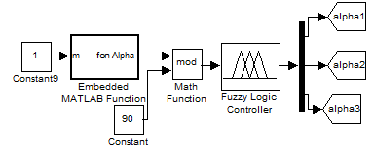

Fig.3. Matlab simulation Circuit

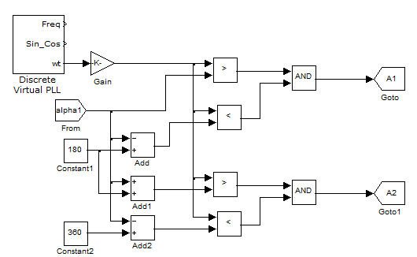

Fig.4. Switching angles for H₁

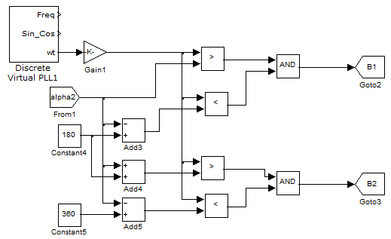

Fig.5. Switching angles for H₂

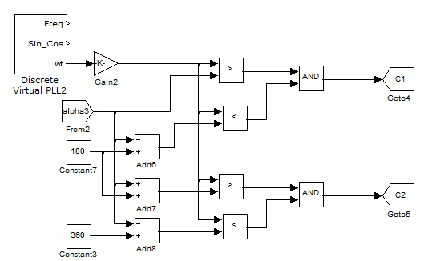

Fig.6. Switching angles for H₃

The performance of Fuzzy logic controller is well recognized for enhancement. The fuzzy logic controller is very useful due to exact mathematical model for it is not necessary . Mainly it can be divided into four major functional blocks namely Knowledge base, Fuzzification, Inference mechanism and Defuzzification. The knowledge base is consists of data-base and rule-base. The data-base, consist of input and output membership functions, which provides information for suitable fuzzification operations, the inference mechanism and defuzzification. The rule-base consists of a set of linguistic rules linking the fuzzy input variables to the preferred control actions.

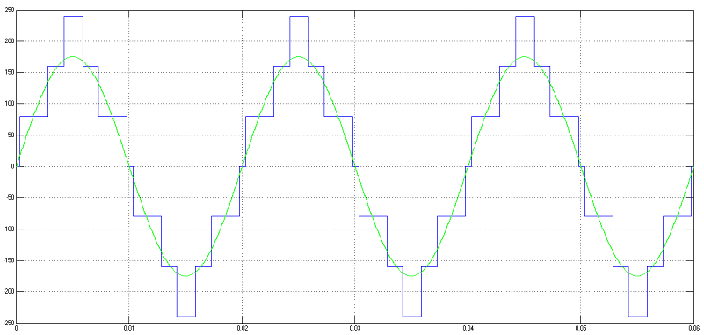
(a)Final output waveform from the inverter

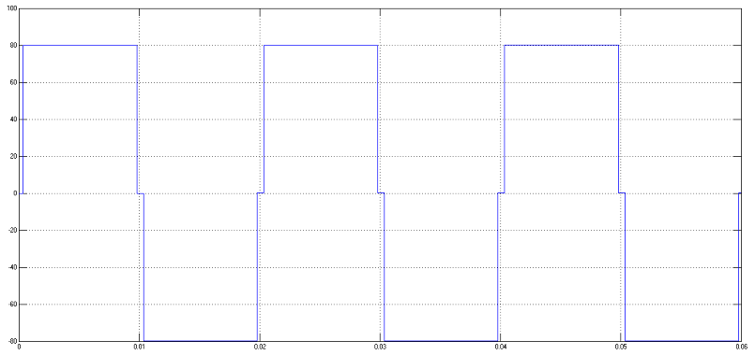
(b)Output waveform switching angles of inverter bridge1

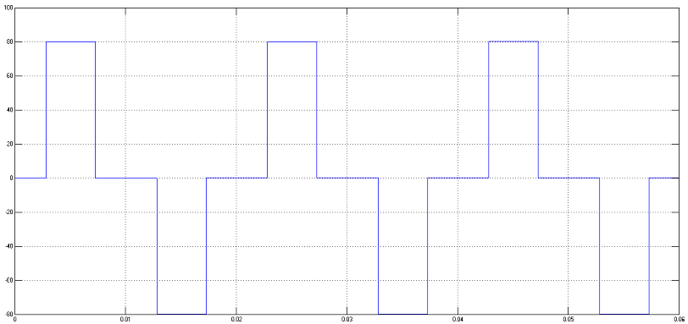
(c)Output waveform switching angles of inverter bridge2
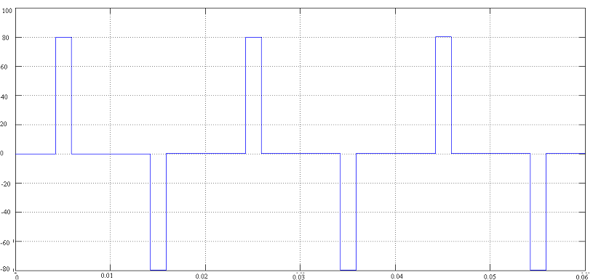
(d)Output waveform switching angles of inverter bridge3

Fig.7.Output voltage obtained for optimal switching angles

From the obtained, we can visualize the effectiveness of the proposed technique. The final output obtained from multilevel inverter shows the harmonics less waveform. The generated waveform shows the harmless way to the nonlinear utilities. Fig.8 and Fig.9 shows the FET analysis for without and with fuzzy controller .Table 1 shows the performance comparison of controller.

Fig 8. FET analysis for without Fuzzy controller

Fig.9. FET analysis for with Fuzzy controller

Table 1 gives the comparison between for Total harmonic distortion percentage before control and after control,. Hence it is clear that the projected Fuzzy Logic Controller used in this paper gives better result with the THD minimal value.

TABLE I

Performance Comparison of Controller

Method | System Condition | THD ( % )
Fuzzy Logic | Before Compensation | 25.61
Fuzzy Logic | After Compensation | 15.50

- CONCLUSION

In this paper, a hybrid technique has been projected to eliminate the harmonics that are originated from the cascaded H-bridge multilevel inverters. The technique was implemented to estimate its performance in the elimination or eradication of harmonics in a 7-level (i.e 3 H-bridge inverter). The presentation was estimated in different iteration levels of the hybrid estimation(evaluation) technique. From the results, it has been shown that the proposed technique can reach a outstanding level in harmonics elimination by justifying the dominant odd harmonics. The results analysis has shown that the recommended optimal switching angles can pass up the generation of harmonics and so the originated voltage waveform can maintain its free shape harmonics. By using the obtained switching angles, the harmonics can be avoided.

REFERENCES

[1]. Bensraj, R., Natarajan, S. P.and Padmathilagam, V. “Multicarrier Trapezoidal PWM Strategies Based On Control Freedom Degree for MSMI”, ARPN Journal of Engineering and Applied Sciences, Vol. 5, No. 5, pp. 400-411, May 2010.
[2]. AsgharAbedini, SalaheddinZabalawi and Adel Nasiri, “A three-phase uninterruptible power supply with an adaptive reference waveform generator”, Int. J. Power Electronics, Vol.1, No.1,pp.63-86, 2008.
[3]. Avik Bhattacharya and ChandanChakraborty, “A Shunt Active Power Filter With Enhanced Performance Using ANN-Based Predictive and Adaptive Controllers”, IEEE Transactions on Industrial Electronics, Vol. 58, No. 2,pp.421-428, February 2011.
[4]. Antony Albert, A.V., Rajasekaran, V. and Selvaperumal, S. “Harmonic Elimination of H-Bridge Seven Level Inverter”, European Journal of Scientific Research ,Vol.65,No.4, pp. 594-600,2011.
[5]. S. Jeevananthan,“Evolutionary Computing Based Area Integration PWM Technique for Multilevel Inverters”, Journal of E;lectrical Systems, vol.3, no.2, pp. 61-72, 2007..
[6]. G. Murugesan, M. Jagabar Sathik, M. Praveen, “A New Multilevel Inverter Topology Using Less Number of Switches”, International Journal of Engineering Science and Technology, vol, 3, no. 2, pp. 1500-1510, Feb 2011..

BIBLIOGRAPHY OF AUTHORS

 | Y.Lalitha Kameswari was born in Vijayawada India . She received the B.Tech (Electrical and Electronics Engineering) degree in Vijaya Institute of Technology for Women, Vijayawada, India. Now she is doing M.Tech (Power Electronics and Drives) in K.L. University, Guntur, India. Her areas of interest are Power Electronics and Power Quality. In her carrier two International journal was published.
 | Dr. O. Chandra Sekhar is currently the Professor and Head of EEE Department in K.L.University, Guntur,Ap, India. He had worked in different capacities in technical institutions of higher learning for a period of over ten years. He obtained B.Tech. and M.Tech. degrees from JNT University, Hyderabad. He obtained Ph.D. in the year 2014 from JNT University, Hyderabad in the area of Modulation and Control of Multi – Level Inverter – Fed Direct Torque Control of Induction Motor Drives. He has over 25 publications in International and National Journals/Conferences. He received prestigious young scientist award from SERB/DST. His current research interests are in Multi – Level Inverters, FACTS Controllers, Micro Grids and Smart Grids.

