**Speed Control of 3-Phase Induction Motors under Fault Conditions Supplied by Wind Turbine Using Indirect Vector Control**

**Mohammad Jannati*, Solieman Eskandari**, Tole Sutikno\*\*\***

* UTM-PROTON Future Drive Laboratory, Faculty of Electrical Engineering, Universiti Teknologi Malaysia, Johor Bahru, MALAYSIA

** Islamic Azad University, Karaj Branch, Iran

*** Department of Electrical Engineering, Universitas Ahmad Dahlan, Yogyakarta, Indonesia

|  |  |  |
| --- | --- | --- |
| **Article Info** |  | **ABSTRACT** |
| ***Article history:***  Received Jun 12th, 201x  Revised Aug 20th, 201x  Accepted Aug 26th, 201x |  | This article studies speed control of 3-phase Induction Motors (IMs) under fault conditions supplied by wind turbine using Indirect Vector Control (IVC). The wind turbine plays as a prime mover to a connected DC generator. Pulse Width Modulation (PWM) is used to obtain 3-phase AC voltage from the DC generator output. The proposed modified controller is able to control a star-connected 3-phase IM under normal, stator winding open-circuit fault and speed-sensor fault conditions. Simulation results are presented and shown the performance, validity and possibility of the proposed technique. The results demonstrate that, the proposed scheme provides good dynamic performance especially in reduction of IM speed and torque pulsations. |
| ***Keyword:***  3-phase induction motor  Indirect vector control  Fault conditions  Speed and torque pulsations  Wind turbine |
| *Copyright © 201x Institute of Advanced Engineering and Science.  All rights reserved.* |
| ***Corresponding Author:***  Mohammad Jannati,  Faculty of Electrical Engineering,  Universiti Teknologi Malaysia,  UTM Skudai, 81310 Johor, Malaysia.  Email: jannatim94@yahoo.com | | |

1. **INTRODUCTION**

The AC drives, are used in a wide range of industrial applications as they are more reliable than the DC drives. Indirect Vector Control (IVC) method is one of the useful methods for implementing high performance vector control of Induction Motor (IM) drive systems [1]-[5]. IVC is widely used for electrical drives since it provides very accurate and quick responses. However, this technique does not have good dynamic performance under fault conditions such as open-phase/short-circuit fault in stator/rotor windings (for wound rotor type) and/or mechanical/electrical fault in sensors [6]-[17].

In the recent years, the reliability of the electric machine drives, particularly in some critical applications has become a very interesting research topic. In the literature, many researches have been presented on the fault-tolerant control strategies of electric machine drives [6]-[17]. In [6]-[9], some methods to control a 3-phase IM under speed-sensor fault, in [10]-[14], different methods to control a 3-phase motor under open-circuit fault and in [15]-[17], some techniques to control an IM under inverter faults have been proposed.

In this article, we propose speed control of a star-connected 3-phase IM under open-phase fault and speed sensor fault supplied by wind turbine using IVC method (It can be pointed out none of the presented methods in [6]-[17] proposes an analysis in the case of two types of faults for a 3-phase IM). The proposed method can be employed in applications where require fault-tolerant control. Simulation tests are presented to show the good performance of the proposed strategy. This paper is organized as follows: after introduction in section 1, in section 2, the system under study is presented. In section 3, the vector control of a 3-phase IM under normal and open-circuit fault conditions is presented. The proposed method to estimate motor speed is shown in section 4. To check the performance of the proposed methodology, simulation results are presented in section 5. Conclusions are listed in section 6.

1. **SYSTEM UNDER STUDY**

The system under study consists of wind turbine which plays as a prime mover to a connected DC generator. PWM is used to obtain 3-phase AC voltage from the DC generator output. The 3-phase AC voltage of PWM is supplied to the IM. The proposed controller based on IVC is used to speed control of IM. The block diagram of the system is shown in Figure 1.

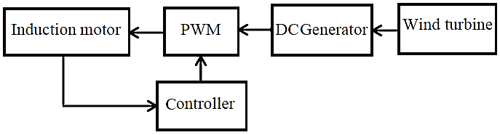

Figure 1. Block diagram of the system

*A: Wind Turbine Model:*

The wind turbine is characterized by no dimensional curves of the power coefficient as a function of both the tip speed ratio and the blade pitch angle [19], [20].

 (1)

where [19],

 (2)

 (3)

Moreover, *β* is the blade pitch angle, *λ* is the tip speed ratio, *R* is the wind turbine rotor radius, *Vω* is the wind speed, *CP* is the wind power coefficient and *ωt* is the mechanical angular rotor speed of the wind turbine. The equation between *λ* and *β* can be expressed as [19], [20]:

 (4)

The maximum value of *C­P* characteristics is achieved for *β=*0 and *λ*=8.1. This particular value of *λ* is defined as the nominal value. The power output equation of wind turbine can be expressed as:

 (5)

where, *Pt* is the wind power, *ρ* is the air density, *V* is the wind speed and *RA* is the area of turbine blades.

*B: DC Generator Model*

The DC generator can be written in terms of following equations [19]:

 (6)

 (7)

 (8)

where, *ia*, *Va* are the armature generator current and terminal voltage. *if*, *Vf* are the field generator current and voltage. *Ra*, *La* are the armature resistance and inductance. *Rf*, *Lf* are the field resistance and inductance. *Maf* is the mutual inductance between stator and rotor. *ω* is speed. *Rt=Ra+RL*. *Lt=La+LL. RL*, *LL* are the load resistance and inductance.

*C: 3-Phase IM Model*

For the purposes of the present study, the 3-phase IM is described by the following equations (in these equations superscript “*s*” indicates the use of a stationary reference frame):

*Stator voltage equations:*

 (9)

*Rotor voltage equations:*

 (10)

*Torque equations:*

 (11)

 (12)

where, *vsds*, *vsqs*, *vsdr*, *vsqr*, *isds*, *isqs*, *isdr*, *isqr* are the stator voltages, the rotor voltages, the stator currents andthe rotor currents. *rs*, *rr*, *Lds*, *Lqs*, *Lr*, *Md*, *Mq* are the stator and rotor resistances,the stator and rotor self and mutual inductances. *ωr* is the motor electrical speed. *Te*, *Tl*, *J* and *B* are the electromagnetic torque, the load torque, the moment of inertia and the viscous friction coefficient respectively. Notice that (9)-(12) indicates normal 3-phase IM if [18],

 (13)

and faulty 3-phase IM (3-phase IM under stator winding open-circuit fault) if [13],

 (14)

1. **IVC OF A 3-PHASE IM**

Among the various control techniques, IVC technique is more convenient. Due to the unsymmetrical structure of a 3-phase IM under open-circuit fault, the regular VC technique cannot be used for faulted IM. If regular VC technique is used to control faulted IM significant oscillations in the motor torque are produced [10]-[13]. It was recommended in [10], using suitable transformation matrices it is possible to remove the unsymmetrical structure of a 3-phase IM under open-circuit fault. These transformation matrices for the stator voltage and current variables are as (15) and (16):

 ${[V}_{abcr}]={[R}_{r}] [i_{abcr}]+ \frac{d}{dt}[λ_{abcr}]$ (15)

 (16)

where, *θe* is the angle between the stationary reference frame and the rotating reference frame (in this paper, the superscript “*e*” indicates the variables are in a rotating reference frame). Using (15) and (16), the new mathematical model of the 3-phase IM can be written as [10]:

*Stator voltage equations:*

 (17)

*Rotor voltage equations:*

 (18)

*Torque equation:*

 (19)

where,

 (20)

In (17), *ωe* is the angular velocity of the rotor field-oriented reference frame. Since in the rotor field-oriented control method *λdre*=|*λr*| and *λqre*=0, from (17)-(19) we can write:

 (21)

 (22)

 (23)

 (24)

 (25)

where,

|  |  |
| --- | --- |
|  | (26) |

In (26), *Tr*=*Lr*/*rr*. From the equations (21)-(26), it is possible to adopt the IVC scheme for a 3-phase IM under open-circuit fault condition. The block diagram of the IVC for a 3-phase IM under open-circuit fault condition is shown in Figure 2. In Figure 2 [10]:

 (27)

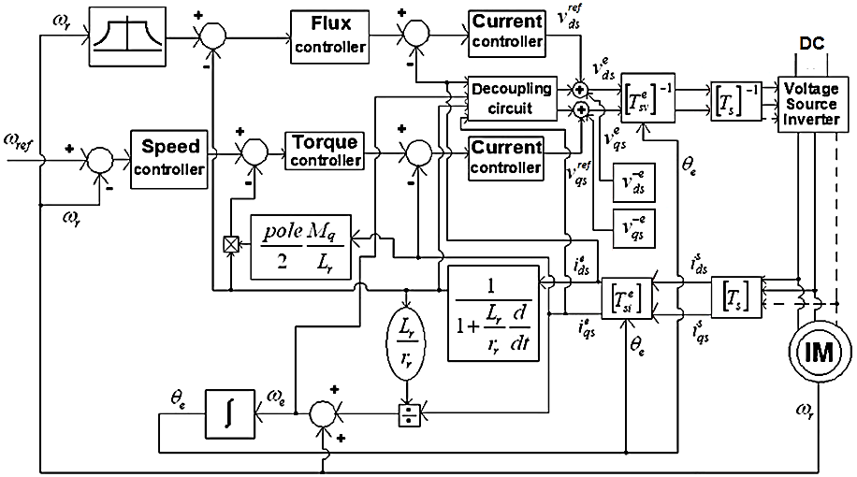

Figure 2. Block diagram of the IVC for a 3-phase IM under open-circuit fault condition

Notice that by only changing in motor parameter as given in (13) and changing in the transformation matrix as given in (28) the proposed scheme can be used for VC of the 3-phase IM under normal condition. In this condition, Figure 2 can be simplified as Figure 3 which is the same as regular controller.

 (28)

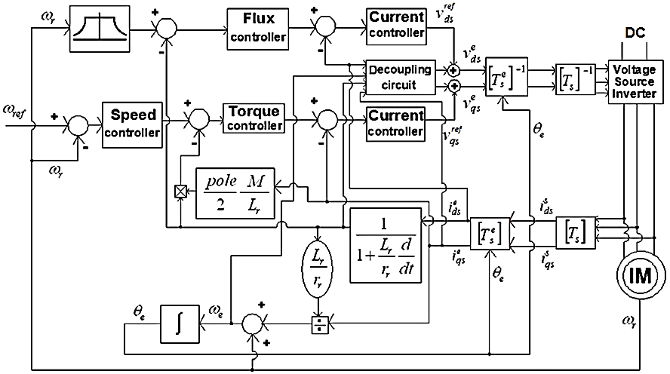

Figure 3. Block diagram of the regular IVC for a 3-phase IM

In Figure 3:

 (29)

1. **SPEED ESTIMATION OF A 3-PHASE IM**

In order to compensate speed-sensor fault, this paper investigates a method that uses an estimator for estimation of the rotor speed. In this paper, a technique based on measurable stator variables (currents and voltages) is proposed to estimate the angular velocity of the rotor field-oriented reference frame (*ωe*). Then, using (23), the motor speed is estimated.

The d-axis voltage is given by:

 (30)

From these equations, an estimate of the motor speed, can be calculated by:

 (31)

Notice that (31) can be used for estimation of motor speed in the normal and open-circuit fault conditions by only changing in motor parameter as given in (13) and (14).

1. **SIMULATION RESULTS AND DISCUSSION**

The regular (based on Figure 3) and proposed (based on Figure 2 and equations (30), (31)) controllers for a star-connected 3-phase IM is developed and simulated using Matlab software. The parameters of the simulated motor are as follows:

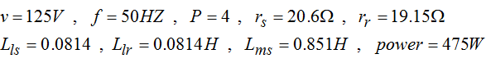

Simulation results of the conventional and proposed controllers such as stator a-axis current, torque and motor speed are shown in Figures 4-6. Figure 4 shows simulation results of the conventional technique (based on Figure 3) for VC of a 3-phase IM under open-circuit fault (Figure 4(a): stator a-axis current, Figure 4(b): torque and Figure 4(c): speed). Figure 5 shows simulation results of the proposed controller without speed estimator (based on Figure 2) for VC of a 3-phase IM under open-circuit fault (Figure 5(a): stator a-axis current, Figure 5(b): torque and Figure 5(c): speed). Figure 6 shows simulation results of the proposed controller with speed estimator (based on Figure 2 and equations (30), (31)) for VC of a 3-phase IM under open-circuit fault and speed sensor fault (Figure 6(a): stator a-axis current, Figure 6(b): torque and Figure 6(c): speed). To analyze dynamic and steady-state performance of all cases the motor is started on no-load with speed of 450rpm. At t=2s an open-phase fault is happened in phase “c”. The simulation carried over a sampling time of 0.0001s.

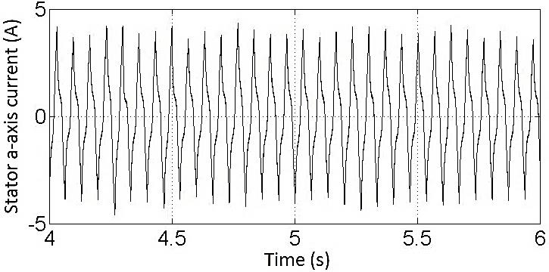

(a)

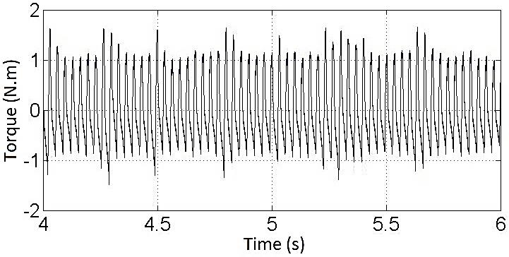

(b)

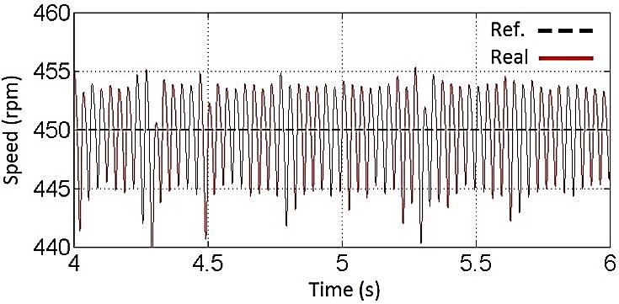

(c)

Figure 4. Simulation results of the conventional technique for VC of a 3-phase IM under open-circuit fault; (a) Stator a-axis current, (b) Torque and (c) Speed

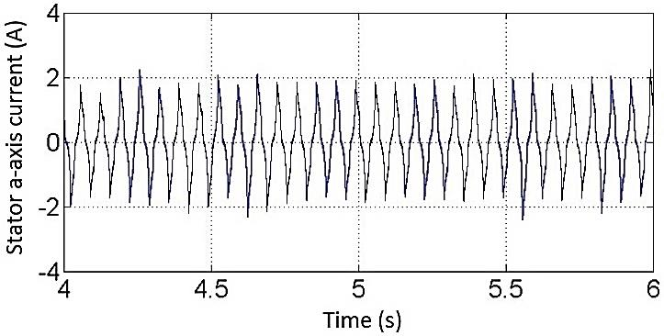

(a)

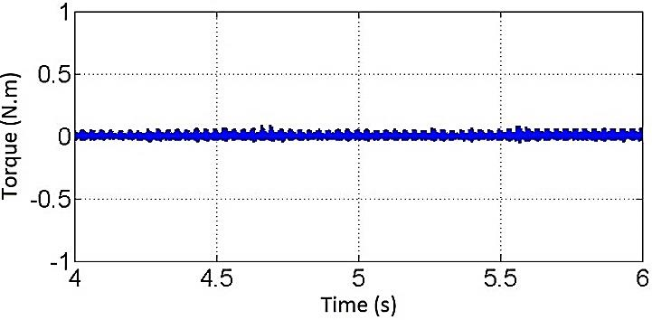

(b)

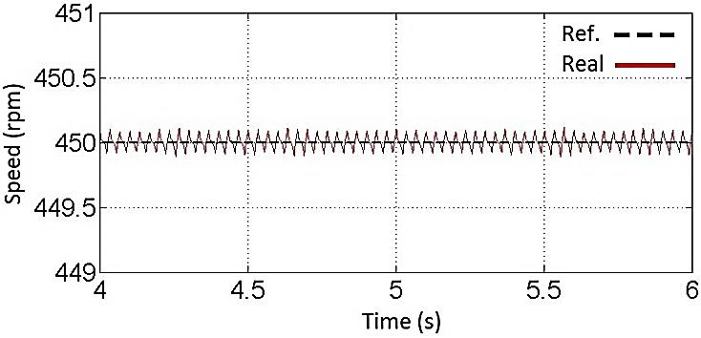

(c)

Figure 5. Simulation results of the proposed controller without speed estimator for VC of a 3-phase IM under open-circuit fault; (a) Stator a-axis current, (b) Torque and (c) Speed

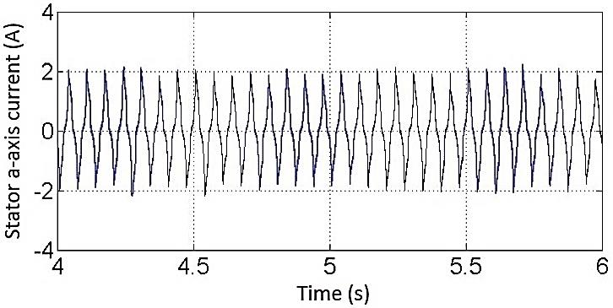

(a)

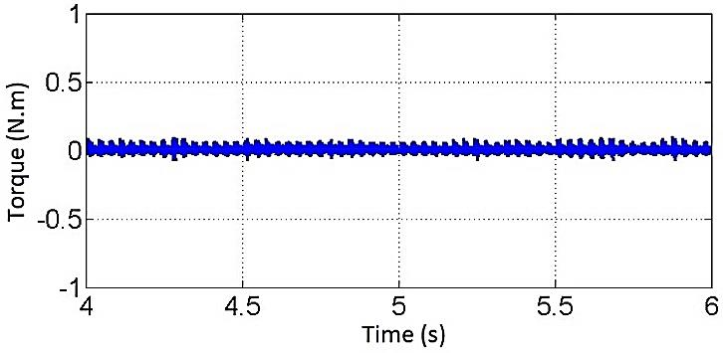

(b)

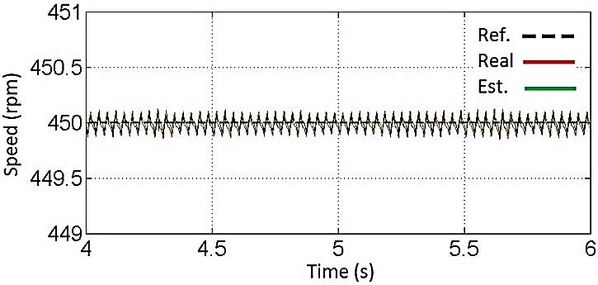

(c)

Figure 6. Simulation results of the proposed controller with speed estimator for VC of a 3-phase IM under open-circuit fault and speed sensor fault; (a) Stator a-axis current, (b) Torque and (c) Speed

As can be seen both regular and proposed schemes are able to reach steady state 450rpm (see Figure 4 (c) and Figure 5 (c)). It can be observed from Figure 4 and Figure 5 that the dynamic performance of the proposed controller is better than regular controller. Using conventional controller, the pick to pick torque oscillation is ~ 2.4 N.m (see Figure 4 (b)) but using proposed controller, the pick to pick torque oscillation is ~ 0.2 N.m (see Figure 5 (b)). It is also evident from Figure 6 that using proposed IVC technique, the estimated speed of the 3-phase IM under open-circuit fault can follow the real speed without any steady-state error. In this case the pick to pick torque oscillation is ~ 0.3 N.m (see Figure 6 (b)). The presented results show a considerable reduction in speed and torque ripples and better steady-state behaviour when the proposed controller is used.

1. **CONCLUSION**

This paper presented speed control of a 3-phase IM under fault conditions supplied by wind turbine using IVC strategy. This paper has shown that with some changes in the regular IVC strategy it is feasible to use same controller for VC of a star-connected 3-phase IM under open-circuit fault and speed-sensor fault. The simulation results have shown the correctness and possibility of the proposed methodology. The results demonstrate that in comparison with the regular IVC strategy, the performance of the proposed technique is satisfactory for VC of a 3-phase IM during fault conditions particularly in reduction of the motor speed and torque ripples.

**REFERENCES**

1. D. R. Espinoza-Trejo, D. U. Campos-Delgado, G. Bossio, E. Bárcenas, , J. E. Hernández-Díez, and L. F. Lugo-Cordero, "Fault diagnosis scheme for open-circuit faults in field-oriented control induction motor drives," *IET Power Electronics*, vol. 6, no. 5, pp. 869–877, 2013.
2. G. K. Singh, K. Nam, and S. K. Lim, "A simple indirect field-oriented control scheme for multiphase induction machine," *IEEE Transactions on Industrial Electronics*, vol. 52, no. 4, pp. 1177–1184, 2005.
3. A. B. de Souza, T. R. Fernandes Neto, D. D. A. Honorio, L. H. S. Barreto, and L. L. dos Reis, "Hybrid position controller for an indirect field-oriented induction motor drive," *In Applied Power Electronics Conference and Exposition (APEC)*, 2015, pp. 1541–1547.
4. G. Singh, "A fuzzy pre-compensated-PI controller for indirect field oriented controlled induction motor drive," *In Innovative Applications of  Computational Intelligence on Power, Energy and Controls with their impact on Humanity (CIPECH)*, 2014, pp. 257–261.
5. M. Jannati, S. Anbaran, N. R. N. Idris, and M. J. A. Aziz, "Vector control of three-phase induction motor under open-phase fault," *In 2013 IEEE Student Conference on Research and Development (SCOReD)*, 2013, pp. 105–110.
6. S. Fan and J. Zou, "Sensor Fault detection and fault tolerant control of induction motor drivers for electric vehicles," *In 7th International Power Electronics and Motion Control Conference (IPEMC)*, 2012, pp. 1306–1309.
7. T. R. Chelliah, A. Dominic, and R. Thangaraj, "Analysis of induction motor drives under sensor faults with mine hoist load diagram," *In 11th International Conference on Power Electronics and Drive Systems (PEDS)*, 2015, pp. 274–277.
8. S. K. Kommuri, J. J. Rath, K. C. Veluvolu, M. Defoort, and Y. C. Soh, "Decoupled current control and sensor fault detection with second-order sliding mode for induction motor," *IET Control Theory & Applications*, vol. 9, no. 4, pp. 608–617, 2015.
9. X. Zhang, G. Foo, M. Don Vilathgamuwa, K. J. Tseng, B. S. Bhangu, and C. Gajanayake, "Sensor fault detection, isolation and system reconfiguration based on extended Kalman filter for induction motor drives," *IET, Electric Power Applications*, vol. 7, no. 7, pp. 607–617, 2013.
10. M. Jannati, A. Monadi, N. R. N. Idris, and M. J. A. Aziz, "Speed Sensorless Vector Control of Unbalanced Three-Phase Induction Motor with Adaptive Sliding Mode Control," *International Journal of Power Electronics and Drive Systems (IJPEDS)*, vol. 4, no. 3, pp. 406–418, 2014.
11. Z. Yifan and T. A. Lipo, "An approach to modeling and field-oriented control of a three phase induction machine with structural imbalance," *In Proc. APEC, San Jose, TX*, 1996, pp. 380–386.
12. A. Saleh, M. Pacas, and A. Shaltout, "Fault tolerant field oriented control of the induction motor for loss of one inverter phase," *In 32nd Annual Conference on IEEE Industrial Electronics, IECON*, 2006, pp. 817–822.
13. M. Jannati, T. Sutikno, N. R. N. Idris, and M. J. A. Aziz, "A Novel Method for IRFOC of Three-Phase Induction Motor under Open-Phase Fault," *International Journal of Power Electronics and Drive Systems (IJPEDS)*,vol. 6, no. 3, pp. 439–448, 2015.
14. A. Sayed-Ahmed, B. Mirafzal, and N. A. O. Demerdash, "Fault-tolerant technique for Δ-connected AC-motor drives," *IEEE Transactions on Energy Conversion*, vol. 26, no. 2, pp. 646–653, 2011.
15. F. Meinguet, P. Sandulescu, X. Kestelyn, and E. Semail, "A method for fault detection and isolation based on the processing of multiple diagnostic indices: application to inverter faults in AC drives," *IEEE Transactions on Vehicular Technology*, vol. 62, no. 3, pp. 995–1009, 2013.
16. B. Dhanya, S. Nagarajan, and S. Rama, "ReddyFault analysis of Induction Motor fed by a fault tolerant voltage source inverter," *In 2012 International Conference on Computing, Electronics and Electrical Technologies (ICCEET)*, 2012, pp. 51–58.
17. G. Grandi, P. Sanjeevikumar, Y. Gritli, and F. Filippetti, "Fault-tolerant control strategies for quad inverter induction motor drives with one failed inverter," *In 2012 XXth International Conference on Electrical Machines (ICEM)*, 2012, pp. 959–966.
18. P. Vas, "Vector Control of AC Machines," Clarendon press Oxford, 1990.
19. E. S. Ali, "Speed control of induction motor supplied by wind turbine via Imperialist Competitive Algorithm," *Energy*, vol. 89, pp. 593–600, 2015.
20. K. Trinadha, A. Kumar, and K. S. Sandhu, "Wind driven induction generator study with static and dynamic loads," *International Journal of Energy Science*, vol. 1, no. 3, pp. 151–161, 2011.