A New Approach for classification of fault in transmission line with combination of Wavelet
Multi Resolution Analysis and Neural Networks

Y Srinivasa Rao *, Dr. G. Ravi kumar **
* Department of Electrical and Electronics Engineering, K L University
** Department of Electrical Engineering, Bapatla Engineering College

Article Info |  | ABSTRACT
Article history:  Received Sep xx, 2016  Revised Sep xx, 2016  Accepted Sep xx, 2016 |  | An appropriate fault detection and classification of power system transmission line using discrete wavelet transform and artificial neural networks is performed in this paper. The analysis is carried out by applying discrete wavelet transform for obtained fault phase currents. The work represented in this paper are mainly concentrated on classification of fault and this classification is done based on the obtained energy values after applying discrete wavelet transform by taking this values as an input for the neural network. The proposed system and analysis is carried out in Matlab Simulink.
Keyword:
Transmission line,
discrete wavelet transform and artificial neural network.
Copyright © 201x Institute of Advanced Engineering and Science.
All rights reserved.
Corresponding Author:
Y.Srinivasa Rao,
Departement of Electrical and Computer Engineering,
KL University,
Greenfields, Vaddeswaram, India 522 502
Email: lsntl@ccu.edu.tw

- INTRODUCTION
The performance of power system is frequently affected by faults, which give rise to disruption in power flow by occurrence of transients in voltage and current signals. The determination of faults quickly with a reasonable accuracy helps in faster maintenance and restoration of supply resulting in improved economy, safety and reliability of power system. This paper is a new approach based on wavelet multi-resolution analysis and artificial neural network based on the energy obtained from wavelet coefficients. When a fault occurs in transmission line, it initiates a transition condition. Transients produce over currents in the power system, which can damage the power system depending upon its severity of occurrence. They also contain useful information which can be used for analyzing disturbances that occur in transmission lines. The analysis of transients are due to the presence of high frequency components in voltage and current fault signals and there are various methods to extract useful information from these high frequency components. These methods are based on Fourier transform, wavelet transform, artificial neural network or combination of these techniques [10].Fourier transform and wavelet transform are the two major tools which are a great help in frequency domain analysis of any signal. Fourier transform is used for stationary signal and it provide twodimensional information, it converts signal from time domain to frequency domain. Fourier transform has zero-time resolution and very high frequency resolution i.e.; it is only localized in frequency. Whereas wavelet transform is used for stationary and non-stationary signal and it gives a complete three-dimensional information of any signal. Wavelet transform has high time resolution and high frequency resolution i.e., it is localized in both time and frequency. It provides non-uniform division of frequency domain means it uses short window at high frequencies and long window at low frequencies. Using wavelet multi-resolution analysis, a particular band of frequencies present in the fault signal can be analyzed [1].
- RESEARCH METHOD:
Wavelet means ‘small wave’. So wavelet analysis is about analyzing signal with short duration finite energy functions. They transform the signal under investigation in to another representation which represents the signal in a more useful form. This transformation of signal is called wavelet transform. Wavelet transform performs the signal translation and scaling. If the process is done in a smooth and continuous fashion then the transform is called continuous wavelet transform. If the scale and position are changed in discrete steps, the transform is called discrete wavelet transform [2]. These wavelet transform decomposes the analyzing wavelets (mother wavelets) in to translated and dilated versions called daughter wavelets and then the coefficients are derived. Different types of mother wavelets are haar, daubechies, symlet and coiflet.
The discrete wavelet transform (DWT) is normally implemented by Mallat’s algorithm its formulation is related to Multiresolution analysis theory. Discrete wavelet transform can be efficiently implemented by using only two filters, one high pass (HP) and one low pass (LP) at level (k) at which fundamental components generate. The results are down-sampled by a factor two and the same two filters are applied to the output of the low pass filter from the previous stage of the signal. The high pass filter is derived from the wavelet function (mother wavelet) and measures the details in a certain input having low pass filter on the other hand delivers a smoothed version of the input signal and is derived from a scaling function associated to the mother wavelet. The idea is illustrated in Figure.1. Thus discrete wavelet transform decomposes the signal in to approximation and detail coefficients, approximation coefficients are high frequency coefficients and detail coefficients are low frequency coefficients and these approximation coefficients have high energyand detail coefficients have low energy at the same level of the decomposition tree [4].
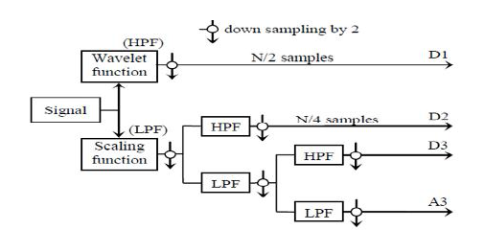

Fig.1.DWT multilevel decomposition

In this paper analysis are carried out by using db4 as mother wavelet. The fault current signals are analyzed with db4 at level 6 thus approximation and detailed coefficients at level 6 are obtained. We calculate energy of the approximation coefficients by using the formula
$$E=\sum_{k=0}^{n-1}{{x\left(k\right)}^{2}}$$
Classification of fault is done from the obtained energy of the approximation coefficients, by using artificial neural network.

2.1 NEURAL NETWORK
Artificial Neural Network (ANN) is a network which is made of several layers, each consisting of neurons, which are connected by the links with proper weights. They are trained using a set of statistical learning algorithms. A neural network has the ability to learn and is a complex adaptive system, which means it can change its internal structure (weights) based on the information (error) flowing through it. So, this makes it efficient in solving the complex problems where the linear computing fails. Hence it is employed in applications where formal analysis is difficult or impossible such as pattern recognition and nonlinear system identification and control is required.
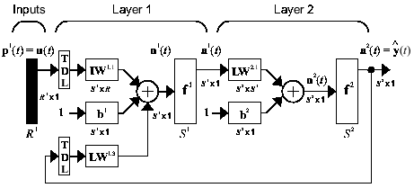
Fig.2. Model of ANN
Neural networks are composed of simple elements which operate in parallel with interconnection between them. The weights of connection (link) determine the network function. It is considered as the simplest kind of feed forward network. A neural network when created has to be trained which is done using training function. The weights of the link in the network are adjusted automatically to get a particular target output for specific input. A neural network can have several layers. Each layer consists of set of predefined neurons for which weight matrix, bias vector and an output function exists. Each neuron in one layer has direct connections with the neurons of the neighboring layer. The layer which is in between the input layer and output layer is called hidden layer. By increasing the number of hidden layers and neurons the network is enabled to extract higher order statistics which is advantageous when number of inputs is large and highly nonlinear [8].

- RESULTS AND ANALYSIS
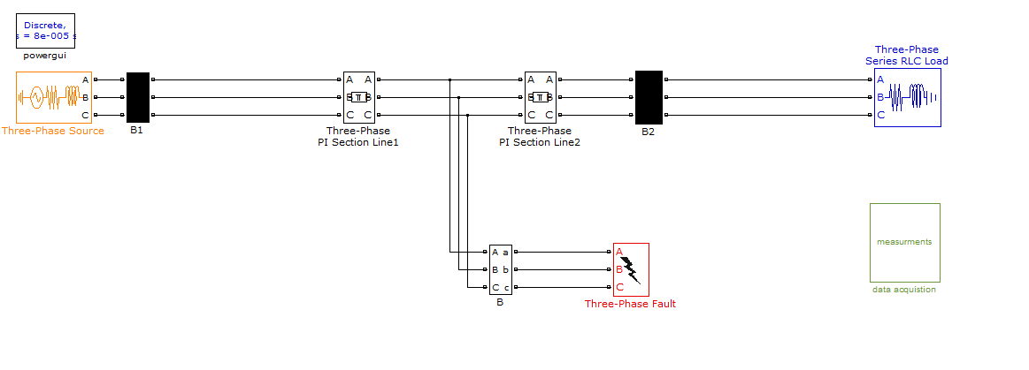
Fig.3.Simulink model of transmission line

A 220 kV power system is simulated using MATLAB Simulink, the transmission line parameters are R1=0.01273 Ω/km; R0 = 0.3864 Ω/km; L1=0.9337 mH/km; L0 = 4.1264 mH/km; C1=12.74 nF/km, C0 = 7.751 nF/km and Load with 100kw active power and 900w reactive power are considered. Transmission line length is 300km
3.1 Simulation results
(a) during normal condition

(b) during A-G fault
(c) during AB-G fault

(d) during ABC-G fault
- PROPOSED SYSTEM ALGORITHM
Here we consider discrete wavelet transform db4 as mother wavelet with 6th level because among different levels only 6th level is considering for analysis because the frequency corresponding to this level is covering 2nd and 3rd harmonics which are dominant in the fault conditions [7]. Based on 6th level approximation coefficients, an efficient algorithm proposed and is shown in figure 3.
S.no | O/p of neural n/w for phase Ia | O/p of neural n/w for phase Ib | O/p of neural n/w for phase Ic | O/p of neural n/w for ground | Type of fault
1 | 1 | 0 | 0 | 1 | A-G
2 | 0 | 1 | 0 | 1 | B-G
3 | 0 | 0 | 1 | 1 | C-G
4 | 1 | 1 | 0 | 0 | AB
5 | 0 | 1 | 1 | 0 | BC
6 | 1 | 0 | 1 | 0 | AC
7 | 1 | 1 | 0 | 1 | AB-G
8 | 0 | 1 | 1 | 1 | BC-G
9 | 1 | 0 | 1 | 1 | CA-G
10 | 1 | 1 | 1 | 1 | ABC-G

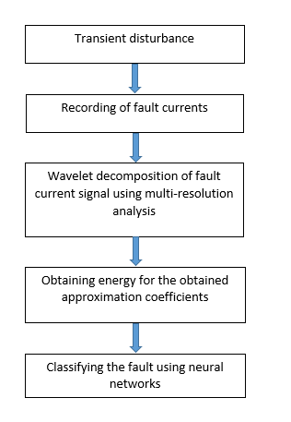
Fig.4. algorithm for fault analysis

Here we are using radial basis neural network for classification in which neural network is initially trained with inputs and targets with values 1 and 0. Based on the energy of the approximations coefficients obtained from the normal condition we design a logic circuit for obtain input values in the form values 1 and 0 and target is trained with high (1) if fault exists and low (0) if there is no fault. Thus we can able to classify the fault and fault classification format is shown in table 1.

5. CONCLUSION
This paper presents the application of wavelet multi resolution analysis in combination with artificial neural network for accurate classification. The method uses energy of approximation coefficients for fault classification. Wavelet transform is used to get approximation coefficients for fault currents and thus classification of faults was exact. This work deals with fault classification, but the proposed algorithm and scheme can be extended to locate the fault distance from sending end and receiving end.

REFERENCES
[1] P. Soman, K.I.ramachandran and N.G.resmi, “Insight in to wavelets”, New Delhi, PHI Learning Private Limited, 2010.
[2] A.M. Gaouda, M.M.A. Salama, M.K. Sultan and A.Y. Chikhani, “Power Quality Detection and Classification using Wavelet-Multiresolution Signal Decomposition”, IEEE Transactions on Power Delivery, Vol. 14, No. 4, pp.1469-1476, October 1999.
[3] D.Chanda, N.K.Kishore and A.K.sinha, “A wavelet multiresolution analysis for location of fault on transmission lines”, Electrical power and Energy systems, pp.59-69, 2003.
[4] S.A.Shaaban and Prof.Takashi Hiyama, “Transmission Line Faults Classification Using Wavelet Transform”, Proceedings of the 14th International Middle East Power Systems Conference (MEPCON’10), Cairo University, Egypt, pp.19-21, December 2010.
[5] Kale V.S., Bhide S.R., Bedekar P.P., “Faulted phase selection on double circuit transmission line using wavelet transform and neural network”, Third International Conference on Power System, Kharagpur, India, 2009.
[6] Gafoor S.A., Ramana Rao P.V., “Wavelet based fault detection, classification and location in transmission line”, Power and Energy Conference, PECon ‟06, IEEE International, 2006.
[7] Dileep Kumar, S. Raghunath Sagar, “Discrimination of Faults and Their Location Identification on a High Voltage Transmission Lines Using the Discrete Wavelet Transform”, IJEAR Vol. 4, Issue Spl-1, pp.107-111, Jan - June 2014.
[8] Othman M.F. and Amari H.A., Online fault detection for power system using wavelet and PNN, 2nd IEEE International Conference on Power and Energy (PECon 08), Johor Baharu, Malaysia, 2008.
[9] Costa F.B., Silva K.M., Souza B.A., Dantas K.M.C. and Brito, “A method for fault classification in Transmission Lines based on ANN and wavelet Coefficient Energy”, International Joint Conference on Neural Networks Vancouver, BC, Canada, , 2006.
[10] Mamta Patel and R. N. Patel, “Fault Detection and Classification on a Transmission Line using Wavelet Multi Resolution Analysis and Neural Network”, International Journal of Computer Applications (0975 – 8887), Volume 47– No.22, pp.27-33, June 2012.

BIOGRAPHIES OF AUTHORS

 | I completed B.Tech Electrical and Electronics Engineering in Avanthi Institute of Engineering and Technology in the year 2006. Completed M.Tech in Computational Engineering and Networking in the year 2009, And Presently working as an Assistant Proffesor in department of EEE K L University. The total teaching Experience is 7 Years.
 | I completed B.E Electrical Engineering in Andhra University college of Engineering and Technology in the year 1993. Completed M.Tech in Advanced Power Systems in the year March 2007, And awarded Doctorial Degree in 2014 in the specialization of Electrical Power Systems.Presently working as a Proffesor & HoD in the department of EEE Bapatla Engineering College. The total teaching Experience is 16 Years.

