**A Simplified Space Vector Pulse Width Modulation Method Including Over Modulation Operation for Five Level Cascaded H-Bridge Inverter with FPGA Implementation**

**B. Sirisha, P. Satish Kumar**

Assistant Professor

Department of Electrical Engineering, Osmania University, Hyderabad, INDIA

e-mail:sirishab2007@yahoo.com, e-mail:satish_8020@yahoo.co.in

|  |  |  |
| --- | --- | --- |
| **Article Info** |  | **ABSTRACT** |
| ***Article history:***  Received Jun 12, 201x  Revised Aug 20, 201x  Accepted Aug 26, 201x |  | Thispaper presents simplified control strategy of Space Vector Pulse Width Modulation method including over modulation region with linear transfer characteristic for cascaded H-bridge inverters. Because of large number of switching states of the cascaded H- Bridge inverter, the over modulation operation is very complex. And also requires incorporation of both under modulation and over modulation algorithms. The proposed control method is effective in terms of selecting the optimal switching states with reduced computational complexity using simplified linear calculations which makes it easier for digital implementation. The performance of the proposed method is simulated and tested experimentally through Spartan 3A FPGA processor for five level Cascaded H-bridge Inverter. The simulation results and harmonic analysis of voltage and current at various modulation indexes as are presented which are in well agreement. (9 pt). |
| ***Keyword:***  SpaceVectorModulation, Cascaded H-Bridge Inverter, Over Modulation,  FPGA,  Induction Motor |
| *Copyright © 201x Institute of Advanced Engineering and Science.  All rights reserved.* |
| ***Corresponding Author:*** B.Sirisha, Department of Electrical Engineering,  Osmania University, Hyderabad, INDIA  e-mail:sirishab2007@yahoo.com | | |

1. **INTRODUCTION**

Multilevel inverters are used as an alternate choice for high power medium voltage applications, The unique feature of these topologies that they can reach high voltage levels with minimum harmonics without the need of transformers which makes them a alternative choice for high power applications and FACTS [1]. Due to their ability of synthesizing the waveforms with good harmonic spectrum with fast response with autonomous control by which the power quality problems are reduced and dynamic behavior is improved they are extensively used in industrial drive applications. The various multilevel inverter topologies such as Cascaded H-Bridge Inverter with separate dc sources, Neutral point clamped Inverter, Flying Capacitor are being used in various applications [2]. Among various Pulse Width Modulation techniques for controlling the inverter output voltage , proposed is the literature[3-10], SVM method has greater flexibility of selecting switching states and their pattern design makes them suitable for digital implementation. Many of the SVPWM algorithms presented in the literature requires the extensive computation of switching patterns, with many algebraic equations in every sector which makes the SVPWM method complex. The main objective of this paper is to design a simplified SVPWM method with optimal switching states for linear and over-modulation regions. Operation in over modulation region is very much required in medium-voltage applications. Since it gives the effective utilization of dc bus thus minimizing the cost of the overall system [11]. This paper presents simplified SVPWM method including over modulation operation implemented experimentally for five level cascaded H-Bridge inverter with FPGA processor. The performance of the method both linear and over modulation regions are analyzed.

2. CASCADED H-BRIDGE INVERTER

The basic structure of five level Cascade H-bridge multilevel inverter is shown in Fig.1. Each H-Bridge inverter uses dc link voltage to generate a modulated voltage at output terminals. The total output voltage is sum of each individual inverter module output voltage. Each H-Bridge inverter module will produce three output voltage levels. +Vdc, 0, -Vdc. For higher level several units of H bridge inverter modules are connected in series.The number of H Bridges required for ‘L’ level is. The number of voltage levels in a phase voltage Vph with ‘N’ number of H-Bridges is 2N+1.

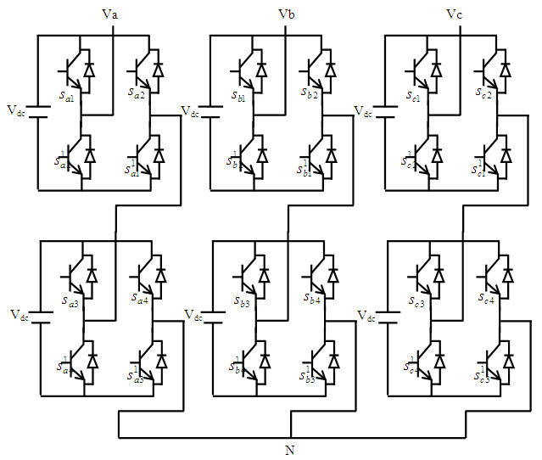

Figure 1:Three Phase five level Cascaded H-Bridge Inverter.

Table I shows the gate switching for single phase five level cascaded multilevel inverter.

Table.1 Gate Switching for five level CHB Inverter

|  |  |  |  |  |  |  |  |  |
| --- | --- | --- | --- | --- | --- | --- | --- | --- |
| Output Voltage | S1 |  | S2 |  | S3 |  | S4 |  |
| +2Vdc | 1 | 0 | 0 | 1 | 1 | 0 | 0 | 1 |
| +Vdc | 1 | 0 | 0 | 1 | 0 | 1 | 0 | 1 |
| 0 | 1 | 0 | 0 | 1 | 0 | 1 | 1 | 0 |
| -Vdc | 0 | 1 | 1 | 0 | 0 | 1 | 0 | 1 |
| -2Vdc | 0 | 1 | 1 | 0 | 0 | 1 | 1 | 0 |

# 3. SPACE VECTOR PULSE WIDTH MODULATION METHOD

Space Vector PWM relies on the representation of the inverter output voltage as space vectors. The space vector diagram of three phase inverter is a Hexagon with six sectors. Considering the geometrical characteristic that the angle between basic space vectors of 3-level inverter is all 600, using a non orthogonal 600 reference frame, the synthesis of reference vector and dwell time calculation becomes less computational. Therefore the orthogonal system is transformed into 600 co-ordinate system. Components of reference vector along 600 axes

 (1)

 (2)

 (3)

 (4)

Where m and n are defined by vector (m, n) in m1-n1 axis

(0,1)

(0,2)

(0,3)

(0,4)

(1,0)

(2,0)

(3,0)

m’

0

A

B

C

D

Vref

(4,0)

n’

Figure 2: Location of reference vector and identification of triangle in 60° axis

The reference voltage in a sector is synthesized by using V1, V2, V0 applied for the time T1, T2, T0.In the proposed technique the reference vector is synthesized in non orthogonal 600 reference frame. If Vref <= (m+n+1) then Vref is located in ΔABD else ΔCBD. After identifying the triangle where the reference vector is located, the dwelling times are calculated using the equations 5,6and 7 where ( m1, n1) (m2, n2) and (m3,n3) are the vertices of triangle where the reference vector lies then

 (5)

 (6)

 (7)

Where TB, TD, TA are dwell times of vector VB, VD, VA

# 3.1 Over modulation-Operation

For the value of m higher than 0.866 the operating region is considered as over modulation region.

P

B

m

R

S







n

(0,0)

x

y

z

v



**Figure 3:** Over modulation regions(Zone-I & Zone-II) in space vector modulation.

In the linear modulation region ( mi <= 0.866) the trajectory of the reference vector is a circle inscribed inside the hexagon with maximum sinusoidal output voltage. In the over modulation region (0.866<=mi<=0.953) the trajectory of the reference vector crosses the hexagonal track which is shown identified by the cross over angle. In the over modulation region its magnitude of the reference vector is modified through multiplication of decomposition vectors with the voltage reduction factor given as.

 (8)

The modified reference vector is calculated by the equations (9) and (10) this modified vector in called distorted continuous reference voltage space vector, in which the angle remains the same.

 (9)

 (10)

In circular track region ON-times are modified and given by equation (11)

 (11)

The loss in volts-seconds during hexagonal region is compensated by gain in volts-seconds during circular track region. For the over modulation zone- II (0.953 < m < 1), the magnitude of the reference vector is modified to compensate for the loss in fundamental voltage in the hexagonal track region. Else the reference is held at two large vectors sequentially for the time period till  to compensate for the loss in volt seconds.

This method brings the characteristics of linear range without increasing computational complexity. In this method the redundancy of the switching states is utilized to minimize voltage THD.The triangles of the space vector diagram are classified based on their switching states and given in the Table

Table 2:Classification of Triangles of the space vector diagram

|  |  |  |
| --- | --- | --- |
| **If (m+n) is even then**  **Type-I** | **If m is odd and n is even then**  **Type-II** | **Otherwise If m is even and n is odd then**  **Type-III** |
| **Sa=(m+n)/2**  **Sb=(n-m)/2**  **Sc=-(m+n)/2** | Sa=(m+n+1)/2  Sb=(n-m+1)/2  Sc=-(m+n-1)/2 | Sa=(m+n-1)/2  Sb=(n-m-1)/2  Sc=-m+n+1)/2 |

The switching sequence design is selected so that there will be minimum number of switches per switching period. There will be only one level change per commutation of switching devices and lower output THD. The sequence is designed based on co-ordinates of the vertices of the triangle where the reference vector lies.The sequence followed corresponding to Type-I switching states of the inverter triangle where the reference vector lies is (m3,n3)🡪(m1,n1) 🡪 (m2,n2) 🡪 (m1,n1) 🡪 (m3,n3). For Type-II the switching sequence is (m1,n1) 🡪 (m3,n3) (m2,n2) 🡪 (m3,n3) 🡪 (m1,n1). Otherwise for Type-III (m1,n1) 🡪 (m2,n2) 🡪 (m3,n3) 🡪 (m2,n2) 🡪 (m1,n1). By selecting the switching states in the above manner the average inverter phase voltage will have lowered substantial total harmonic content. The proposed technique is simulated with induction motor load.

The induction motor model is developed in stator reference frame; the electromagnetic torque is given by

 (13)

Where η = angle between the stator and rotor flux linkage

σ = Leakage coefficient = 

# 4. Results and Discussions

The performance analysis of the proposed method is done for five level Cascaded H-Bridge inverter through simulation and experimentally using FPGA for various values of modulation indexes.

# 4.1 Simulation results:

The simulation is carried out with DC voltage of 100V .The parameters of Induction motor for simulations are,

The parameters of the Induction motor for simulation are V=240V, 0.5Hp, Rotor resistance (Rr) =2.5Ω;Statorresistance(Rs)=2.3Ω;Statorleakageinductance(Ls)=0.25Ω;Rotor leakage inductance(Lr)=0.25Ω; Magnetizinginductance(Lm)=0.25Ω;mutualinductance(M)=0.0905H;RatedFrequency=50Hz; dampingcoefficient(B)=0.000124;Momentof inertia=0.019J; Number of poles=4; .

The simulation results are shown.



Figure 4: The Line voltage of the five level inverter with mi of 0.8.



Figure 5: Three Phase Stator currents of induction motor with mi of 0.8.

Fig 5 shows the simulated waveforms of stator current. The motor starts under rated voltage and frequency without mechanical load; The peak value of starting current is around 35A.The starting time is 0.15 seconds, due to inertia and high starting current. At 0.25 seconds load torque of 30Nm is applied which causes currents to increase.



Figure 6**:**The Phase voltage of the inverter with variation of m

The value of modulation index is varied with o.6 at starting to 0.9 at 0.5 sec and 0.99 at 0.7 sec



Figure 8:.The Line voltage and current of the inverter with variation of m

From the above Figure it can be seen that the magnitude of Current increases at 0.5seconds due to increase of mi, and stabilizes and further increases with increase of m to 0.99.



Figure 9: The Torque of induction motor with variation mi with respect to time

The above figure clearly shows the increase in torque corresponding to increase in mi at 0.5seconds and settles to a rated value within 0.05seconds duration.



Figure 10:The speed of induction motor with variation mi with respect to time

Table 3: Voltage and Current THD as a percentage of fundamental for Five level Cascaded H-Bridge Inverter for switching frequency of 1050.

|  |  |  |  |  |
| --- | --- | --- | --- | --- |
| **S.No** | **m** | **%VLTHD** | **%VPTHD** | **%ITHD** |
| **1** | 0.82 | 18.6 | 34.3 | 5.3 |
| **2** | 0.87 | 19.5 | 31.4 | 5.7 |
| **3** | 0.9 | 17.3 | 27.4 | 6.0 |
| **4** | 0.96 | 15 | 28.6 | 6.4 |
| **5** | 0.99 | 15.5 | 28.1 | 5.3 |

Table 4: Voltage and Current THD as a percentage of fundamental for Five level Cascaded H-Bridge Inverter for switching frequency of 3600.

|  |  |  |  |  |
| --- | --- | --- | --- | --- |
| **S.No** | **m** | **%VLTHD** | **%VPTHD** | **%ITHD** |
| **1** | 0.82 | 17.5 | 34.5 | 1.6 |
| **2** | 0.87 | 18.1 | 30.7 | 2.5 |
| **3** | 0.9 | 16.4 | 26.6 | 2.5 |
| **4** | 0.96 | 14.2 | 28.3 | 3.7 |
| **5** | 0.99 | 14.7 | 27.6 | 3 |

**4.2 Experimental Results:**

The performance of the proposed method is tested with induction motor of rating 0.75KW, 415V, and 1415 rpm 0.8p.f as load for prototype Five level Cascaded H-Bridge multi level inverter with The Spartan-3A FPGA processor. VHDL program code is simulated and implemented using XILINX 15E-14.5 Software. The FPGA design flow comprises of Design entry- with assigning constraints such as timing, pin location and area constraints including UCF file, Synthesizing the design with source code converting into net list of gates. The net list is translated mapped and routed for logic circuits of the Spartan 3E FPFA.After functional and timing verification the bit file is downloaded to target device (Spartan 3E processor) by using impact with a programming cable. Once the program is dumped to FPGA kit it acts as a controller and generates the gate signals to drive the three phase inverter.

The harmonic analysis at various modulation indexes is presented.

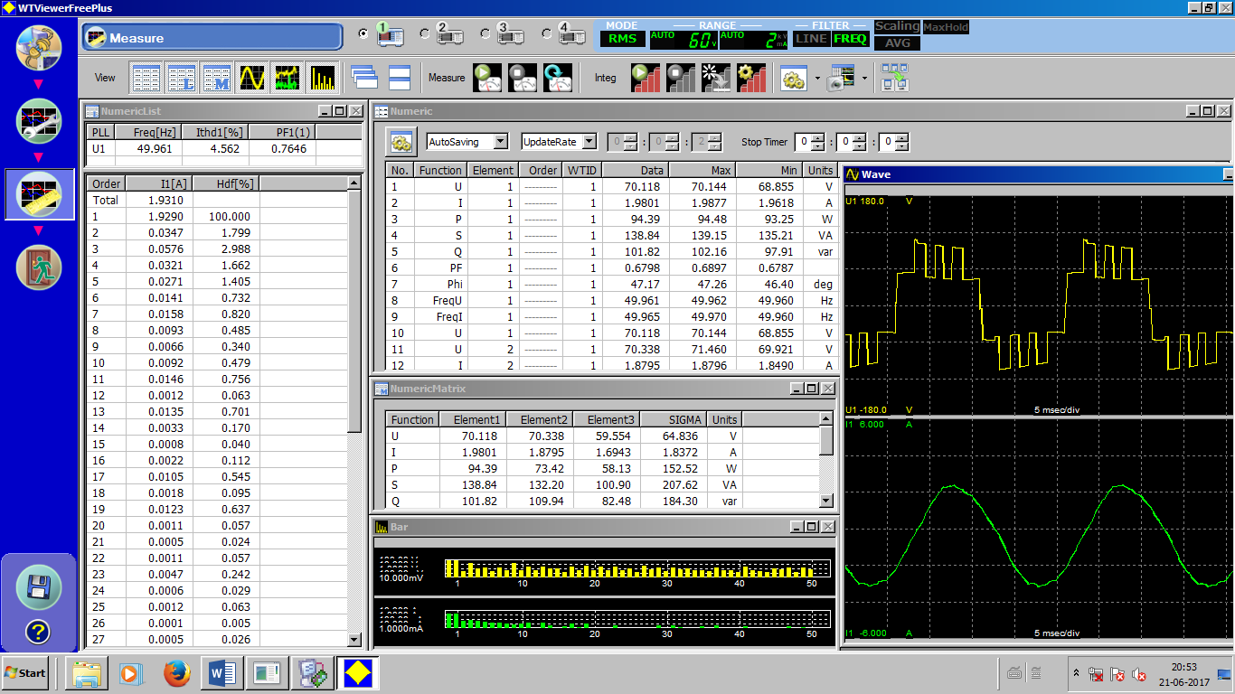

Figure 11:. Experimental Phase voltages and currents for 0.6 modulation index and switching frequency of 2000Hz for Five level Cascaded H-Bridge Inverter.

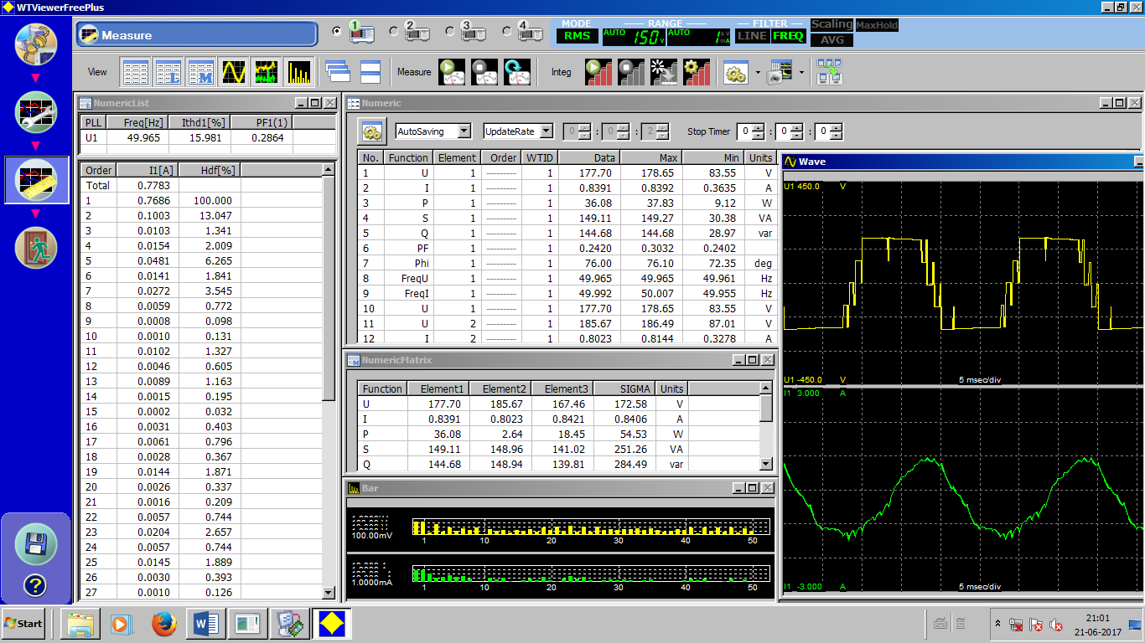

Figure 12: Experimental Phase output voltages and currents for 0.87 modulation index and switching frequency of 2000Hz for Five level Cascaded H-Bridge Inverter.

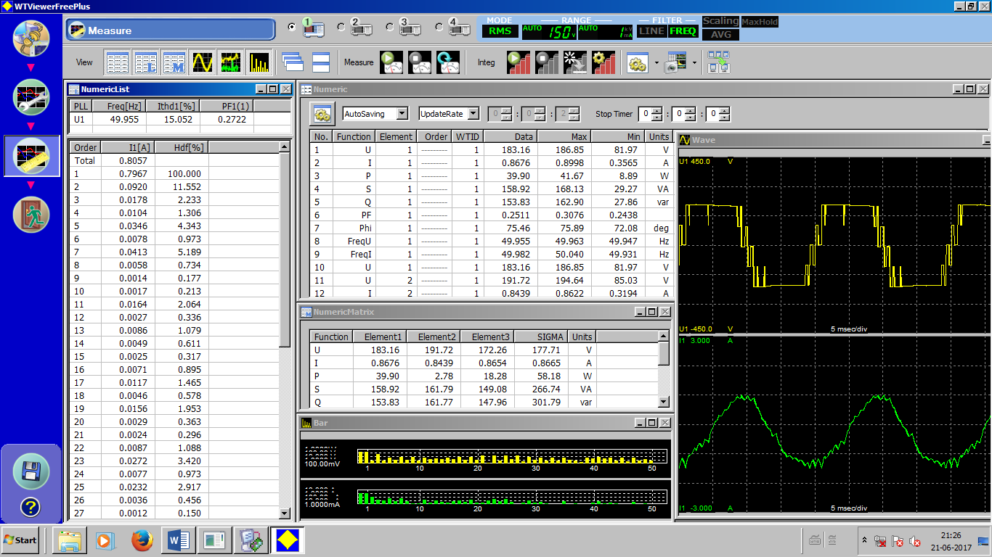

Figure 13:. Experimental Phase output voltages and currents for 0.97 modulation index and switching frequency of2000Hz for Five level Cascaded H-Bridge Inverter.

Table 5: Experimental values of current and voltage THD`s for various values of mi

|  |  |  |  |  |  |
| --- | --- | --- | --- | --- | --- |
| **m** | **Outputvoltage**  **(vph)** | **current** | **Power in Watts**  **Po** | **VphTHD** | **ITHD** |
| 0.7 | 64.6 | 1.8 | 151.9 | 42.3 | 4.5 |
| 0.8 | 159.7 | 0.75 | 46.4 | 29.40 | 15.0 |
| 0.9 | 155 | 0.73 | 44 | 29.54 | 15.3 |
| 0.97 | 167.3 | 0.79 | 52.9 | 30.7 | 16.5 |
| 0.99 | 164.7 | 0.78 | 50.8 | 29.7 | 15.0 |

# 5. Conclusions

The proposed method effective in terms of reducing computational complexity of Space Vector Modulation method, by which the co-ordinates of the space vector are in integer scales, and easily extended for over modulation region with combination of reference voltage vector modification and on time modification. This technique is more precisely suitable for hardware implementation. This technique is applied for five level cascaded H-Bridge inverter for both linear and over modulation regions using Spartan 3A FPGA Processor. The results corresponding to the various values of mi indicates the linear characteristics in the over modulation region. The current and voltage THD increases slightly due to increase of sub harmonic components for higher mi, but the rms value of the output line voltage magnitude also increased giving the effective utilization of DC bus voltage.

### 6. ACKNOWLEDGEMENT

We thank the University Grants Commission (UGC), New Delhi for providing Major Research Project to carry out the research in the area of Multi level inverters.

**7. REFERENCES**

1. J. Rodríguez, J. Lai, and F. Peng, “Multi level converters: a survey of topologies, controls and applications,” *IEEE Trans. Ind. Electron*., Vol. 49, No.4, pp. 724-738, Aug. 2002.
2. J.S.laiandF.Z.peng,“multilevelconverters–Anewbreedof power converters,” IEEE *Trans. Industrialappl.,* vol.32,No.3, pp. 509-517, may/june,1996.
3. Lei Hu, Hongyan Wang, yan Deng and Xiagning "A simple SVPWM Algorithm of Multilevel inverter “Power Electronics specialistic conference, Achen, 2004.
4. A.Nabae, I.Takahashi, cd H.Akagi, “A new neutral-point clamped pwm inverter”. *IEEE Trans. Ind. Appl*., vol.1A-17, no.5, pp.518-523, sept/oct 1982.
5. N. Celanovic, and D. Boroyevich, “A fast space vector modulation algorithm for multilevel three phase converters,” *IEEE Trans on Industry Applications*, Vol.37, No.2, 2001, pp.637-641.

l. yiqiao, and c.o. nwankpa, “a new type of statcom based on cascadingvoltage source inverters with phase-shifted unipolar spwm,” *IEEE trans. on industry applications*, vol.35, no.5, 1999, pp.1118-1123.

1. Anshuman Tripati, Khambadkone and S.K Panda,” Direct Method of Over modulhion with integrated closed loop Stator Flux vector control.” *IEEE Trans. on Power Electronics*, Vol.no20, no.5, pp.1161-1168, sep, 2005. Vol.20 No 5 September 2005
2. d.w. kang, y.h. lee, b.s. suh, c.h. choi, and d.s. hyun, “a carrier wave-based svpwm using phase-voltage redundancies for multilevel h-bridge inverter,” International conference on industrial electronics, control, and instrumentation ( iecon ), vol.1, 1999, pp.324-329.
3. Hu,HongyanWang, yan Deng and Xiagning "A simple SVPWM Algorithm of Multilevel inverter "Power Electronics Specialistic conference, Achen, 2004.
4. Amit Kumar Gupta, Ashwin M. Khambadkone”A General Space Vector PWM Algorithm for multi level inverters ,including operation in overmodulation range” *IEEE Transactions on Power Electronics*, vol 22, No.2, March 2007.
5. Sanmin Wei and Bin Wu “A General Space Vector PWM control Algorithm for Multi-level inverters” IEEE 2003, pp 562-568.
6. B.Sirisha, Dr P.Satish Kumar, “A Simplified Space Vector Pulse Width Modulation Method for Cascaded H-Bridge Multilevel Inverters”, IJAREEIE, Volume-3, Issue 12, December 2014.
7. B.Sirisha, P.Satish Kumar, “A Simplified Space Vector PWM for Cascaded H- Bridge Inverter including Over Modulation Operation”. B.Sirisha,13th International IEEE India Conference INDICON 2016. at IISC, Bengaluru,India. December 16-18, 2016.
8. B.S. Suh. and D.S. Hvun. “A New N-Level High Voltage Inversion System.” *IEEE Trans. On Industrial Electronics*. Vol.44, No.14 1997, pp. 107-I 15.
9. L. Yiqiao, and C.O. Nwankpa, “A new type of STATCOM based on cascading voltage source inverters with phase-shifted unipolar SPWM,” IEEE Trans. on Industry Applications, Vol.35, No.5, 1999, pp.1118-1123.
10. www.xilinx.com/technology/dsp/BDTI_techpaper.pdf
11. Koutroulis E., Dollas A.and Kalaitzakis K., “High-frequency pulse width modulation implementation using FPGA and CPLD ICs”, Journal of Systems Architecture , Vol.52 (2006) pp. 332–344.

**BIBLIOGRAPHY OF AUTHORS (10 PT)**

|  |  |
| --- | --- |
|  | **B.Sirisha** obtained her B.E degree in Electrical & Electronics Engineering from Osmania University and M.E degree in 2003 from JNTU, Hyderabad and persuing Ph.D. in the area of multilevelinverters . She is currently working as Assistant Professor in Department of Electrical Engineering, University College of Engineering(Autonomous), Osmania University, Hyderabad, Telangana, India. Her research interests include Power Electronics, multilevel inverters and drives . |
|  | **Dr. P. Satish Kumar** was born in Karimnagar, Andhra Pradesh, INDIA in 1974. He obtained the B.Tech degree in electrical engineering from JNTU College of Engineering, Kakinada in 1996. He obtained M.Tech degree in power electronics in 2003 and Ph.D. in 2011 from JNTUH, Hyderabad. He has more than 16 years of teaching and research experience and presently working as Senior Assistant Professor in the Department of Electrical Engineering, University College of Engineering,Osmania University, Hyderabad, INDIA. He presented many research papers in various national and international journals and conferences. Achieved Award for Research Excellence and Best young teacher Award-2014.Holds UGC-Major Research Project and SERB(DST)-Research Projects on multilevel inverters. His research interests include Power Electronics Drives, Multilevel inverters, Matrix Converters and special machines. |