Pulse Width Modulation Based Decentralized Street LED Light Dimming System

Hussain Attia*, Amjad Omar*, Maen Takruri*, Halah Y. Ali**
* Electrical, Electronics & Communication Engineering Dept., American University of Ras Al Khaimah
** Biotechnology Dept., American University of Ras Al Khaimah

Article Info |  | ABSTRACT
Article history:  Received xxxx xx^{th}, 201x  Revised xxxx xx^{th}, 201x  Accepted xxxx xx^{th}, 201x |  | The high power consumption of conventional street lighting systems, and the consequences on environmental ecosystem due to continuous turning ON of light, have led researchers to seek solutions to this problem. LED light dimming system has been presented in many studies using computerized systems with or without wireless monitoring facility. The demerits of these systems include complexity, high cost and unfixed data transfer speed. This paper proposes to reduce power consumption of street lighting through a decentralized light dimming system that is based on Pulse Width Modulation (PWM). This is in addition to replacing conventional high power lamps with lower power LED lamps. The dimming control circuit of this system is fixed on each pole and controlled individually resulting in faster and more reliable response. The proposed system uses the available infrastructure and is suitable for small or main streets regardless of the number of light poles. It is also flexible in its coverage distance due to the freedom of motion detector selection. The advantages of using LED lighting on the environment as compared to conventional lighting are explained. Simulations reveal the effectiveness of the proposed system on energy saving and on the environment.
Keyword:
Light dimming system PWM DC-DC converter
Light Emitting Diode
Environmental conditions
Copyright © 201x Institute of Advanced Engineering and Science.
All rights reserved.
Corresponding Author:
Hussain Attia,
Electrical, Electronics & Communication Engineering Dept.,
American University of Ras Al Khaimah ,
Ras Al Khaimah, 10021, UAE.
Email: hattia@aurak.ac.ae

- INTRODUCTION
LED street light dimming systems are adopted by many researchers for energy saving, performance improvement, and environmental conditions enhancement. Almost all of these systems are remotely monitored and controlled via computerized systems. The disadvantages of these systems include high complexity and cost, in addition to unfixed data transfer speed.
The majority of the new lighting systems replace conventional Sodium or Metal Halide Lamps (400 W) with low power LED lamps (<150 W). LED lamps enhance the lighting system in terms of improved luminance intensity, reduced power consumption, longer lifetime, improved visibility and current rendering capability [1]-[2]. A smart lighting system is proposed in [3] which adjusts the light intensity automatically using a wireless network of ZigBee units. In [4], an intelligent wireless system is implemented with supervisory control and data acquisition (SCADA) system. A real time web based information monitoring system is proposed in [5]. This system optimizes the LED driver performance for higher efficiency. LED light dimming and data transmission functions are dealt with individually in [6] to avoid the response delay which may occur during data transfer. Performance optimization of remotely controlled street lighting system is done in [7] and ZigBee units are designed to be used for data transfer.
Pulse width modulation is adopted in power electronic systems of inverters/converters [8]-[19]. Load power control and inverter/converter performance optimization through different strategies of PWM technique are demonstrated in [8]-[10]. The study in [11] proposed on/off switching for street lighting lamps based on the traffic conditions on the road. Two solutions of centralized systems for street light dimming are presented in [12]. In the first solution, a Multi-tap autotransformer is adopted, while in the second solution, a high switching frequency converter is adopted. A detailed comparison is done between the two solutions.
Other studies focused on controlling the light intensity by using DC-DC converters to generate multi levels of lighting. The approach of multi-level current control for LED dimming is proposed in [13] through buck-boost DC-DC converters. The merits of the proposed system of [13] include high power factor, reduced harmonic distortion, and improved efficiency. A DC-DC boost converter is designed in [14] for providing DC voltage with higher level for LED lighting system. In [15], a three-stage system including boost converter, electronic transformer, and LED is presented. The implemented system reflects higher efficiency level of 93% for a prototype of 160 W. A photovoltaic (PV) maximum power point tracking (MPPT) system for battery charging and a high intensity discharge process based system for street lighting are presented in [16]. In [17]-[19], a Dual Tone Multi Frequency (DTMF) is presented for remote load power and light intensity controls.
Almost all of the above mentioned studies either use computerized or wirelessly monitored computerized systems which have the disadvantages of complexity and high cost, as well as unexpected data transfer speed. Unlike the two steps decentralized dimming system in [20], this paper presents an analog dimming decentralized system having an unlimited number of light dimming levels thus resulting in more energy saving.
The rest of the paper is organized as follows; section II includes our design and comparison with the design of [20]. Section III explains the advantages of using LED lighting on the environment. Section IV demonstrates simulation results and demonstrate the enhancement of energy saving. Summary of findings and conclusions are presented in section V.

- RESEARCH METHOD

2.1 System model Design of proposed LED light dimming system
Dimmable LED lamp is selected for the function of streets lighting instead of higher power lamp of conventional systems. The dimming function in this paper is designed through the principle of decentralization, in other words each lamp light will be controlled by the dimming drive circuit which is fixed on the lamp pole itself.
The proposed design uses an RF motion sensor to sense the motion of vehicles or pedestrians on the roads. These sensors measurements are not affected by weather conditions like fog and haze, etc., as for PIR sensors. To have flexible design that is capable of dealing with RF sensors having different ranges, the proposed design is done generally for DC output voltages that are assumed to be between V_{a} (V) and V_{b} (V). Based on this assumption, Figure 1 represents the main block diagram of the proposed system which provides unlimited levels of output DC voltage to the dimmable LED so as to control the light from low light level to full light level. To do the light dimming action individually for each lamp, there is an RF sensor fixed on each pole to sense the vehicle motion and to measure the distance between the vehicle and the light pole. Fixing the direction of the sensor and its coverage area dimensions are important parameters for successful action. An RF sensor produces a certain DC voltage value that is inversely proportional to the distance between vehicle and sensor pole. Figure 2 shows the positions on each pole and coverage angles of the RF motion sensors. Based on the sensor specifications of coverage area dimensions (X, Y) the system has flexibility of desired distance (R) selection as shown in Eq. (1) [21-22].
(1)
where P_{r} is the received power, P_{t} is the transmitted power, G_{t} is the sensor antenna gain, σ is the radar cross sectional area of the target, A_{e} is the effective area of the sensor antenna and R is the distance between sensor and target.
The output voltage of the RF sensor circuit will remain at low voltage (V_{a}) until the sensor starts to sense the vehicle on the street. Then the sensor output voltage will start to increase continuously with the vehicle motion towards the pole. The maximum voltage (V_{b}) of the RF sensor circuit will be reached when the vehicle is right under the pole. The sensor output voltage will return to the low voltage value of (V_{a}) when the vehicle starts to leave the coverage area of the sensor and at that time the LED light will return to its lowest level.
As shown in Figure 1, for any voltage output of sensor, adaptation circuit is necessary for adapting and modifying the voltage range to an acceptable range, the new range can be used to produce a desired pulse width modulation (PWM) pulses through unlimited duty cycle. These pulses are used to drive the designed DC-DC converter to produce a certain DC load voltage for a desired lighting level of LED.
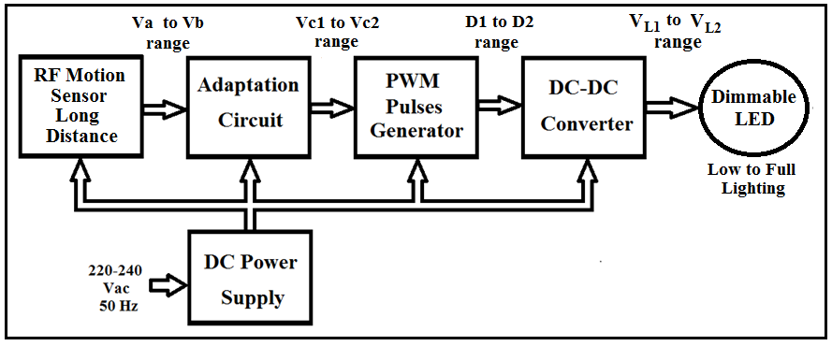
Figure 1. Main block diagram of the proposed system

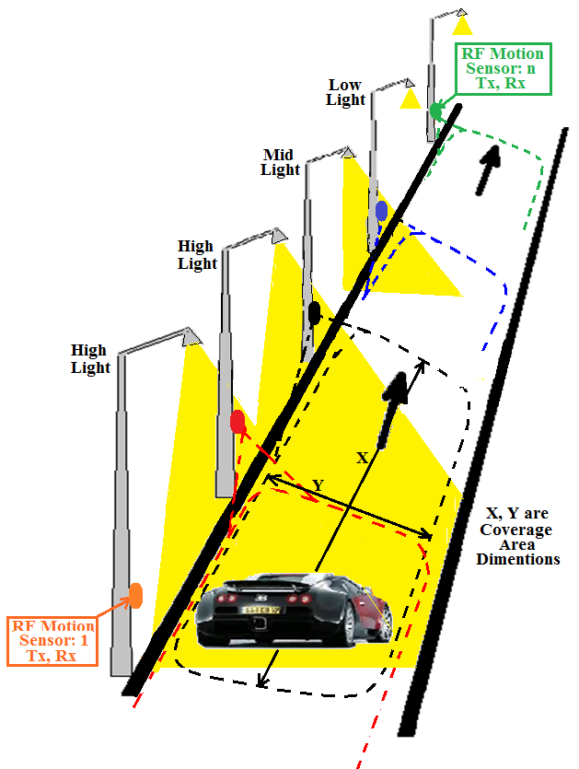
Figure 2. Physical arrangement of the proposed street light
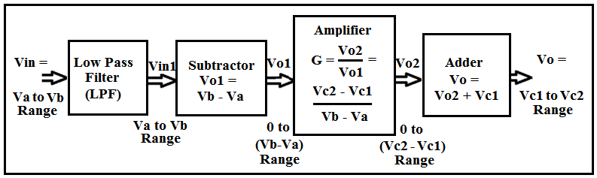
Figure 3. Adaptation Circuit
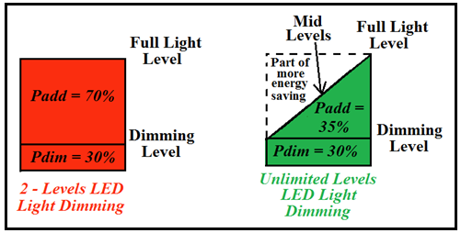
Figure 4. Comparison between 2-levels and unlimited levels LED light dimming; red color proposal of [20], green color proposal of this study
Comparing with the 2 level LED light dimming work of [20], the work in this paper is continuous lighting change based on the instantaneous distance of vehicle to the sensor, as shown in Figure 4, there is clearly enhancement in saving energy which is 35 % (green triangle) of the normalized load power at full lighting while full lighting equal 70% (red rectangle) and due to this there is additional saving in energy through proposing the analog continuous light dimming of this study.
- RF Motion Sensor
An RF motion sensor operating at 17 GHz will be used to detect the motion of vehicles or pedestrians on the streets in the proposed street lighting system. The antenna of the RF sensor will transmit an amount of power P_{t} which will propagate at the speed of light to hit the target. During its propagation, the signal power density (which is the power per unit area) will decrease in a manner that is inversely proportional with the square of the distance R between the sensor’s antenna and the target. This power density will also be proportional to the transmitting antenna gain G_{t} [21] which reflects the ability of the sensor antenna to direct radiation in certain directions as well as its radiation efficiency. After hitting the target, a portion of the incident power will reflect back towards the sensor depending on the radar cross section of the target σ [22]. The reflected power density will again suffer attenuation as it propagates towards the sensor. The amount of power ultimately received by the sensor antenna will depend on the power density falling on this antenna after reflecting from the target and its effective area A_{e} (which is the area which when multiplied by the power density gives the power delivered to the load). The received power by the sensor’s antenna is can be expressed in the form of equation widely known as the radar equation [22] as shown in Eq. (1).
Equation (1) indicates that the received power by the sensor antenna decreases with increasing R. Hence, the open circuit voltage generated across the receiving antenna also decreases with increasing R and has an amplitude that changes with R which we may assume to be in the range V_{a} to V_{b}.
- Adaptation Circuit
The adaptation circuit begins with a low pass filter (LPF) as shown in Fig. 3 that is needed to remove the noise which may affect the signal received by the RF sensor. The instantaneous DC voltage level will be in range between Va to Vb. This voltage range needs to be further processed in order to deliver a desired new voltage range as needed by the PWM pulses generator (see Fig. 3). The process after LPF begins by op-amp subtractor to subtract Va from the range of sensor voltage so that the new range will start from 0 V and increase to maximum value of (Vb – Va). This new range needs to be amplified to another voltage range that start from 0 V and end at maximum value of (Vc2 – Vc1). To have a final range of Vc1 to Vc2, the last voltage range needs to be increased by Vc1 through the last sub-block of op-amp adder circuit. The instantaneous voltage of adaptation circuit is used as a comparing level in the PWM generation block to determine the desired duty cycle of the produced pulses.
The following Eq.s (2)-(6) are representing the process of the adaptation circuit;
(2)

, V_{in1} ∈ [V_{a} to V_{b} range] (3)

(4)

(5)

(6)
where f_{o} is the Cut-off frequency of LPF, and for fo equals 20 Hz with capacitor C = 1 µF, the value of the suitable filter series resistor is approximately 8 kΩ. V_{a} is the lower limit of RF sensor output voltage at no sense state, V_{b} is the higher limit of RF sensor output voltage at full sense state. G is the desired amplification gain, V_{c1}, V_{c2} desired lower and higher voltage limits for PWM generation respectively.

- Pulse Width Modulation and DC-DC Converter
PWM pulses generation with a desired width or duty cycle is done through comparing the output DC level of adaptation circuit with a triangular carrier of high frequency 10 kHz. The generated pulses are used as gate drive pulses to the power electronic switch of DC-DC converter which converts the DC voltage level to other desired level [14], [23]-[24]. Boost, bulk, and boost-bulk are common topologies of DC-DC converter. The adopted topology in this paper is a boost converter due design simplicity as shown in Figure 5.
Boost converter works with one of the two operating modes, namely; Continuous Conduction Mode (CCM), and Discontinuous Conduction Mode (DCM). Converter design is easier with CCM mode and the relation between input DC voltage Vin and output DC voltage Vo is given by Eq. (7);
(7)

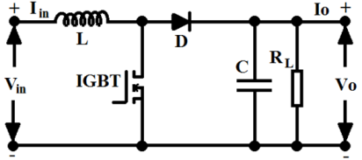
Figure 5. Boost DC-DC converter topology

where D is the duty cycle of the PWM trigger pulses used for driving the IGBT. Converter DC link input voltage V_{Conv.in} is connected to the DC supply while the converter output voltage V_{Conv.o} is delivered to LED lamp. The converter parameters values are determined through the below eq.s (8), and (9) [23-26];
(8)

$C_{min}= \frac{V_{o}-V_{{in}_{min}}}{R_{L_{max}}∙V_{pp}∙ f}$ (9)
where L_{c}, C_{min} are minimum limits of converter inductance, and capacitance respectively, R_{L} represents load resistance, V_{PP} is a desired ripple voltage when the converter is working in CCM mode, and f is the PWM switching frequency.
The DC-DC converter parameters are designed with maximum load power 60W, Vin with range = +11 V to +13 V, lower limit of output load voltage V_{omin} = +15 V at minimum width of duty cycle D₁ for lower level of dimming LED light, higher limit of output load voltage V_{omax} = +24 V at the maximum width of duty cycle D₂ for full LED light, Vpp = 2%, switching frequency f = 10 kHz, and load resistor R_{L} = 9.6 Ω, L_{C} is 64 µH, and C_{min} is 65 µF. D_{1(min)} is 20% (represented by comparing level of 2 V) for output load voltage +15 V of lower limit of dimming light, while D_{2(max)} is 50% (represented by comparing level of 5 V) for full lighting output voltage 24 V.

2.2 Environmental and health advantages of LED
LED lights have a clearly less negative impact on the population and environment if compared with high- pressure Sodium (HPS) and metal Halide lamps (MHL). There is a reduction of the poisonous repercussions which result from toxic chemicals such as Argon and mercury that are released from broken bulbs. The rest of these poisonous chemicals stay in the glass itself thus leading to contamination of the soil, water, people, and animals. Simply mercury has the potent neurotoxic effect that impacts the nervous system through ingestion, inhalation, or by touching the broken bulbs. For these reasons and more, the Environmental Protection Agency (EPA) put steps for proper disposal of these bulbs. Moreover, the disposing of traditional lamps as general waste is considered illegal due to harmful effects on the environment [27-28].
Another aspect is that the heat emission from a LED bulb is only 3.4 Btu which makes LED more environment-friendly as it attenuates the temperature productivity gradient by 75% compared to the conventional lamp. Nevertheless, 90% of the environmental impact is from energy consumption and associated greenhouse gas emissions that originate from the conversion of fossil fuel into electricity. The fact that LED bulbs consume less energy reduces this impact by generating almost a tenth of the CO2 emissions compared to the conventional light source [28-29]. Many climate scientists demand reducing the CO2 level to 350 ppm to avoid the climate changes due to greenhouse gas emissions. Global awareness of this issue is important to change the CO2 emission activities, especially, when we know that the atmospheric CO2 levels could be more than 1000 ppm in this century and this escalation in atmospheric carbon monoxide not only leads to climate change but also leads to serious health issues such as kidney failure, bone atrophy and even loss of brain function. Moreover, some researchers indicate that there is a relationship between the increase of ambient CO2 and increase in cancers [30].
Another advantage is that LEDs hardly emit infrared light compared to other light sources and this small emission is not high enough to cause any harm. Moreover, LEDs do not emit any UV radiation (unless they are designed for that purpose). Therefore, LEDs are not harmful to people particularly those patients with autoimmune diseases such as Lupus or photodermatoses. The blue wavelength light of LED is at a level comparable with other traditional sources of streetlights. The peak blue light exposure is around (460-480nm) which is important because it regulates the biological clock and activates the metabolic processes especially to people who do not receive their daily portion of blue light due to spending most of their daytime indoors [31].
Using LED with dimming capability minimizes light pollution and thus reduces disturbance to animal and plant ecosystems. Additionally, LED light is directed where they are needed on the road surface and they are reflected downwards instead of shedding upward. This is opposite to HPS lamps which create an orange glow above the roads or cities leading to the sky glow which is considered one of the light pollutants that impact the environment. In addition, the long lifespan of LEDs (2-5 times more than the conventional streetlights) represents another advantage which could decrease the amount of waste in landfills. Also the fact that LED bulbs are recyclable makes them environmentally friendly. One of the notable advantages of LEDs is their positive effects on plants growth rate due to their cool emitting temperature. The option to select the wavelength made NASA’s Kennedy Space Center examine LEDs as light sources for plants growth on Mars [31-32].

- RESULTS AND ANALYSIS
The design is verified using National Instruments NI Multisim software for electronic circuit design. DC-DC converter is simulated with 100 µF capacitor, 0.1 mH inductor, 10 kHz switching frequency, and the DC link voltage is 12 V when input AC supply is 230V. Simulation results are collected with the assumption that the output signal of RF sensor falls in the range 0.1 V to 0.3 V indicating the vehicle motion sensing. 0.1 V is for long distance sensing of approximately 60 meter, while RF sensor produces 0.3 V for short vehicle motion distance. The RF sensor signal is also assumed to include a wide frequency band of white noise.
As shown in Figure 6, the adaptation circuit is receiving input noisy signal (red color signal of oscilloscope XSC1 left side of Figure 6) in range of(0.1 V to 0.3 V) and the circuit process starts be first filtering the white noise using LPF filter as shown in filtered signal (blue color signal of oscilloscope XSC1 in Figure 6). Subtracting 0.1 V from the signal voltage range results in a new range of (0 V to 0.2 V), then amplifying this range by gain of (desired new range / old range) = (Vc2 – Vc1)/0.2, with the designing of (20% the desired minimum D1, and 50% maximum D2 duty cycles at lower comparing limit of VC1 = 2 V, and at higher comparing limit of Vc2 = 5 V respectively so the required gain equals (5 – 2)/0.2 = 15.

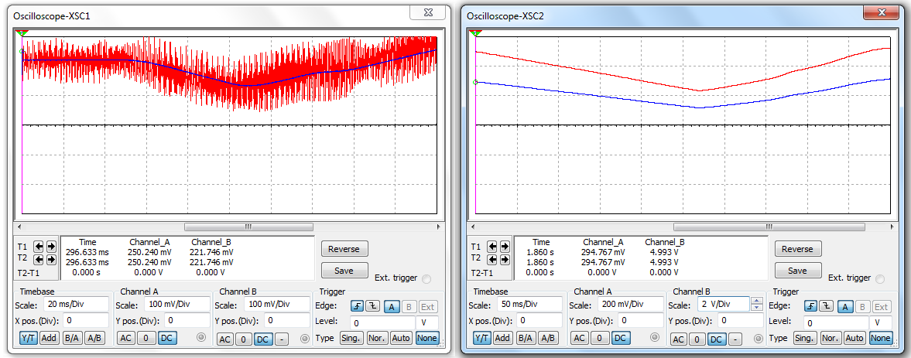
Figure 6. Adaptation circuit process; XSC1 noisy signal (red color) and
filtered signal XSC1 (blue color), XSC2 filtered signal (blue color),
adaptation circuit output XSC2 (red color)

The new voltage range will be from 0 V to 3 V, while the required range is from 2 V to 5 V, so the last step of adaptation process is addition of 2 V to the new voltage range. The mentioned process is demonstrated in oscilloscope XSC2 right side of Figure 6; blue color signal is filtered signal with range of 0.1 V to 0.3 V, while the adaptation circuit output voltage is in the range of 2 V to 5 V as shown in red color signal of oscilloscope XSC2.
Steps of pulse width modulation pulses generation for three different cases of duty cycle are explained in Figure 7.
Load voltages and powers as well as the initial voltage of adder stage of adaptation circuit at dimming level in addition to mid and full light dimming states all explained in Fig. 8. It is clearly demonstrated from this Figure 8 that the load powers have different values based on different duty cycle which originally depend on the output voltage of RF sensor.
In addition to the merits of decentralization proposal, this study provide more energy saving compared to the work of [20] through proposing analog changing of load power through unlimited levels of duty cycle.
For more comparing, the enhancement of energy saving through the analog unlimited dimming, same assumption of the 12 working hours (6:00 PM to 6:00 AM) or 12 hours of the street lighting system is adopted. The collected simulation result of rated power 60.83 W per pole lamp (DC 24.93 V) of resistive load 10 Ω is collected. The power difference between lower limit of lighting and the integration of power till full lighting of the unlimited duty cycle levels is ∆p = (full power – dimming power)/2 = (60.83 W – 23.19)/2 = 18.82 W, so the additional saving of energy through this study comparing to [20] is 18.82 W per pole load. The total additional energy saving of 12 hours equals to 18.82 x 12 = 225.84 W/h. The details of additional saving energy for different vehicle occupying rate on the street are explained in Fig. 9 which shows the quantity of additional power saving per one pole load for 12 hours working.
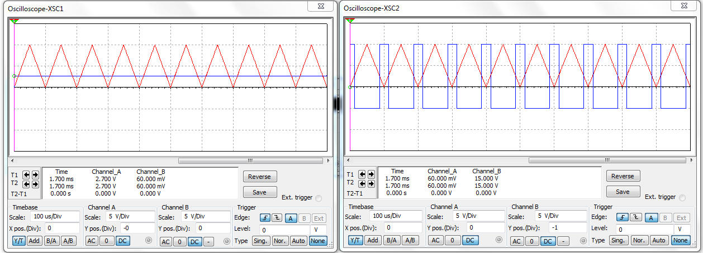
(a)
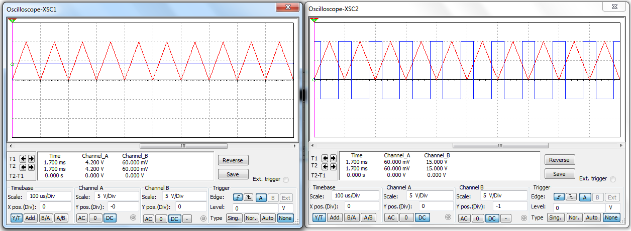
(b)
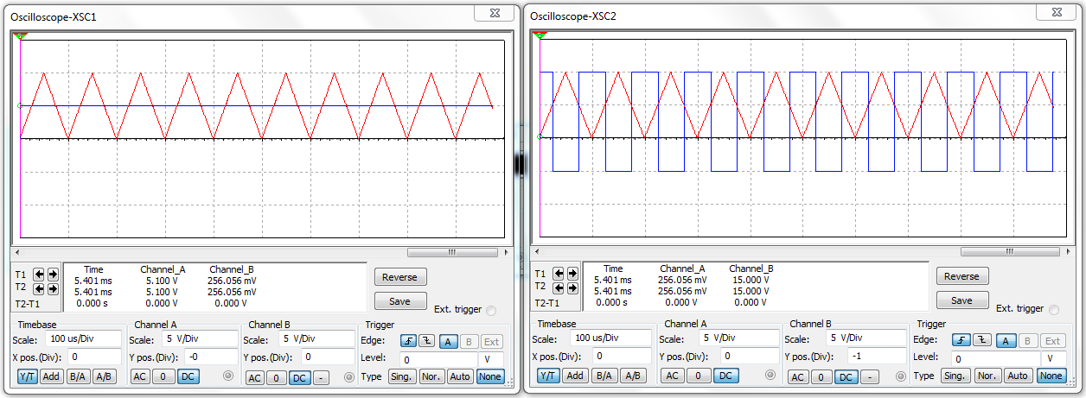
(c)
Figure 7. PWM pulses generation; (a) at dimming light state, (b) mid dimming light state, and (c) at full light state.

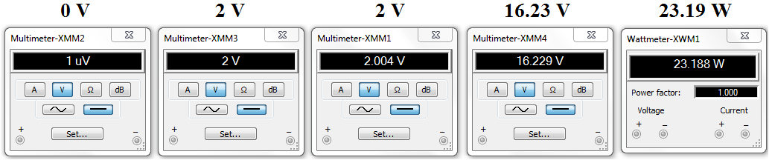
(a)
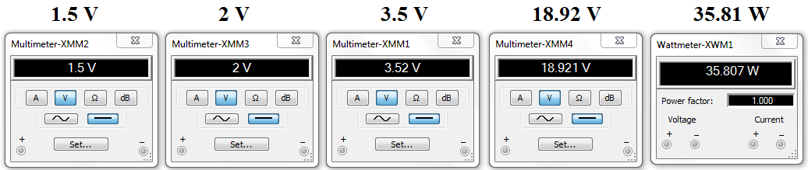
(b)
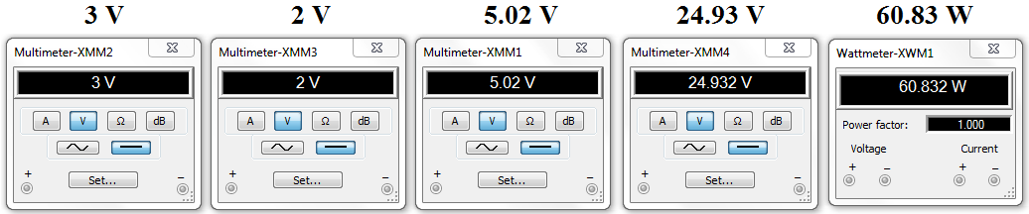
(c)
Figure 8. Simulation results; (a) dimming light state, (b) mid dimming light state
and (c) at full light state

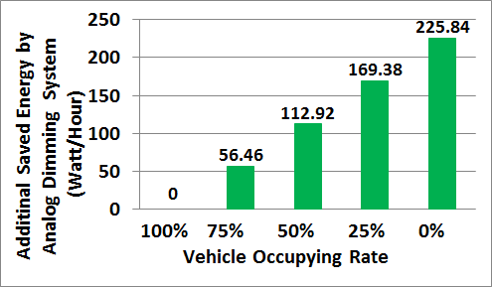
Figure 9. Quantity of additional energy saving through proposed unlimited levels dimming system

- CONCLUSION
A decentralized dimming system which has unlimited number of light levels as opposed to conventional two level systems is presented in this paper. This multilevel dimming is carried out using PWM with DC-DC converter. The work here offers an additional saving of energy by analog controlling of the duty cycle through comparing high frequency triangle carrier with the adapted DC voltage level of instantaneous output of RF sensor. In addition to the merits of decentralization of dimming circuit for each pole lamp, unlimited levels of output load voltage led to have extra saving of consumed power comparing to the two steps LED light dimming system. Simulations show that 35% more energy saving is achieved using analog multilevel dimming as compared to two stage dimming in [20]. This indicates highly effective proposed street lighting system performance and promising successful practical module.

ACKNOWLEDGEMENTS
The authors appreciate the financial support provided by school of engineering, American University of Ras Al Khaimah – UAE, www.aurak.ac.ae/en/school-of-engineering/

REFERENCES
- H. A. Attia and B. N. Getu, “Authorized Timer for Reduction of Electricity Consumption and Energy saving in Classrooms”, I JAER, Vol. 11, No. 15, (2016), pp 8436-8441.
- BN Getu, HA Attia, “Electricity Audit and Reduction of Consumption: Campus Case Study”, IJAER, Vol. 11, No. 6, (2016), pp. 4423-4427.
- M. Shahidehpour, et al., “Streetlights Are Getting Smarter: Integrating an Intelligent Communicationsand Control System to the Current Infrastructure”, IEEE power & energy magazine, may/june 2015, pp. 67-80.
- M. Magno, et al., “A Low Cost, Highly Scalable Wireless Sensor Network Solution to Achieve Smart LED Light Control for Green Buildings”, IEEE SENSORS JOURNAL, VOL. 15, NO. 5, MAY 2015, pp. 2963-2973.
- A. Farahat, et al., “Energy Efficiency Considerations for LED-Based Lighting of Multipurpose Outdoor Environments”, IEEE Journal of Emerging and Selected Topics in Power Electronics, VOL. 3, NO. 3, SEPTEMBER 2015, pp. 599-608.
- L. Xiang, et al., “Separate Dimming Controlling and Data Transmission for an Indoor Visible Light Communication System”, Communications System Design, China Communications • March 2015, pp. 71-76.
- F. Leccese, “Remote-Control System of High Efficiency and Intelligent Street Lighting Using a ZigBee Network of Devices and Sensors”, IEEE Trans. on Power Delivery, VOL. 28, NO. 1, 2013, pp. 21-28.
- Hussain A. Attia, et al., “Confined Band Variable Switching Frequency Pulse Width Modulation (CB-VSF PWM) for Single-Phase Inverter with LCL Filter”, IEEE Trans. on Power Electronic, Dec. 2016, ISSN: 0885-8993, DOI: 10.1109/TPEL.2016.2645739.
- Hussain A. Attia, et al., “Design and analysis for high performance synchronized inverter with PWM power control” Clean Energy and Technology (CEAT), 2013 IEEE Conference.
- Attia Hussain, Sagafinia Ali, “Novel Discrete Components Based Speed Controller for Induction Motor”, International Journal of Power Electronics and Drive Systems (IJPEDS), Vol. 7, Issue 4, 2016, pp. 31-38.
- W. T. Sung and J. S. Lin, “Design and Implementation of a Smart LED Lighting System Using a Self Adaptive Weighted Data Fusion Algorithm”, Sensors 2013, 13, pp. 16915-16939.
- G. V. Quesada, et al., “Comparison of Central Dimmer Systems Based on Multiple-Tapped Autotransformer and High-Frequency Switching Converter”, IEEE Trans. on Industrial Electronics, VOL. 59, NO. 4, 2012, pp. 1841-1848.
- D. Camponogara, et al., “Offline LED Driver for Street Lighting With an Optimized Cascade Structure”, IEEE Trans. on Industry Applications, VOL. 49, NO. 6, 2013, pp. 2437-2443.
- H. A. Attia, et al., “Design and Simulation of a High Performance Standalone Photovoltaic System,” ICREGA’14, Springer Proceedings in Energy 2014, pp 683-697.
- M. Arias, et al., “High-Efficiency LED Driver Without Electrolytic Capacitor for Street Lighting”, IEEE Trans. on Industry Applications, VOL. 49, NO. 1, 2013, pp. 127-137.
- H. J. Chiu, et al., “Design and Implementation of a Photovoltaic High-Intensity-Discharge Street Lighting System”, IEEE Trans. on Power Electronics, VOL. 26, NO. 12, 2011, pp. 3464- 3471.
- B. N. Getu, H. A. Attia, “Remote Controlling of Light Intensity using Phone Devices.” Accepted (April 2015) for publication in RJASET, Maxwell Science Publication.
- H. A. Attia, B. N. Getu, “Design and Simulation of Remotely Power Controller”, IJAER, 10 (12), (2015) 32609-32626.
- H. A. Attia, et al., “Experimental Validation of DTMF Decoder Electronic Circuit to be used for Remote Controlling of an Agricultural Pump System,” (EBECEGC2015), 2015, Dubai, UAE
- H. A. Attia, et al., “Design of Decentralized Street LED Light Dimming System”, presented paper in ICEDSA2016, IEEE Conference, 6-8 Dec. 2016, Ras Al Khaimah, UAE.
- C. A. Balanis, Antenna Theory: Analysis and Design. Wiley, 4th Edition, 2016.
- M. Skolnik, Introduction to Radar Systems. McGraw Hill, 3rd edition, 2002.
- A. J. Forsyth and S. V. Mollov, “Modelling and control of DC-DC converters”, POWER ENGINEERING JOURNAL 1998, pp. 229-236.
- S.-L. Liu, J. Liu, “An improved boost DC–DC converter based on intrinsic safety and its Design”, 1-4244-0549-1/06 /2006/IEEE.
- Soumya Das, et al., “Solar Photovoltaic Powered Sailing Boat Using Buck Converter”, International Journal of Power Electronics and Drive System (IJPEDS), Vol. 6, No. 1, March 2015, pp. 129~136.
- Jeevan Naik, “Design and Control for the Buck-Boost Converter Combining 1-Plus-D Converter and Synchronous Rectified Buck Converters”, International Journal of Power Electronics and Drive System (IJPEDS), Vol. 6, No. 2, June 2015, pp. 305~317.
- Dale Van Scoyk, “LED Lighting: Is It Time to Change From Fluorescent and Incandescent Lighting?” A White Paper Report on LED Lighting, Advance Control Technologies, INC, March 2010.
- European Commission, Green Public Procurement - Street Lighting and Traffic Lights - Technical Background Report, by BRE, 2011, http://ec.europa.eu/environment/gpp/pdf/tbr/street_lighting_tbr.pdf
- Graff Zivin, J. and Neidell, M., “Temperature and the allocation of time: Implications for Climate change”, NBER working paper, (w15717), 2010.
- P.N. Bierwirth, “Carbon dioxide toxicity and climate change: a serious unapprehended risk for human health”, ResearchGate DOI: 10.13140 / RG.2.2.16787.48168, 2016, http://grapevine.com.au/~pbierwirth/co2toxicity.pdf
- European Lamp Companies Federation, “Optical safety of LED lighting”, CELMA‐ELC LED WG(SM)011_ELC CELMA position paper optical safety LED lighting, July 2011, http://www.lightingeurope.org/uploads/files/CELMA-ELC_LED_WG(SM)011_ELC_CELMA_position_paper_optical_safety_LED_lighting_Final_1st_Edition_July2011.pdf
- Gioia D. Massa, et al., “Plant Productivity in Response to LED Lighting”, HORTSCIENCE vol. 43, no. (7) ,Dec. 2008.

BIBLIOGRAPHY OF AUTHORS

 | Hussain Attia earned his M.Sc. degree in electronic engineering from the University of Technology, Baghdad, in 1999. He earned his B.Sc. in electronic and communication engineering from the same university in 1991. M.Sc. Hussain’s research interests: Power Electronics System, AC & DC Speed Control Drives, Analog & Digital Electronic Circuits Design, PWM Inverters (single phase & three phases).
 | Amjad Omar is a Professor in the Department of Electrical, Electronics, and Communications Engineering at the American University of Ras Al Khaimah (AURAK). He received his Ph.D. in 1993 in Electrical Engineering/Electromagnetics from the University of Waterloo in Canada. Research and Interest: Printed antennas analysis, design, and testing; NDT for Oil & Gas, Computational electromagnetics; RF, MIC and MMIC circuit design and analysis, Biological effects of EM.
 | Dr. Maen Takruri received his PhD in Electrical Engineering from University of Technology (UTS), Sydney in 2010. He also received his BSc and MSc degrees in Electrical Engineering /Communications from the University of Jordan. In 2009, he undertook formal research commercialization training and received a Graduate Certificate in Research Commercialization from the University of Technology, Sydney. Research interest: Wireless sensor networks, Signal and image processing for biomedical applications, Data fusion, localization, target tracking and estimation, Machine learning, pattern recognition, Image and video processing, Computer and communications networks.
 | Halah Yaseen had B.Sc. in veterinary medicine and surgery from College of Veterinary Medicine – University of Baghdad, Iraq / Aug. 2003. In addition to the education academic field, Halah worked in veterinary clinic & laboratory field, particularly in the field of diagnosis, analysis, and treatments for different cases such as obstetrics, poultry diseases. Research interest: General health, Environment pollution, Infectious diseases and prevention methods, Harmful effects of industrial food.

