Firefly Analytical Hierarchy Algorithm (FAHA) for Optimal Allocation and Sizing of DG in Distribution Networks

**Noor Ropidah Bujal1,2, Aida Fazliana Abdul Kadir2, Marizan Sulaiman2,** **Sulastri Manap3, Mohamad Fani Sulaima2**

1Department of Electrical Engineering, Politeknik Sultan Haji Ahmad Shah, Pahang (POLISAS)

2Faculty of Electrical Engineering, University Teknikal Malaysia Melaka (UTeM), Malaysia

3Faculty of Electrical and Electronic Engineering Technology, Universiti Malaysia Pahang, Malaysia

|  |  |  |
| --- | --- | --- |
| **Article Info** |  | **ABSTRACT** |
| ***Article history:***  Received mm dd, yyyy  Revised mm dd, yyyy  Accepted mm dd, yyyy |  | Distributed Generation (DG) can be beneficially allocated in distribution power systems to minimize power loss, grid support and improve the voltage of buses and the system's efficiency. However, erroneous DG's allocation and sizing may cause more complex power loss and voltage profile issues for distribution feeders. Therefore, optimization algorithms are vital for future intelligent power distribution network planning. Hence, this study proposes a multi-objective Firefly Analytical Hierarchy Algorithm (FAHA) for determining the optimal allocation and sizing of DG. The multi-objective function formulation is improved further by integrating Analytical Hierarchy Process (AHP) with FA to obtain the weight of the coefficient factor. The performance of the proposed approach is verified on the 118-bus radial distribution network with different DG location bus voltage (VDG) settings as regulated PV-bus during load flow calculations. The calculated coefficient factors and impact of the unregulated voltage at the voltage-control bus (PV-bus) on the objectives function have been analysed. The findings show that the proposed techniques could allocate the DG at the most voltage deviation while minimizing the power loss and improving the radial distribution system's Voltage Stability Index (VSI). The experimental results indicate that the approach is able to improve the overall voltage profile, especially at PQ-buses. In addition, it is able to simultaneously minimize the voltage deviation and power loss while improving the network's stability index. |
| ***Keywords:***  Distribution Generation  Meta-heuristic techniques  Firefly Algorithm  Loss minimisation  Optimal placement and sizing  AHP |
| *This is an open access article under the* [*CC BY-SA*](https://creativecommons.org/licenses/by-sa/4.0/) *license.* |
| ***Corresponding Author:***  Aida Fazliana Abdul Kadir Faculty of Electrical Engineering, University Teknikal Malaysia Melaka (UTeM),  Hang Tuah Jaya, 76100 Durian Tunggal, Melaka, Malaysia. Email: fazliana@utem.edu.my | | |

1. **INTRODUCTION**

Distributed generation is a technology of generating a small amount of electrical energy close to the load centre [1], [2]. DG can be a standalone facility for residential and commercial use or part of a microgrid [3], [4]. Industrial facilities, military bases, power supply, and huge colleges are potential locations to use DG. In other words, "electricity production within distribution networks or on the consumer side of the network" could be referred to as DG [5]. Solar energy, wind power, biomass, and solar thermal systems are among Malaysia's renewable energy sources that can be incorporated in the DG implementation [6]. An increase in power loss, an unbalanced power system, and rising operating costs are some of the effects due to poorly located DG units with the wrong size selection [7]–[9]. Hence, it is extremely important for the appropriate placement and optimal DGs to be investigated and analysed [10], [11]. As several factors must be considered when optimizing this particular problem, the multi-objective formulation has been studied for optimally allocating and sizing the DG. In relation to this study, previous researchers proposed numerous methods to solve multi-objective formulation associated with optimization methods such as Pareto-front, weight-sum method and other multi-criteria decision approaches, including Analytical Hierarchy Process (AHP) [12]–[14].

TL Saaty created the AHP Model in the 1970s as a complex decision-making tool [14]. This model is based on the idea that when confronted with a difficult decision, the natural human tendency is to group the decision parts based on similar features. It involves developing a decision-making hierarchy and comparing each possible combination in each cluster as a matrix while Each element within a hierarchy cluster is given weight in these steps. In the meantime, the consistency of ratio is used to assess the reliability of data while the steps to calculate the weights in AHP were discussed by the authors in [14]. Another study in [15] solves the multi-objective problem using AHP for order preferences by similarity to an ideal solution for power generation system optimization. TL Saaty [14], also proposed the AHP for prime power system PMU monitoring as a combinatorial way for monitoring the prime power system components. On the other hand, the authors in [16] integrated the weighted-sum approach with AHP in order to solves the optimization problem with the idea of, the AHP optimising the objective function weights. Meanwhile, the research work in [17] applied AHP to calculate the resiliency scores to enhance strategy in distributed energy resources and automated switches. Srikanth [18] states that AHP is used for the optimised tuning in the algorithm proposed where the weights of alternatives used and selected were based on the AHP.

Numerous techniques were proposed for locating the optimal solution in the problem set this study is trying to solve and meta-heuristic techniques are one of the techniques widely used due to its promising results. The Firefly Algorithm (FA) is a well-known optimization algorithm invented by Xin-She Yang (2013) which takes inspiration from the flashing behaviours of a group of fireflies that used the bioluminescent communication method for interaction. The methodology of FA can be found in [19] and [20]. More importantly, authors in [8] and used various optimization techniques to investigate the optimal size as well as the placement of the distributed generators in the grid and they found that FA to be able to locate good to optimal solutions with minimum fitness and standard deviation but the major drawback was that the computational time of the algorithm is extremely high [21]. The authors in [22] supports the claim where the experiments conducted also indicated that the results obtained by FA provide superior results when compared against other algorithms [22].

This study focuses on incorporating AHP for automatic calculation of coefficient factor based on three (3) objective functions into the FA where the proposed algorithm is called the Firefly analytical hierarchy algorithm (FAHA). The main aim of this approach is to minimize the objective function which are voltage deviation (VDEV), power loss (Ploss) and maximises the stability index (*SI*) in the distribution system. One of the major contributions of this study is that the AHP is modified based on load flow optimal output to obtain the objective function's weight or coefficient factors (*w1*=VDEV, *w2*=Ploss, *w3*=*SI*). The methodology is then tested in a 118-bus radial distribution network for optimal DG allocation and sizing [23]. Authors in [23], [24] stated that any bus that attaches to megawatt generation can control its voltage magnitude and usually have regulated voltage between 1.0 p.u -1.05 p.u. Therefore, the location of DG becomes a voltage-controlled or also known as PV bus. However, a few authors in [25]–[27] varies the bus voltage and did not regulate bus voltage at the proposed DG location during the optimization process. Therefore, by referring to that reference, the bus chosen by the algorithm to allocate the DG will be considered as a voltage-control bus (PV-bus) of the load flow. The DG provides active power and controls the voltage at the DG location. Thus, this study will analyse the performance of the proposed technique based on three (3) VDG settings: varying VDG (VDG =VBUS), VDG regulated to 1.0 p.u, and 1.05 followed with the optimization process. Then, the power loss reduction along with the voltage profile improvement will be analysed. The algorithm is developed and simulated using MATLAB application software.

1. **PROBLEM FORMULATION**

This study expressed the problem formulation as a multi-objective optimization technique for DG allocation and sizing in a distribution network. This study’s vital intention is to reduce the power loss, minimize voltage deviation while at the same time maximise the stability index (SI) with variation setting of voltage at the proposed DG location. All the objective functions are based on load flow results [28]. The fitness function within the system may be expressed via:

$f_{min}=w1\left(V_{Dev}\right)+w2\left(P_{loss}\right)+w3\left(\frac{1}{SI}\right)$ (1)

Where $f,$ is the fitness function, V*Dev* represents the voltage deviation, and Ploss is the normalized value of total power loss. The $1/SI$ is for SI maximization. While the *w1* is the coefficient factor for voltage deviation, *w2* is the power loss coefficient factor, and lastly, the coefficient factor for *SI* is represented by *w3* ( $w1+w2+w3=1.0).$ The real power loss is expressed by [29].

$P_{\text{loss}}=\sum_{i=1}^{n}{ }P_{{loss}_{i}} i=1,2,3…n$ (2)

where *n,* is the number of lines. On the other hand, the voltage deviation (VDev) is the difference in measured voltage from the nominal value for each bus [20] where smaller VDev indicates better network conditions. The voltage deviation is defined by:

$V_{Dev}=V_{iref}-V_{i }$ (3)

V*iref* is a reference voltage (V*iref*=1.0) at the bus, and V*i* is the actual voltage at the bus. The stability index (*SI*) [30], [31] is defined by:

$SI_{r}=2V_{s}^{2}V_{r}^{2}-V_{r}^{4}-2V_{r}^{2}(PR+QX)-|Z|^{2}\left(P^{2}+Q^{2}\right)$ (4)

The transmission and receiving end voltages are denoted by Vs and Vr, respectively. Line impedance is Z, line resistance is R, and line reactance is X. The active power at the receiving end is denoted by P, whereas the reactive power is represented by Q. The load flow constraints are the real power and reactive power flow for equality constraint[6]. On the other hand, inequality constraints are given in (5), (6).

*Power Generation Limit* [32]: $P_{{DG}_{min} }≤ P_{DG}≤P_{{DG}_{max}}$ (5)

*Bus Voltage Limit* [33]: $\left|V_{i}^{min}\right|≤\left|V_{i}\right|≤\left|V_{i}^{max}\right|$ (6)

Where $\left|V_{i}^{min}\right| and \left|V_{i}^{max}\right|$ are the lower boundary and upper boundary of the bus's voltage and $\left|V_{i}\right|$ is the value of bus voltage, *i*th.

1. **PROPOSED ALGORITHM**

In this study, the FA is integrated with AHP (FAHA) to determine the optimum allocation and sizing of DG in the distribution network. The multi-objective optimization process was simulated based on 20 populations, 200 iterations, and 20 independent trials. The load flow calculation using MATPOWER is applied to this algorithm to obtain the objective functions such as the power loss, voltage deviation, and the stability index. The proposed algorithm automatically calculates the coefficient factors for each objective function and uses them to determine the minimum fitness. Then, the objective function with the minimum fitness solution is considered as the optimal solution.

* 1. **Firefly Analytical Hierarchy Algorithm (FAHA)**

Analytical Hierarchy Process (AHP) is used for multi-criteria decision techniques to rank the criteria involved in the selection process. In this research, the AHP was modified and incorporated into Firefly Algorithm (FA) to identify the weight of coefficient factor (CF) of each objective function (criteria) involved in the optimization process. Therefore, the incorporation process is shown in Figure 1.



Figure 1. Incorporation of AHP into FA for optimal allocation and sizing of DG

The procedure in calculating the weight coefficients as per indicated below [34]:

Step 1: Problem is classified while knowledge required is determined.

Step 2: The level of the decision making hierarchy consisting the objective, criterion and sub-criterion is constructed.

Step 3: Data is collected from the results of load flow analysis based upon the results of relevant statistical test performed using the criterion in the form of numerical scale (refer table below).

Step 4: Several criteria are compared in order to find the significance difference from the main eigenvalue and its equivalent normalized eigenvector from the comparison matrix. Then, the normalized eigenvector will be proposed as the weights to the criterion and the sub-criterion.

Step 5: Assessment of the consistency index (CI) of the decision matrix is conducted because this particular index must not exceed the permissible range or else the test must be repeated.

*CI= $\frac{\left(λ_{max}-n\right)}{n-1}$* (7)

where *n* represents the criterion considered in the decision-making and ${ λ}_{max}$ denotes the judgment matrix's maximum eigenvalue. Next, in order to determine the consistency ratio (CR), the confidence interval (CI) is divided by the random confidence interval (RCI) (shown in Table 1). The consistency ratio (CR) is a ratio used to measure the consistency of the weight obtained from the AHP calculation. The CI is comparable to the RCI. CR is calculated as

*CR= $\frac{\left(CI\right)}{RCI}$* (8)

The value of the ratio above must not exceed 0.10 or else the objective judgments have to be revised.

Table 1. Consistency Indices

|  |  |  |  |  |
| --- | --- | --- | --- | --- |
| Number of criteria | 3 | 4 | 5 | 6 |
| Random constancy index (RCI) | 0.58 | 0.9 | 1.12 | 1.24 |

After obtaining the weight factors of w1, w2 and w3 from AHP calculations, all the CF will be used in the objective function calculation by each and every firefly in every iteration shown in Equation (‎2.1). Then, the optimal solution for DG location and sizing is determined by comparing all the fitness solutions found where the minimum solution is chosen as the optimal solution. The performance of the presented technique in this paper is verified using the IEEE 118-bus radial distribution network and referred to in [35]. Figure 2 shows that the cumulative real and reactive power demand of the 118-bus radial test system are 22.71MW and 17.04MVAr respectively while also producing minimum bus voltage of 0.8688 p.u. An in-depth explanation of FAHA is illustrated in Figure 3.

Figure 2. IEEE 118-bus distribution network system

* 1. **Initial Presumption of the Distributed Generators**

The data from the IEEE radial network were used to demonstrate the usability and the performance of the algorithm for determining the optimal location and size of DG with different VDG settings. The initial presumptions applied in this study are as follows:

* Bus voltage boundary: 0.90 p.u ≤ V≤ 1.05 p.u
* The limit of the DGs' power generation: 0.5 MW ≤ PDG ≤ 4MW
* The simulation is implemented based on the unregulated VDG (VDG= VBUS) and regulated VDG (VDG=1.0 p.u to VDG=1.05 p.u).
* The financial cost is not taken into account in this simulation.
* The DG type-1 is used: only active power is injected because it is more prevalent in the region of receiving constant sunshine annually [36].
* The number of DG units is added consecutively to achieve the target voltage profile within +-5% of the voltage regulation (0.95 p.u to 1.05 p.u).



Figure 3. Flow Chart of FAHA

1. **RESULTS AND DISCUSSION**

The proposed meta-heuristic technique is implemented, analysed and verified on a 118-bus network. The overall load of the system is regarded as a snapshot load where 22.71MW, 17.04 MVar are the total real power of the base configuration with 1.2981MW as the real power loss value for the total connected load (TCL). The stopping criterion for the FAHA algorithm is set as 200 iteration and the population size = 20. Bus 1 is set as the supply source for the system which is also known as the slack bus or reference bus generally powered by a single source and has a fixed voltage of 1.0p.u. The single-line diagram of the system is illustrated in Figure 2 [35].The obtained results from the simulation of all VDG settings were the fitness function, reduction in the power loss and the voltage deviation as well as the stability index at different settings. Figure 4 illustrates the convergence characteristic of FAHA based on 20 trials for VDG = 1.0 and VDG = 1.05 with 3DG as an example tested on the 118-bus network. As can be seen from the convergence curves, VDG=1.0 has the overall best fitness solution when compared against VDG=VBUS and VDG=1.05 based on the voltage deviation, power loss and stability index.

Figure. 4. Convergence Characteristic FAHA for 3 DG in the 118-bus network.

Table 2 displays the base case (without DG) results for power loss, minimum bus voltage and minimum stability index in the network. The coefficient factor of each objective function for different VDG settings has been calculated using FAHA and is shown in Table 3. These weights will be used in fitness calculation for the optimization process.

Table 2. The base case for power loss, minimum bus voltage and minimum stability index

|  |  |  |  |  |
| --- | --- | --- | --- | --- |
| Number of DG | PV-bus  (VDG) | Power Loss (MW) | Minimum bus voltage (Vp.u) | SI |
| 0 | Not Set | 1.2981 | 0.8688 | 0.5699 |

Table 3. The coefficient factors (weight) using FAHA for fitness calculation

| VDG setting  (PV-bus) | DG | *w1*  (VDev) | *w2*  (Ploss) | *w3*  (SI) |
| --- | --- | --- | --- | --- |
| VDG = VBUS  (Unregulated VDG) | 1 | 0.3074 | 0.3335 | 0.3591 |
| 2 | 0.3224 | 0.2899 | 0.3876 |
| 3 | 0.2172 | 0.3388 | 0.4440 |
| 4 | 0.2139 | 0.32549 | 0.4607 |
| VDG = 1.0 | 1 | 0.3174 | 0.3117 | 0.3709 |
| 2 | 0.3502 | 0.2288 | 0.4210 |
| 3 | 0.2382 | 0.2252 | 0.5365 |
| 4 | 0.2402 | 0.2041 | 0.5557 |
| VDG = 1.02 | 1 | 0.3159 | 0.3150 | 0.3691 |
| 2 | 0.3458 | 0.2385 | 0.4157 |
| 3 | 0.2256 | 0.2485 | 0.5259 |
| 4 | 0.2224 | 0.2367 | 0.5409 |
| VDG = 1.03 | 1 | 0.3159 | 0.3150 | 0.3691 |
| 2 | 0.3458 | 0.2385 | 0.4157 |
| 3 | 0.2256 | 0.2485 | 0.5259 |
| 4 | 0.2224 | 0.2367 | 0.5409 |
| VDG = 1.04 | 1 | 0.3124 | 0.3227 | 0.3649 |
| 2 | 0.3339 | 0.2647 | 0.4014 |
| 3 | 0.2212 | 0.2982 | 0.4806 |
| 4 | 0.2242 | 0.2887 | 0.4871 |
| VDG = 1.05 | 1 | 0.3100 | 0.3278 | 0.3622 |
| 2 | 0.3232 | 0.2883 | 0.3885 |
| 3 | 0.2448 | 0.3306 | 0.4245 |
| 4 | 0.2501 | 0.3161 | 0.4338 |

By referring to Table 3, the results show the weights of each objective function obtained from AHP. The weight of VDEV is represented by w1 while w2 is the weight for Ploss and w3 is the weight that represents SI. It can be seen from the table that SI gives the most significant weight from AHP calculation for 1 DG, 2 DG and 3DG, followed by power loss and voltage deviation. Out of the three objective functions, the most significant weight indicates the most important objective among the three (3) objectives. The weights were also verified by calculating the consistency ratio obtained less than 0.1. The proposed DG location, size and minimum fitness obtained from the optimisation process are shown in Table 4. As can be seen in these results, the proposed DG location and the DG size that can minimize the fitness function were obtained from the optimisation process. The location that the algorithm had chosen were the buses with low bus voltage and had significant voltage deviation. So, when the DG power is injected into those buses, the voltage that particular buses and nearby will increase.

Table 4. The best fitness value and optimization results of the different VDG settings and the DG number

|  |  |  |  |  |  |
| --- | --- | --- | --- | --- | --- |
| VDG setting  (PV-bus) | DG | | DG Location | DG Size (MW) | Fitness |
| VDG = VBUS | 1 | 71 | | 2.9785 | 0.7860 |
| 2 | 109, 71 | | 3.1199, 2.9785 | 0.7238 |
| 3 | 50, 71, 109 | | 3.0347,3.5058, 3.1201 | 0.5510 |
| 4 | 50, 72, 96, 109 | | 3.2213, 2.6297,1.8208, 3.1217 | 0.5322 |
| VDG = 1.0 | 1 | 71 | | 2.9986 | 0.7628 |
| 2 | 110, 71 | | 2.8736, 2.9986 | 0.6939 |
| 3 | 70, 48, 110 | | 2.8411, 3.2632, 2.8736 | 0.4920 |
| 4 | 82, 110, 72, 33 | | 1.7923, 2.8815, 2.7197, 4 | 0.4879 |
| VDG = 1.02 | 1 | 71 | | 3.6023 | 0.7660 |
| 2 | 110, 71 | | 3.6720, 3.6023 | 0.6968 |
| 3 | 110, 71, 47 | | 3.6720, 3.6023, 4 | 0.4910 |
| 4 | 50, 70, 42, 110 | | 3.5259, 3.3052, 1.9629, 3.6720 | 0.4846 |
| VDG = 1.03 | 1 | 71 | | 2.9986 | 0.7628 |
| 2 | 110, 72 | | 4, 3.7154 | 0.7008 |
| 3 | 72, 110, 50 | | 3.7154, 4,4 | 0.4953 |
| 4 | 110, 43, 71, 50 | | 4, 2.0172, 3.6945, 3.9046 | 0.4891 |
| VDG =1.04 | 1 | 74 | | 3.6603 | 0.7739 |
| 2 | 111, 74 | | 4, 3.6603 | 0.7080 |
| 3 | 111, 50, 74 | | 4, 4, 3.6603 | 0.5083 |
| 4 | 50, 99, 74, 111 | | 4, 2.8225, 3.2934, 4 | 0.5043 |
| VDG =1.05 | 1 | 74 | | 3.9243 | 0.7794 |
| 2 | 113, 74 | | 4, 3.9243 | 0.7226 |
| 3 | 113, 50, 74 | | 4, 4, 3.9243 | 0.5440 |
| 4 | 50, 74, 112, 111 | | 4, 3.9244, 2.2514, 2.5348 | 0.5342 |

Table 5 shows the impact of DG on bus voltage, power loss and stability index for unregulated and regulated VDG by using FAHA. From the results, the DG allocation and sizing have proven to be able to reduce power losses. At PV-bus, P was generated and regulates the voltage. The line current will reduce when the voltage increases at the particular bus (DG location). Therefore, the power loss is also reduced due to I2R losses. In general, regulated PV-buses produce smaller loss reduction compared to unregulated busses (VDG = VBUS). The results show that the loss reduction percentage decrease with the increasing value of VDG. VDG regulated to 1.0 p.u to 1.03 p.u give 37% to 41% loss reduction compared to 48% at unregulated VDG. On the other hand, VDG equal to 1.04 p.u to 1.05 p.u gives a smaller loss reduction, whereas the VDG =1.05 p.u gives almost the same loss reduction as unregulated VDG. VDG =1.05 shows that the loss is higher due to the high current in the line. indicates that VDG = 1.05p.u is too large for radial distribution system. However, the power loss is still less than without any DG and notice that the 3DG is sufficient to reduce power loss at maximum value for these VDG settings. Overall, RDS regulated voltage from 1.0 p.u to 1.03 p.u produces a greater percentage loss. Normally, the power loss is calculated by I2R. However, as the voltage magnitude increase (VDG=1. 05 p.u), the loss percentage become greater and can be determined using V2/R.

Table 5. DG impact on bus voltage, power loss and stability index for unregulated and regulated VDG using FAHA on 118-bus system

|  |  |  |  |  |  |  |
| --- | --- | --- | --- | --- | --- | --- |
| VDG setting  (PV-bus) | DG | Minimum Vbus  (p.u) | Maximum Vbus  (p.u) | Loss  (MW) | Loss  reduction (%) | Minimum  SI |
| Without DG | 0 | 0.8688 | 0.9963 | 1.2981 | 21.67 | 0.5699 |
| VDG = VBUS | 1 | 0.9053 | 0.9971 | 1.0168 | 21.7 | 0.6758 |
| 2 | 0.9095 | 0.9980 | 0.8052 | 38.0 | 0.6872 |
| 3 | 0.90563 | 0.9980 | 0.6748 | 48.0 | 0.8365 |
| 4 | **0.9589** | 0.9980 | 0.6179 | 52.4 | **0.8458** |
| VDG = 1.0 | 1 | 0.9053 | 0.9982 | 0.9200 | 29.1 | 0.6758 |
| 2 | 0.9095 | 0.9992 | 0.5852 | 54.9 | 0.6872 |
| 3 | **0.9611** | 0.9992 | 0.3638 | 72.0 | **0.8535** |
| 4 | 0.9623 | 0.9994 | 0.3167 | 75.6 | 0.8578 |
| VDG = 1.02 | 1 | 0.9342 | 0.9053 | 0.9342 | 28.0 | 1.0172 |
| 2 | 0.6177 | 0.9095 | 0.6177 | 52.4 | 1.0192 |
| 3 | 0.4069 | 0.9627 | 0.4069 | 68.7 | 1.0192 |
| 4 | 0.3741 | 0.9645 | 0.3741 | 71.2 | 1.0192 |
| VDG = 1.03 | 1 | 0.9496 | 0.9053 | 0.9342 | 28.0 | 1.0263 |
| 2 | 0.6547 | 0.9095 | 0.6177 | 52.4 | 1.0292 |
| 3 | **0.4480** | **0.9626** | 0.4069 | 68.7 | **1.0292** |
| 4 | 0.4330 | 0.9647 | 0.3741 | 71.2 | 1.0296 |
| VDG = 1.04 | 1 | 0.9682 | 0.9053 | 0.9682 | 25.4 | 1.0393 |
| 2 | 0.7100 | 0.9095 | 0.7100 | 45.3 | 1.0393 |
| 3 | 0.5334 | 0.9631 | 0.5334 | 58.9 | 1.0393 |
| 4 | 0.5096 | 0.9631 | 0.5096 | 60.7 | 1.0393 |
| VDG =1.05 | 1 | 0.9909 | 0.9053 | 0.9909 | 23.7 | 1.0493 |
| 2 | 0.7987 | 0.9095 | 0.7987 | 38.5 | 1.0493 |
| 3 | 0.6681 | 0.9636 | 0.6681 | 48.5 | 1.0493 |
| 4 | 0.6252 | 0.9636 | 0.6252 | 51.8 | 1.0499 |

Table 5 also shows the minimum bus voltage, maximum bus voltage and stability index within the network. The results showed that voltage magnitude for PQ-buses are well within 0.95 p.u to 1.05 p.u (± 5%) for the minimum number of DG (1 DG). In general, the minimum bus voltage and stability index in the network after DG installation had been improved with unregulated VDG. The minimum bus voltage improved from 0.8688p.u to voltage between 0.9053p.u and 0.9589 p.u. For VDG = 1.0, the minimum bus voltage improved and achieved 0.95 p.u after 3DG and 4DG installation. VDG = 1.05 also shows the minimum bus voltage increase until 0.9623p.u (4DG). For the SI value, the minimum SI in the network increased significantly with the number of DG. While regulated VDG has much better SI than unregulated VDG and without DG. Moreover, the results highlight that 3 DG is enough for this network to achieve a standard voltage regulation of ± 5% between 0.95 to 1.05 for the PQ (load) buses and SI of minimum, 0.85.

Figure 5 illustrates shows the comparison of voltage profiles without DG, unregulated VDG and regulated VDG of a 118-bus network. As shown in the figures, voltage profiles without DG were low, with all bus voltages below 0.95 p.u. When the voltage is low, the current in the line will increase and cause more power losses. Thus, when the DG is installed at the proposed location, which is the bus with a lower voltage, it will inject active power (P) to the bus and increase the bus voltage. Consequently, the voltage profile will be improved. Figure 5(a) shows that the 1 DG allocated to the lower bus in the network can improve the voltage profile which increased from 0.8688 p.u at the lowest bus (without DG) up to 0.9546 p.u, 1.0 p.u and 1.05p.u after DG was optimally installed based on the implementation of FAHA .This is further validated in Figure 5(b) which shows that the improvement made in the optimally placed and sized 2DG setup were even more significant.. In addition, Figure 5(c) and 5(d) both show the voltage profiles after the installation of 3DG and 4DG in the network. It can be seen that installing both 3 DG or 4 DG can improve all the buses within the network to achieve the standard voltage regulation, which is ± 5%. Therefore, installing 3DG is adequate to reduce optimal allocation and sizing of DG in the selected network. For unregulated VDG, the voltage profiles were lower than regulated VDG, and there are still many buses lower than 1.0 p.u. When VDG is regulated from 1.0 p.u to 1.05p.u, the voltage at particular buses increases better than unregulated VDG. For higher regulated VDG, there were many buses increases between 1.02 to 1.05 p.u. When VDG = 1.04 p.u, the bus voltage reaches almost the maximum value and the maximum bus voltage at VDG = 1.05 p.u is too high for a radial network. However, the required bus voltage is only around 1.0 p.u. Therefore, it is proposed that only VDG equal to 1.0 p.u to 1.03 p.u are suitable for the radial distribution network.

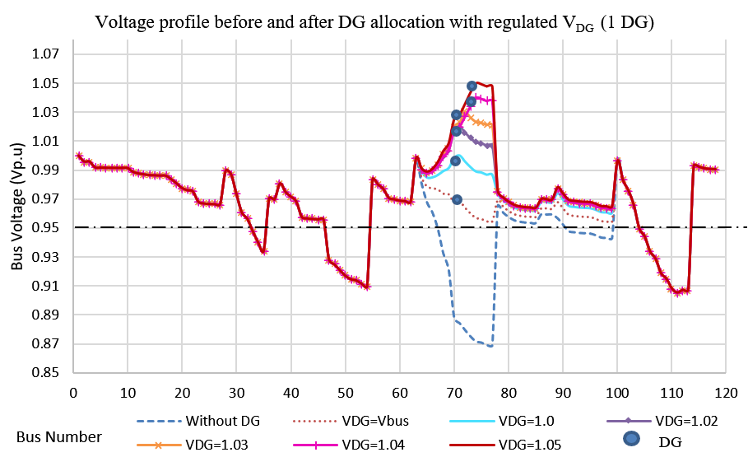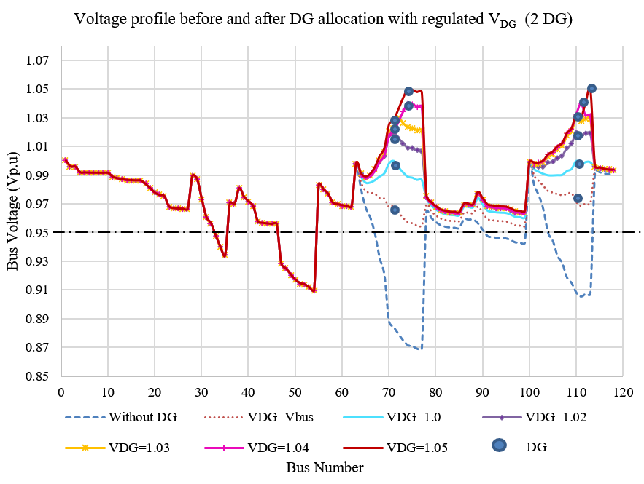

(a) (b)

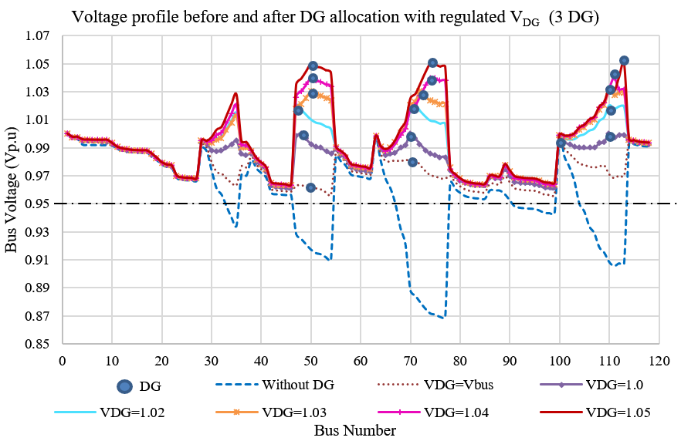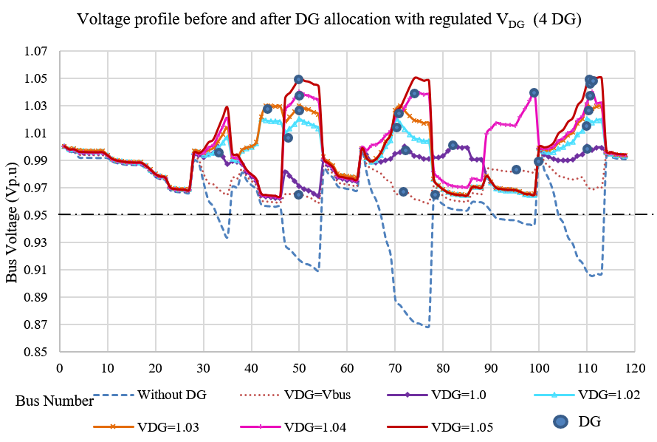

(c) (d)

Figure 5. Voltage profile before and after (a) 1DG (b) 2DG (c) 3DG and (d) 4DG installation for different VDG settings on the 118-bus network

1. **CONCLUSION**

This study proposed a novel meta-heuristic technique for determining the appropriate allocation and the capacity of the DG units in the distribution network by implementing the FAHA by considering the multi-objective function approach. The AHP was integrated with FA to automatically or systematically calculate each objective function's accurate weight (coefficient factor) for obtaining the optimal fitness solution. This technique analyses the impact of different VDG settings (regulated PV-bus) at the proposed DG location and size based on minimizing voltage deviation, power loss and improving stability index. In summary, the results yielded that the FAHA is effective for optimal allocation and sizing of DG to achieve overall minimum voltage deviation and power loss. At the same time, it improves the stability index in the network. This novel study also proved that the regulated VDG from 1.0 p.u to 1.03 p.u with a minimum of 3 DG with sizes of 3.7154 MW, 4MW and 4MW would produce a percentage of losses of 65 %. In addition, the minimum bus voltage profile of within 0.95 to 1.05 and the SI is 0.85 as a minimum. Based on these findings, the regulated VDG provided better optimisation performance than the unregulated VDG and also improved the power loss, VDev and SI of the radial distribution network.

**ACKNOWLEDGEMENTS**

The authors would like to acknowledge the FRGS grant given by the Ministry of Higher Education, (FRGS/1/2020/TK0/UTEM/02/66) through which the financial support is received for this research project. The authors also would like to thank to Universiti Teknikal Malaysia Melaka for their endless support from the beginning of this study.

**REFERENCES**

[1] F. D. A. Kahar, I. Musirin, M. F. M. Nazer, S. Jelani, and M. H. Mansor, “Index-based transmission for distributed generation in voltage stability and loss control incorporating optimization technique,” *IAES Int. J. Artif. Intell.*, vol. 9, no. 2, pp. 244–251, Jun. 2020, doi: 10.11591/ijai.v9.i2.pp244-251.

[2] M. S. Atabaki and V. Aryanpur, “Multi-objective optimization for sustainable development of the power sector: An economic, environmental, and social analysis of Iran,” *Energy*, vol. 161, pp. 493–507, 2018, doi: 10.1016/j.energy.2018.07.149.

[3] A. Kumar, P. Vijay Babu, and V. V. S. N. Murty, “Distributed Generators Allocation in Radial Distribution Systems with Load Growth using Loss Sensitivity Approach,” *J. Inst. Eng. Ser. B*, vol. 98, no. 3, pp. 275–287, 2017, doi: 10.1007/s40031-016-0242-8.

[4] T. T. Nguyen and D. T. Long, “Network reconfiguration for minimizing power loss by moth swarm algorithm,” *Int. J. Adv. Comput. Sci. Appl.*, vol. 11, no. 7, pp. 33–39, 2020, doi: 10.14569/IJACSA.2020.0110705.

[5] T. Ackermann, G. Ran Andersson, and L. Sö Der, “Distributed generation: a definition,” *Electr. Power Syst. Res.*, vol. 57, pp. 195–204, 2001, doi: 10.1016/S0378-7796(01)00101-8.

[6] A. F. A. Kadir, M. Fani, N. Ropidah, M. Nazri, and E. Erwani, “Analysis of Load Variation Consideration for Optimal Distributed Generation Placement,” *Int. J. Adv. Comput. Sci. Appl.*, vol. 12, no. 4, pp. 366–372, 2021, doi: 10.14569/IJACSA.2021.0120446.

[7] M. Azam Muhammad, H. Mokhlis, K. Naidu, A. Amin, J. Fredy Franco, and M. Othman, “Distribution Network Planning Enhancement via Network Reconfiguration and DG Integration Using Dataset Approach and Water Cycle Algorithm,” *J. Mod. Power Syst. Clean Energy*, vol. 8, no. 1, pp. 86–93, 2020, doi: 10.35833/mpce.2018.000503.

[8] G. Deb, K. Chakraborty, and S. Deb, “Modified Spider Monkey Optimization-Based Optimal Placement of Distributed Generators in Radial Distribution System for Voltage Security Improvement,” *Electr. Power Components Syst.*, vol. 48, no. 9–10, pp. 1006–1020, 2020, doi: 10.1080/15325008.2020.1829186.

[9] N. Eltawil, M. Shamshiri, M. Sulaiman, Z. Bin Ibrahim, and N. Ropidah, “Improvement of bus voltages and line losses in power system network through the placement of capacitor and DG using PSO,” *ARPN J. Eng. Appl. Sci.*, vol. 13, no. 24, pp. 9568–9578, 2018.

[10] S. Settoul, R. Chenni, M. Zellagui, and H. Nouri, “Optimal Integration of Renewable Distributed Generation Using the Whale Optimization Algorithm for Techno-Economic Analysis,” in *Lecture Notes in Electrical Engineering*, no. October, Springer Singapore, 2021, pp. 513–532.

[11] A. Shuaibu Hassan, Y. Sun, and Z. Wang, “Optimization techniques applied for optimal planning and integration of renewable energy sources based on distributed generation: Recent trends,” *Cogent Eng.*, vol. 7, no. 1, 2020, doi: 10.1080/23311916.2020.1766394.

[12] C. A. Coello Coello, “Multi-objective optimization,” in *Handbook of Heuristics*, 2018.

[13] J. B. F. Islam, M. T. Rahman, H. Mokhlis, M. Othman, T. F. Tengku Mohmed Noor Izam, and H. Mohamad, “Combined analytic hierarchy process and binary particle swarm optimization for multiobjective plug-in electric vehicles charging coordination with time-of-use tariff,” *Turkish J. Electr. Eng. Comput. Sci.*, vol. 28, no. 3, pp. 1314–1330, 2020, doi: 10.3906/elk-1907-189.

[14] T. L. Saaty, “How to make a decision: The analytic hierarchy process,” *Eur. J. Oper. Res.*, vol. 48, no. 1, pp. 9–26, 1990, doi: 10.1016/0377-2217(90)90057-I.

[15] P. Mojaver, S. Khalilarya, A. Chitsaz, and M. Assadi, “Multi-objective optimization of a power generation system based SOFC using Taguchi/AHP/TOPSIS triple method,” *Sustain. Energy Technol. Assessments*, vol. 38, 2020, doi: 10.1016/j.seta.2020.100674.

[16] B. Kiran Babu and S. Maheswarapu, “New hybrid multiverse optimisation approach for optimal accommodation of DGs in power distribution networks,” *IET Gener. Transm. Distrib.*, vol. 13, no. 13, pp. 2673–2685, 2019, doi: 10.1049/iet-gtd.2018.5763.

[17] I. Diahovchenko, G. Kandaperumal, and A. Srivastava, “Distribution Power System Resiliency Improvement Using Distributed Generation and Automated Switching,” *2019 IEEE 6th Int. Conf. Energy Smart Syst. ESS 2019 - Proc.*, vol. 1, pp. 126–131, 2019, doi: 10.1109/ESS.2019.8764185.

[18] M. V. Srikanth and N. Yadaiah, “An AHP based optimized tuning of Modified Active Disturbance Rejection Control: An application to power system load frequency control problem,” *ISA Trans.*, vol. 81, pp. 286–305, 2018, doi: 10.1016/j.isatra.2018.07.001.

[19] X. S. Yang and X. He, “Firefly algorithm: recent advances and applications,” *Int. J. Swarm Intell.*, vol. 1, no. 1, p. 36, 2013, doi: 10.1504/ijsi.2013.055801.

[20] M. A. Muhammad *et al.*, “Enhancement of simultaneous network reconfiguration and DG sizing via Hamming dataset approach and firefly algorithm,” *IET Gener. Transm. Distrib.*, vol. 13, no. 22, pp. 5071–5082, Nov. 2019, doi: 10.1049/iet-gtd.2019.0264.

[21] O. A. Saleh, M. Elshahed, and M. Elsayed, “Enhancement of radial distribution network with distributed generation and system reconfiguration,” *J. Electr. Syst.*, vol. 14, no. 3, pp. 36–50, 2018.

[22] M. Papadimitrakis, N. Giamarelos, M. Stogiannos, E. N. Zois, N. A. I. Livanos, and A. Alexandridis, “Metaheuristic search in smart grid: A review with emphasis on planning, scheduling and power flow optimization applications,” *Renew. Sustain. Energy Rev.*, vol. 145, no. March, p. 111072, 2021, doi: 10.1016/j.rser.2021.111072.

[23] John J. Grainger and William D. Stevenson Jr, *Power SystemAnalysis*, Internatio. McGraw-Hill, Inc, 1994.

[24] Hadi Saadat, *Power System Analysis*, Second edi. McGraw-Hill, 2004.

[25] M. Zaid, A. Alam, Z. Sarwer, and U. Shahajhani, “Optimal Allocation of Distributed Energy Resources in a Distribution System,” *2019 Innov. Power Adv. Comput. Technol. i-PACT 2019*, pp. 1–6, 2019, doi: 10.1109/i-PACT44901.2019.8959995.

[26] N. K. Et. al., “Optimal siting and sizing of multiple type DGs for the performance enhancement of Distribution System using Differential Evolution Algorithm,” *Turkish J. Comput. Math. Educ.*, vol. 12, no. 2, pp. 1140–1146, 2021, doi: 10.17762/turcomat.v12i2.1135.

[27] M. Kashyap, A. Mittal, and S. Kansal, “Optimal Placement of Distributed Generation Using Genetic Algorithm Approach,” in *Proceeding of the Second International Conference on Microelectronics, Computing & Communication Systems*, vol. 981, Springer Singapore, 2019, pp. 587–597.

[28] T. Noureddine and L. Djamel, “Load flow analysis using newton raphson method in presence of distributed generation,” *Int. J. Power Electron. Drive Syst.*, vol. 12, no. 1, pp. 489–498, 2021, doi: 10.11591/ijpeds.v12.i1.pp489-498.

[29] N. R. Bujal, M. Sulaiman, A. F. Abd Kadir, T. Khatib, and N. Eltawil, “A Comparison Between GSA and IGSA for Optimal Allocation and Sizing of DG and Impact to Voltage Stability Margin in Electrical Distribution System,” *Journal of Electrical Engineering and Technology*. 2021, doi: 10.1007/s42835-021-00829-y.

[30] M. S. Norazliani, “Load shedding scheme based on frequency and ranked stability index considering optimal selectivity of load in islanded distribution system/Norazliani Md Sapari,” 2018.

[31] B. Abdelkader and L. Djamel, “Contribution of DGS in the stability and voltage drop reduction for future MV network in desert regions,” *Int. J. Power Electron. Drive Syst.*, vol. 11, no. 2, pp. 977–987, 2020, doi: 10.11591/ijpeds.v11.i2.pp977-987.

[32] M. N. Bin Kamarudin, T. J. T. Hashim, and A. Musa, “Optimal sizing and location of distributed generation for loss minimization using firefly algorithm,” *Indones. J. Electr. Eng. Comput. Sci.*, vol. 14, no. 1, pp. 421–427, 2019, doi: 10.11591/ijeecs.v14.i1.pp421-427.

[33] N. R. Bujal, M. Sulaiman, A. F. Abd Kadir, T. Khatib, and N. Eltawil, “A Comparison Between GSA and IGSA for Optimal Allocation and Sizing of DG and Impact to Voltage Stability Margin in Electrical Distribution System,” *J. Electr. Eng. Technol.*, vol. 16, no. 6, pp. 2949–2966, 2021, doi: 10.1007/s42835-021-00829-y.

[34] T. L. Saaty, “Decision making with the Analytic Hierarchy Process,” *Sci. Iran.*, vol. 9, no. 3, pp. 215–229, 2008, doi: 10.1504/ijssci.2008.017590.

[35] Y. Latreche, H. R. E. H. Bouchekara, F. Kerrour, K. Naidu, H. Mokhlis, and M. S. Javaid, “Comprehensive review on the optimal integration of distributed generation in distribution systems,” *J. Renew. Sustain. Energy*, vol. 10, no. 5, 2018, doi: 10.1063/1.5020190.

[36] P. V. V. Satyanarayana and P. V. Ramana Rao, “DG integration to distribution system with active power injection control,” *Int. J. Power Electron. Drive Syst.*, vol. 11, no. 2, pp. 692–701, 2020, doi: 10.11591/ijpeds.v11.i2.pp692-701.

**BIOGRAPHIES OF AUTHORS**

|  |  |
| --- | --- |
|  | **Noor Ropidah Bujal**    received her Diploma in Electrical Engineering and Education from Universiti Teknologi Malaysia (UTM) in 2002, Bachelor of Electrical Engineering with Honours from Universiti Tun Hussein Onn Malaysia (UTHM), Johor, Malaysia, in 2009 and Master of Electrical Engineering from Universiti Teknikal Malaysia Melaka (UTeM), Malaysia in 2014. She is currently a Ph.D. candidate at UTeM and a lecturer at Electrical Engineering Department, Sultan Hj. Ahmad Shah Polytechnic, Pahang, Malaysia. Her main research interest is Electrical Power Systems and Distributed Generation. Mrs. Noor Ropidah is a registered member of the Malaysia Board of Engineers (BEM). She can be contacted at e-mail: noorropidah@gmail.com |
|  | **Aida Fazliana Abdul Kadir**     received a B.Eng in Electrical from Univ. Teknologi Malaysia in 2000, an M.Eng. degree in Electrical from Univ. Teknologi Malaysia, in 2003 and a Ph.D. in Electrical Engineering in the Universiti Kebangsaan Malaysia (UKM), Malaysia. She is currently a Senior Lecturer at theDepartment of Electrical Engineering, Universiti Teknikal Malaysia Melaka, Malaysia. Her research interests include Power systems and Power Quality, Distributed Generation and Energy Efficiency. Ir. Dr. Aida Fazliana is a registered professional member of the Board of Engineers Malaysia (BEM) and a member of the Institute of Engineering and Technology (IET, UK). She can be contacted at email: fazliana@utem.edu.my |
|  | **Marizan Sulaiman**    obtained B.Sc. in Electrical Engineering in 1984, M.Sc. in Electrical Engineering in 1985 and a Ph.D. in Electrical Engineering in 1989 from the University of Missouri, USA. He has held various administrative and academics posts, including the Deputy Dean of academic and students development at the School of Electrical & Electronic Engineering, Universiti Sains Malaysia (USM), Penang. He is currently the Dean of the Faculty of Electrical Engineering, Universiti Teknikal Malaysia Melaka (UTeM), Malaysia. He has published eight books, authored and co-authored more than 55 journal articles and authored and co-authored more than 85 conference papers. His research interests include power systems, energy efficiency and control & automation. Prof. Marizan is a registered member of the Board of Engineers, Malaysia (BEM) and a graduate member of the Institutes of Engineers, Malaysia (IEM). He can be contacted at e-mail: marizan@utem.edu.my |
|  | **Sulastri Manap**    received a bachelor's degree in Electrical Engineering in 2003 from Universiti Teknologi Malaysia and earned an M.Eng. degree in 2012 from the University of Malaya. She is now pursuing Ph.D. studies at the University of Malaya; her area of research is wireless communication, including radio resource management, cognitive radio, and computational intelligence techniques. She can be contacted at email: sulastrimanap@gmail.com |
|  | **Mohamad Fani Sulaima**     is serving as Senior Lecturer in the Faculty of Electrical Engineering, Universiti Teknikal Malaysia Melaka (UTeM). Upon joining UTeM, he served as a Coordinator and headed the Energy Management Division in the Centre for Sustainability and Environment before being appointed as the first internal University Energy Manager in 2015. He received his bachelor's degree from Tokai University, Japan, in 2010 and a Master's degree from the University of Malaya. He received Ph.D. in Electrical Engineering with a specialization in Energy Demand Side Management from Universiti Teknologi Mara (UiTM), Malaysia, in 2020. His research interests include power systems, demand-side management, demand response, energy efficiency, measurement & verification, and artificial intelligence. As a result of his research interest, he has published more than 90 articles, journals, and academic papers. He can be contacted at email: fani@utem.edu.my. |